
The Law-Related Education Academy is facilitated by the Arizona Foundation for Legal Services & Education with funding made possible by the Arizona Department of Education School Safety Program.

“Addressing Bullying Behaviors” Academy
(Middle/High School)
When is it Bullying Lesson Plan
Please obtain administrator approval prior to implementing this lesson.

Objectives:
- Students should be able to discern between bullying and a conflict.
- Students should learn of the long- and short-term effects of bullying in-person and online.

Protective Factor Developed: Critical reasoning skills

Materials:
- Large poster paper and markers for each group
- Technology to show video “Bullying and Conflict – What’s the Difference?” https://www.youtube.com/watch?v=mMmL1Mo2SNI
- Article “Effects of Bullying”, 1 per student (https://www.stopbullying.gov/bullying/effects)
- Ticket Out, 1 per student

Timeframe: 50 Minutes

Team Teaching: For effective implementation of Law Related Education (LRE), team teach with the classroom teacher by…
- Having both the officer and teacher rotate among students and to different groups. Both instructors will provide positive feedback and engage in friendly conversations with students. This procedure will help reduce classroom disruptions, increase student engagement, and build supportive relationships with students.
- Encouraging classroom teachers to participate in all activities by injecting clarification statements by relating relevant content to their curriculum. In this method, students will see more connections to their student life and be willing to carry over concepts and skills learned in LRE.
- Assigning the classroom teacher part of the lesson instructions. Team teaching with the classroom teacher enables the students to further see the importance of LRE lessons. It also provides an opportunity for the classroom teacher to demonstrate teaching skills conducive for effective teaching. Student attention can be maintained more easily with different voices and personalities experienced throughout the lesson.

Lesson:
- Divide students into small groups of 3 or 4 students each. Provide each group with large poster paper and markers.
- Have each group create a t-chart on poster paper. On one side have students write “Bullying” and on the other side they write “Conflict.” Each group will come up with definitions and examples for each one and write them down on their t-chart.
- Show the class the video “Bullying and Conflict – What’s the Difference?”
- After the video, instruct groups to check off some similarities from the video and what they wrote.
- Go around each group and have them share an “aha.” If groups did not catch the following, make sure to add them:
  - Conflict means an equal power and Bullying means an imbalance of power
  - Imbalance of power can include: social status, physical stature, number of friends, etc.
- Hand each student a copy of the article “Effects of Bullying.” Assign each group to read a section of the article and become experts on that section. The small “expert” groups should discuss their section and each person in the small group should take notes on the key points of their section that they will teach to the rest of the class.
- Once the expert groups are ready, assign every student in each small group a letter of the alphabet (i.e. A, B, C, D). Every small group should have the same letters. Then, have all of the A’s sit together, all of the B’s sit together, etc. This should put one expert from each section in every small group so they can share their information.
- Once students are in their new groups, they will educate their new group members on their section. As the groups are teaching to and learning from each other, walk around the room quietly listening and helping if needed.
- Students will go back to their original groups and discuss what they learned from their peers. Have each group report on a new fact that they learned from their peers. They should not report out on their own section of the article.
- Debrief the lesson by distributing “ticket out.” Have volunteers share their responses.

“Addressing Bullying Behaviors” Academy
(Middle/High School)
When is it Bullying Lesson Plan
Ticket Out

Student Name: ______________________

Write your answers based on each question.
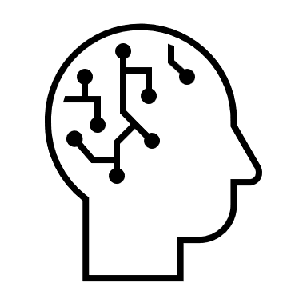
How are you feeling?
What are your thoughts?

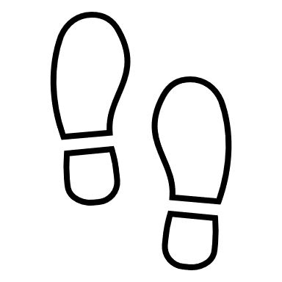
What are your next steps?
The Law-Related Education Academy is facilitated by the Arizona Foundation for Legal Services & Education with funding made possible by the Arizona Department of Education School Safety Program.

“Addressing Bullying Behaviors” Academy
(Middle/High School)
When is it Bullying Lesson Plan

Arizona State Standards Correlations

Civics and Government
Explain the obligations and responsibilities of citizenship: obeying the law. (7-12 S3C4 PO4b-c)

Reading
Integrate information presented in different media or formats (e.g., visually, quantitatively) as well as in words to develop a coherent understanding of a topic or issue. (6.RI.7)

Writing
Write informative/explanatory texts to examine a topic and convey ideas, concepts, and information through the selection, organization, and analysis of relevant content.
d. Use precise language and domain‐specific vocabulary to inform about or explain the topic. (8.W.2.d)

Comprehension and Collaboration
Engage effectively in a range of collaborative discussions (one‐on‐one, in groups, and teacher‐led) with diverse partners on grade 8 topics, texts, and issues. (8.SL.1)

https://www.youtube.com/watch?v=mMmL1Mo2SNI
https://www.stopbullying.gov/bullying/effects

