
The Law-Related Education Academy is facilitated by the Arizona Foundation for Legal Services & Education with funding made possible by the Arizona Department of Education School Safety Program.

Social Media and Campus Issues Academy
Should I Report It? Lesson
Social Media Posts Facilitator Guide

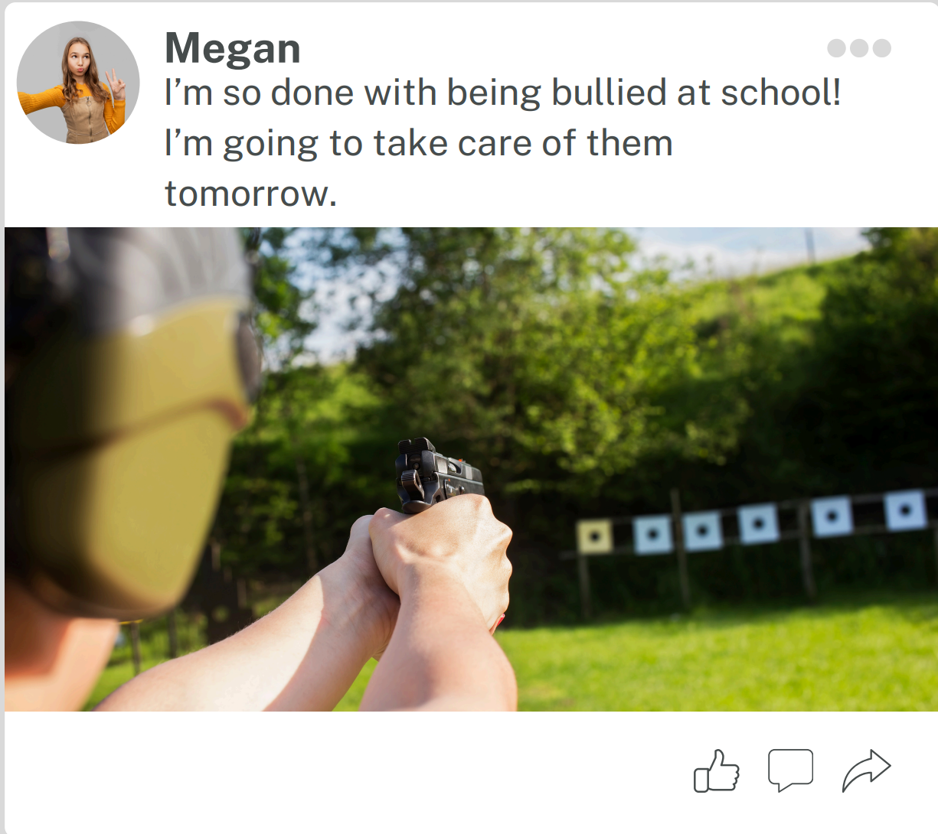

- Could someone get hurt? Yes, a threat to hurt others is being made.
- Can you tell if the person is telling the truth in the post? No but if they are telling the truth, people could get hurt.
- Does the post need to be reported? Yes, a post like this should always be reported.
- What could happen if the post was not reported? If the post was not reported lives could be lost.

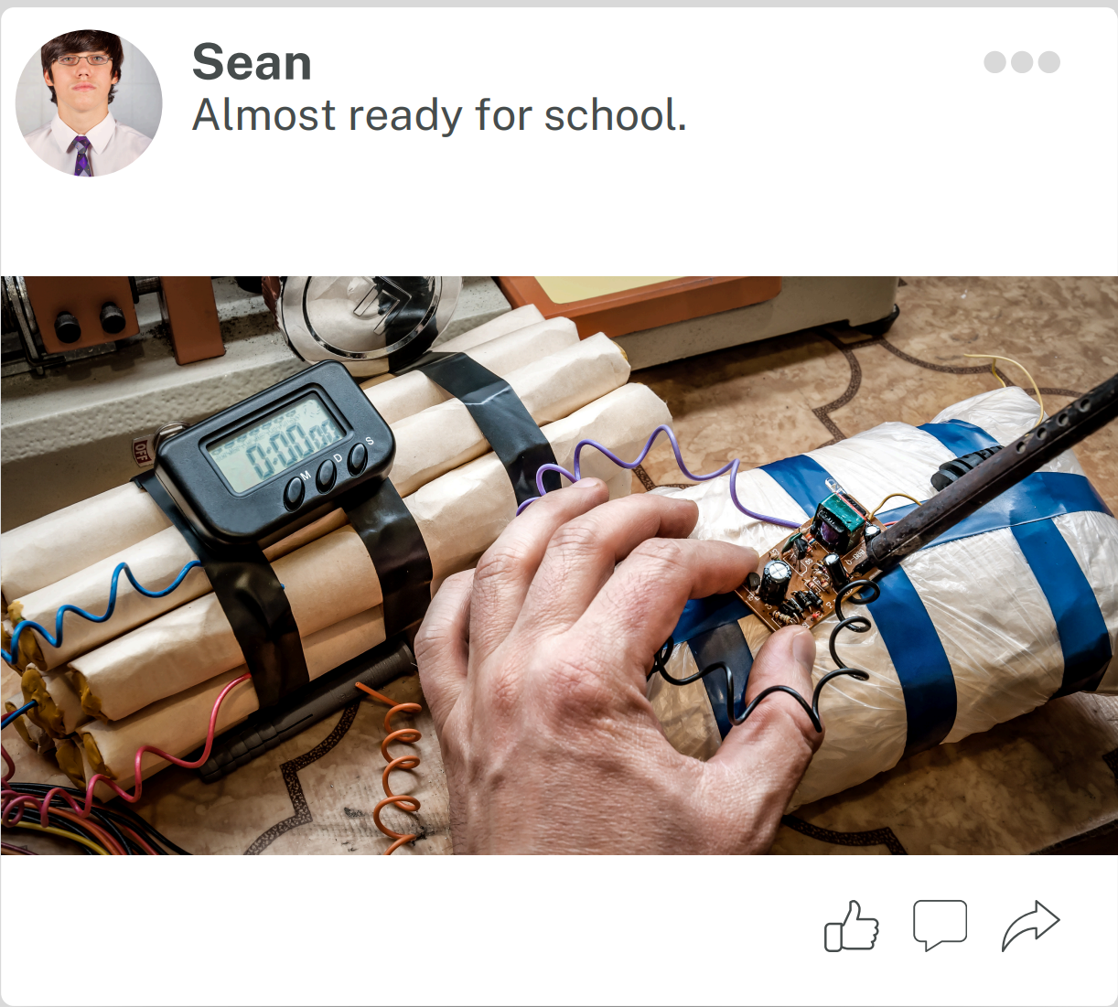

- Could someone get hurt? Yes, any time there is a bomb involved others can be severly hurt.
- Can you tell if the person is telling the truth in the post? No but if they are telling the truth, people could get hurt.
- Does the post need to be reported? Yes, anytime there is a bomb involved reporting is neccesary.
- What could happen if the post was not reported? If this does not get reported others may lose their life.

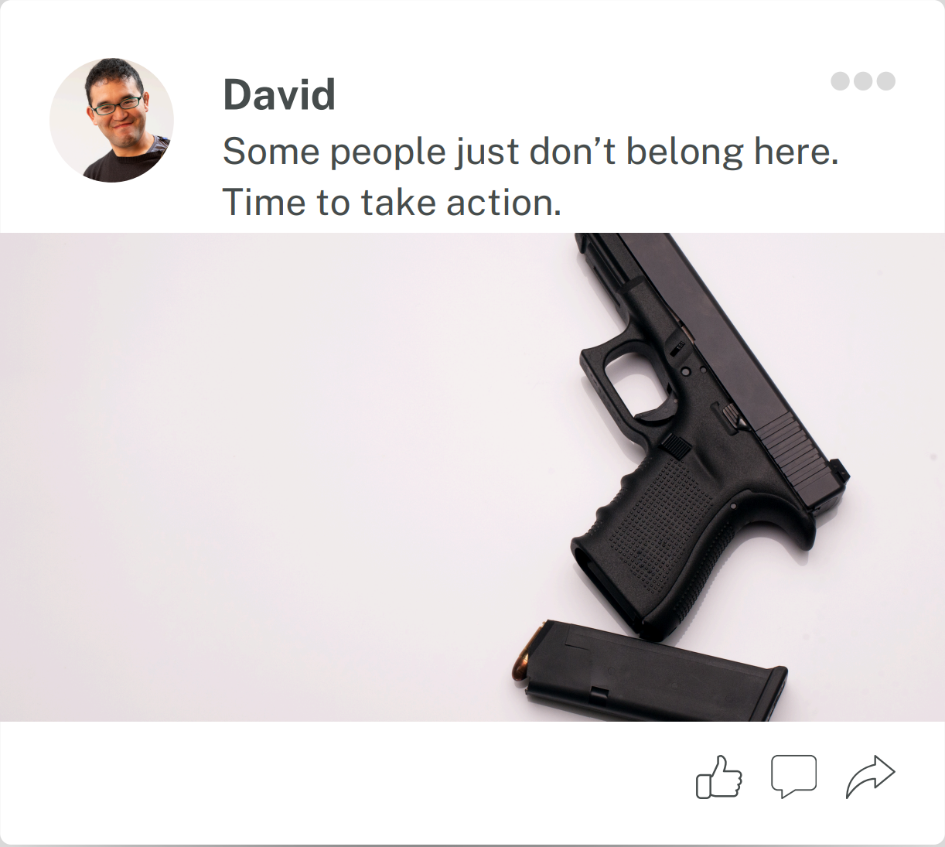

- Could someone get hurt? Yes, any time there is a gun involved others can be severly hurt.
- Can you tell if the person is telling the truth in the post? No but if they are telling the truth, people could get hurt.
- Does the post need to be reported? Yes, anytime there is a gun involved reporting is neccesary.
- What could happen if the post was not reported? If this does not get reported others may lose their life.

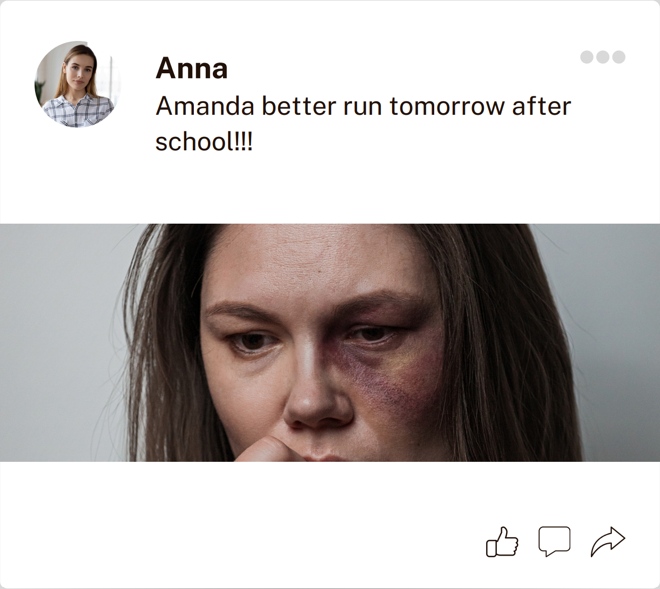

- Could someone get hurt? Possibly
- Can you tell if the person is telling the truth in the post? No but if they are telling the truth, Amanda could get hurt.
- Does the post need to be reported? Yes, this post does need to be reported in order to take precautions. The words in this post are not very direct and an adult needs to be notified in order for them to further investigation.
- What could happen if the post was not reported? It is unclear what could happen and this is why it needs to be reported to prevent anything from happening.

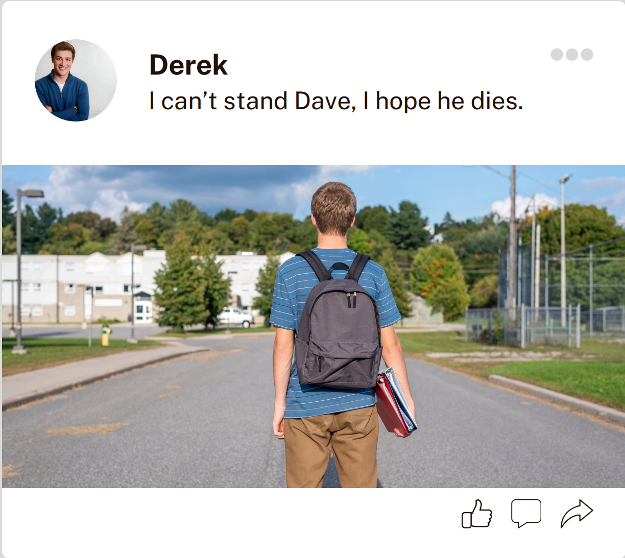

- Could someone get hurt? No, even though this student is sharing negative comments there is no risk of anyone getting hurt.
- Can you tell if the person is telling the truth in the post? No
- Does the post need to be reported? Possibly. There isn’t a direct threat but reporting to school personnel might help the two students get a mediation to calm the situation before it escalates.
- What could happen if the post was not reported? Possible physical altercation in the future.

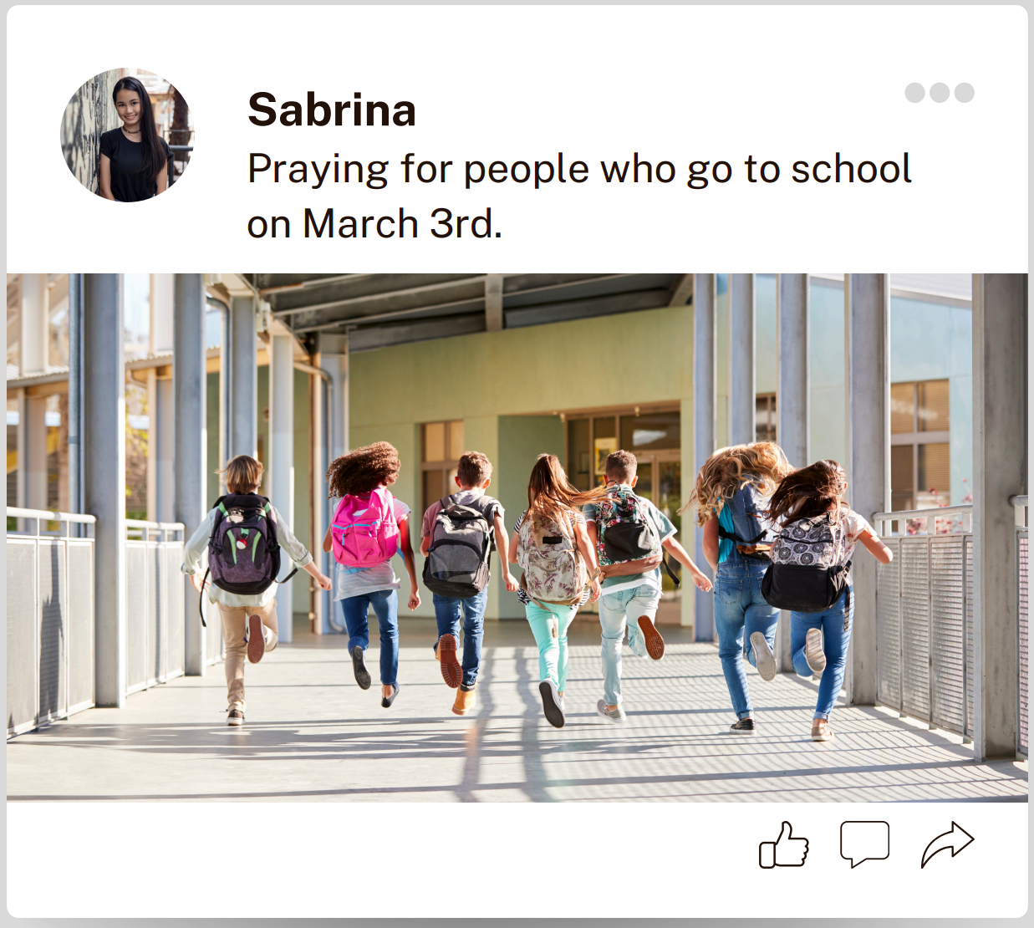
- Could someone get hurt? Possibly
- Can you tell if the person is telling the truth in the post? No
- Does the post need to be reported? Yes, this post does need to be reported in order to take precautions. The words in this post are targeting a specific day and an adult needs to be notified in order for them to further investigation.
- What could happen if the post was not reported? It is unclear what could happen and this is why it needs to be reported to prevent anything from happening.

