
The Law-Related Education Academy is sponsored by the Arizona Foundation for Legal Services & Education with funding made possible by the Arizona Department of Education School Safety Program.

“Technology Use and School” Academy
(Middle/High School)
Safety with Uploads and Downloads Lesson Plan
Officers should obtain administrator approval prior to implementing this lesson.

Objectives: Students will…
- understand what is appropriate to upload.
- learn consequences for inappropriate uploads.
- prepare advice for peers on safe downloading and uploading.

Protective Factors Developed: Critical Reasoning Skills

Materials:
- Large poster paper and markers for each group
- LESS SERIOUS and MORE SERIOUS signs
- Body Parts Pics. pgs. 4-11 or a Body Part Debrief set

Timeframe: 50 minutes

Team Teaching: For effective implementation of Law Related Education (LRE), team teach with the classroom teacher by…
- Having both the officer and teacher rotate among students and to different groups. Both instructors will provide positive feedback and engage in friendly conversations with students. This procedure will help reduce classroom disruptions, increase student engagement, and build supportive relationships with students.
- Encouraging classroom teachers to participate in all activities by injecting clarification statements by relating relevant content to their curriculum. In this method, students will see more connections to their student life and be willing to carry over concepts and skills learned in LRE.
- Assigning the classroom teacher part of the lesson instructions. Team teaching with the classroom teacher enables the students to further see the importance of LRE lessons. It also provides an opportunity for the classroom teacher to demonstrate teaching skills conducive for effective teaching. Student attention can be maintained more easily with different voices and personalities experienced throughout the lesson.

Warm-Up:
- Divide students into small groups of 4 or 5 students each. Provide each group with large poster paper and markers.
- Instruct the groups to discuss the difference between upload and downloads on their electronic device. Call on volunteers to share what they think the differences are.
Upload-sending information or data from your electronic device to another device, a server or website.
Download-bringing information or data from another device, a server or website to your device.
- Now, instruct the groups to create an image that illustrates the terms “Upload” and “Download” on their large poster paper. Groups should also list examples of data that can be uploaded and downloaded next to their illustration.
- Instruct the groups to discuss what is not allowed to download on school electronic devices. Call on each group to share a response for each. Example: music, games, software
- Next, ask the students to call out the school consequences for downloading inappropriate content. Remind students that schools place firewalls on school computers for their protection.
Possible Responses: permission to use-revoked, detentions/suspensions, pay for damages, loss of trust, less privileges, etc.

Lesson:
- Now ask the class to brainstorm about the possible risks with uploads and downloads on their electronic device. Allow students to call out ideas as you record them on the board.
Possible Responses: infect computers with programs that illegally access user’s information, using computer memory, identity theft, receive unwanted, offensive, or inappropriate content, increased ads, or pop-ups, etc.
- Post the following signs on opposite sides of the room: LOW RISK and HIGH RISK. Explain to students that you will read statements from a list. For each statement, students are to decide along a continuum the degree of risk they think it is.
- After each statement is read and students choose their place along the continuum, call on a few volunteers from different points to explain their reasoning. Elaborate with laws or information, see responses in parenthesis.
- Jenny downloads her favorite songs to her school issued tablet to use as background to a class presentation. (Copyright Violation if permission or payment is required)
- Xavier received an email from someone they do not know asking them to click on the link to earn gaming points to his favorite game. (Computer virus, potential harmful programs could infect the system or device, misuse of school device, identity theft)
- Jesse is trying to upload some pictures from a website on a school issued tablet. Jesse keeps receiving a message that the content is blocked but keeps trying to find a way around it. (Copyright Violation if permission or payment is required, misuse of school device, 8-309. Unlawful use of an electronic communication device by a minor; classification; definitions; 13-2316. Computer tampering; venue; forfeiture; classification)
- Marcos downloads a movie he streamed on his school issued tablet. He wants to use a clip from the movie in his school project. (Copyright violation - became illegal in 2020 with the passing of the Protecting Lawful Streaming Act of 2020)
- Laura uploaded a video she took with her school issued tablet. She sent the video out to other members of the class. It shows a teacher having words with a student when they were standing alone outside the classroom door. (Misuse of school devices, invasion of student privacy if the conversation had an expectation of privacy from either teacher or student, 8-309. Unlawful use of an electronic communication device by a minor; classification; definitions; 15-507. Abuse of teacher or school employee in school; classification)
- Instruct students to return to their group seating. Ask the class to brainstorm with you for advice on legally and safely downloading and uploading information on school computers. Allow students to call out information as you record it on the board.
Possible Responses: Only use school approved apps, don’t download anything without asking the teacher first
- Next, instruct the groups to design a webpage educating their peers on downloading and uploading on their large poster paper. Groups can display their posters on the wall and take turns presenting to the class.
- Provide each group with a picture of the following body parts, see Body Parts pgs. 4-11, or use the pieces in a Body Part Debrief set. Post the following and instruct the groups to think of something from today’s lesson that the body part would remind them of.
  - Brain-Something you learned
  - Heart-Something you felt
  - Hand-Something you helped with
  - Eye-Something you saw
  - Stomach-Something that took guts to do
  - Ear-Something you heard
  - Smiley-Something that made you happy
  - Foot-Something you will take away with you
- Call on each group to share their ideas.

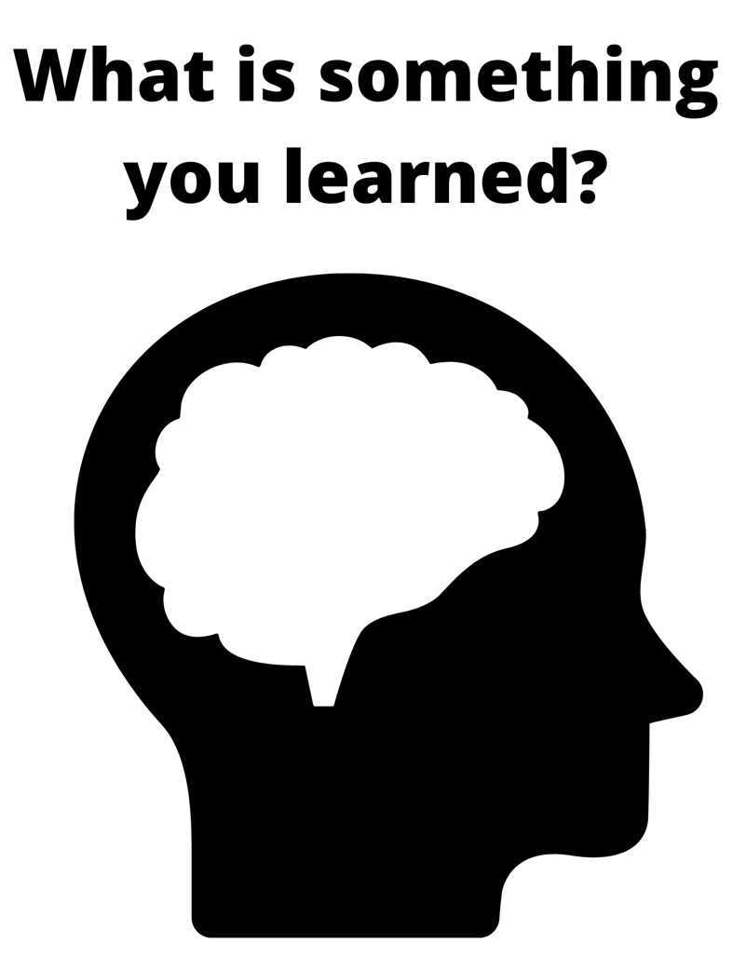


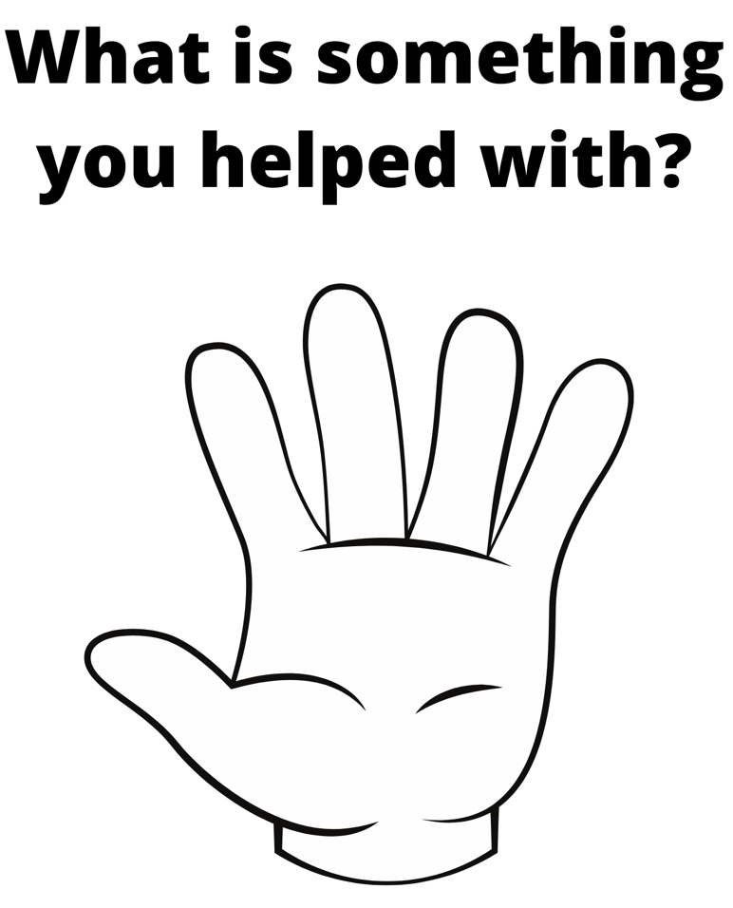




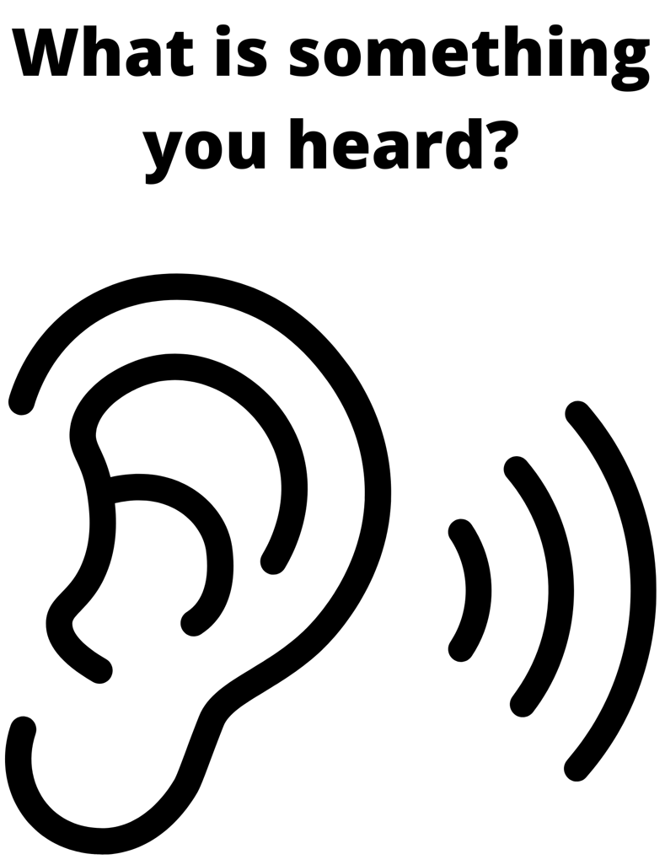





The Law-Related Education Academy is sponsored by the Arizona Foundation for Legal Services & Education with funding made possible by the Arizona Department of Education School Safety Program.

“Technology Use and School” Academy
(Middle/High School)
Safety with Uploads and Downloads
Correlations

Civics and Government
Explain the obligations and responsibilities of citizenship: obeying the law.
(7-12 S3C4 PO4b-c)
Describe the regulatory functions of government pertaining to consumer protection, environment, health, labor, transportation, and communication. (HS S3C3 PO4)

Comprehension and Collaboration
SL.1 Prepare for and participate effectively in a range of conversations and collaborations with diverse partners, building on others’ ideas and expressing their own clearly and persuasively.
SL.2 Integrate and evaluate information presented in diverse media and formats, including visually, quantitatively, and orally.

Presentation of Knowledge and Ideas
SL.4 Present information, findings, and supporting evidence such that listeners can follow the line of reasoning and the organization, development, and style are appropriate to task, purpose, and audience.

Visual Art
Explain purposeful use of subject matter, symbols, and/or themes in his or her own artwork. (S1C4PO 201)
Create artwork that communicates substantive meanings or achieves intended purposes (e.g., cultural, political, personal, spiritual, and commercial). (S1C4PO 302)

Technology
Assess situations in which it is appropriate and safe to use a personal digital device in the home, school, community, and in the workplace. (7-12 S5C1 PO1)
Articulate and practice the school and district rules governing the use of digital tools as defined by school board policy and procedures. (7-12 S5C1 PO3)
Advocate and exhibit legal and ethical behavior when using technology. (6-12 S5C1PO6)
Promote and exhibit digital citizenship by consistently leading by example and advocating social and civic responsibility to others. (7-12 S5C2PO 1)

