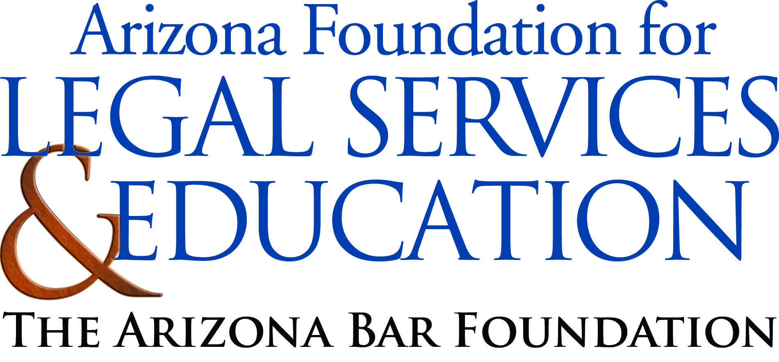

The Law-Related Education Academy is sponsored by the Arizona Foundation for Legal Services & Education with funding made possible by the Arizona Department of Education School Safety Program.

Illicit Use of Legal Drugs: What’s the Harm? Academy
“Purpose of Legal Drugs” Lesson Plan
Middle/High School

Objectives: As a result of this training, participants will be able to…
- Understand the purpose and use of legal drugs
- Chart the effects of abusing legal drugs
- Advise safety practices with drugs

Materials:
- Sentence Strips: one per group
- Facilitator sentence strip with definition of drugs
- Dry Erase Board and Markers
- Markers/Highlighters for groups
- Sticky note pad: a different color for each table
- Timer, watch or clock to time groups-pens for each participant
- Poster paper
- Two signs one labeled ‘Positive’ and one labeled ‘Negative’
- Effects of Abusing Drugs Reference Sheet

Timeframe: 45 minutes
Activity:
- Place students into small groups of 3-5 students each.
- Give each group one sentence strip.
- Facilitator writes the word “Drug” on the board and asks groups to discuss the meaning and come up with one definition to write on their sentence strip.
- Give groups time to finish and then ask each group one at a time to reveal their answer. When all groups have revealed their definitions, show your sentence strip with your definition (a substance used as a medicine; affects the function of the body *m-w.com)
- Tell students to consider all definitions and as a whole group draft one class definition. Facilitator writes on large Post It paper as class volunteers words then post it on wall.
- Facilitator writes the following on the board: “What are drugs used for?” Instruct groups to use the sticky notes (different color for each group) and when you say, “go” they are to use as many sticky notes as needed to record their ideas on but only one answer per note. Tell groups they will have three minutes (while they are working post the sign labeled “Positive” on one wall and on another wall post the sign labeled “ Negative” ), when time is up call “stop! ”
- Tell students when their group is called, all members are to come up and bring their ideas written on sticky notes and post them under the “Positive” or “Negative” signs. Have members report out each time a group is called up.
- When all notes are posted ask if any one disagrees with the postings, allow for discussion.
- Tell students that legal drugs have a medical use and can help you when you need them (refer to positive uses) but taking them when you do not i.e., abusing legal drugs can (refer to negative uses) cause health risks, dependencies and can carry legal consequences the same as abusing illegal drugs. (ARS…)
- Next, write the following on the board or large paper for the class to see:
Effect of Abusing Drugs
Body Brain Life
- Tell groups to make their own chart on their large paper and brainstorm together as a group and list as many effects under each category as they can. Give groups 5 minutes and then ask each group to post their chart and report out. Facilitator refers to Effects of Abusing Drugs Reference Sheet to guide responses if necessary.
- Now, have students divide their group into two sides and give one side red paper and the other side green paper at each table.
- Tell students that they are going to draft safety advice signs to their same age group about the use of drugs and post them on the wall. Those that have green are to make it a safety statement such as “Only take a drug…” Those that have red paper are to make it a warning statement such as “using drugs you don’t need can…”
- As soon as students have finished their signs have them post on wall and report out.

Debrief:
  - What is the purpose of legal drugs?
  - What can happen if you take a legal drug that you don’t need?

The Law-Related Education Academy is sponsored by the Arizona Foundation for Legal Services & Education with funding made possible by the Arizona Department of Education School Safety Program.

Illicit Use of Legal Drugs: What’s the Harm? Academy
“Purpose of Legal Drugs”
Effects of Abusing Drugs Reference Sheet

Suggested Body Answers:
-Decreased/increased breathing
-Decreased/increased heart rate
-Death
-Comas
-Affects your cerebellum, which controls your coordination, you may not be able to control your body.
-Development of brain (shrinkage) less ability for thinking, memory space and learning
-Make you sick with nausea, pain, and lowered immunities
-Physical change to external body such as hair or teeth loss
-Functional changes to internal organs such as kidneys and lungs/dehydration or shut down

Suggested Brain Answers:
-Physical changes to brain wiring, alters the way the brain communicates-may not send correct messages to the body
-Inability to control cravings
-Harder to controlling behavior
-Addiction
-Anxiety
-Hostility
-Emotional imbalances

Suggested Life Answers:
-Loss or restrictions on driver’s license
-Inability to play sports or be eligible
-Inability to treat others with controlled emotions
-Inability to learn-less education or skills
-Money wasted on drugs instead of education or other healthy activities
-Lack of interest in things you used to be interested in like hobbies
-Poor relationships-lack of trust or acceptance from others or for others
-Missed “Milestones” such as getting your driver’s license at 16
-Loss of freedom and responsibilities from legal consequences of drug abuse
-Reduced job opportunities due to criminal records or reduces physical or mental abilities from the effects of drug abuse
-Loss of Longevity due to health issues from drug abuse

The Law-Related Education Academy is sponsored by the Arizona Foundation for Legal Services & Education with funding made possible by the Arizona Department of Education School Safety Program.

Illicit Use of Legal Drugs: What’s the Harm? Academy
“Purpose of Legal Drugs”

Correlations

AZ State Standards

Civics and Government | Writing Applications
Explain the obligations and responsibilities of citizenship: obeying the law  (7-8 S3C4 PO4b) | Record Information related to the topic.  (7-8 S3C2 PO1)

AZ College and Career Ready Standards

Production and Distribution of Writing | Comprehension and Collaboration
Produce clear and coherent writing in which the development, organization, and style are appropriate to task, purpose, and audience.  (6‐12.WHST.4) | Engage, initiate, and participate effectively in a range of collaborative discussions (one-on-one, in groups, and teacher-led) with diverse partners on grade appropriate topics, texts, and issues, building on others’ ideas and expressing their own clearly.  (6-12 SL.1)

