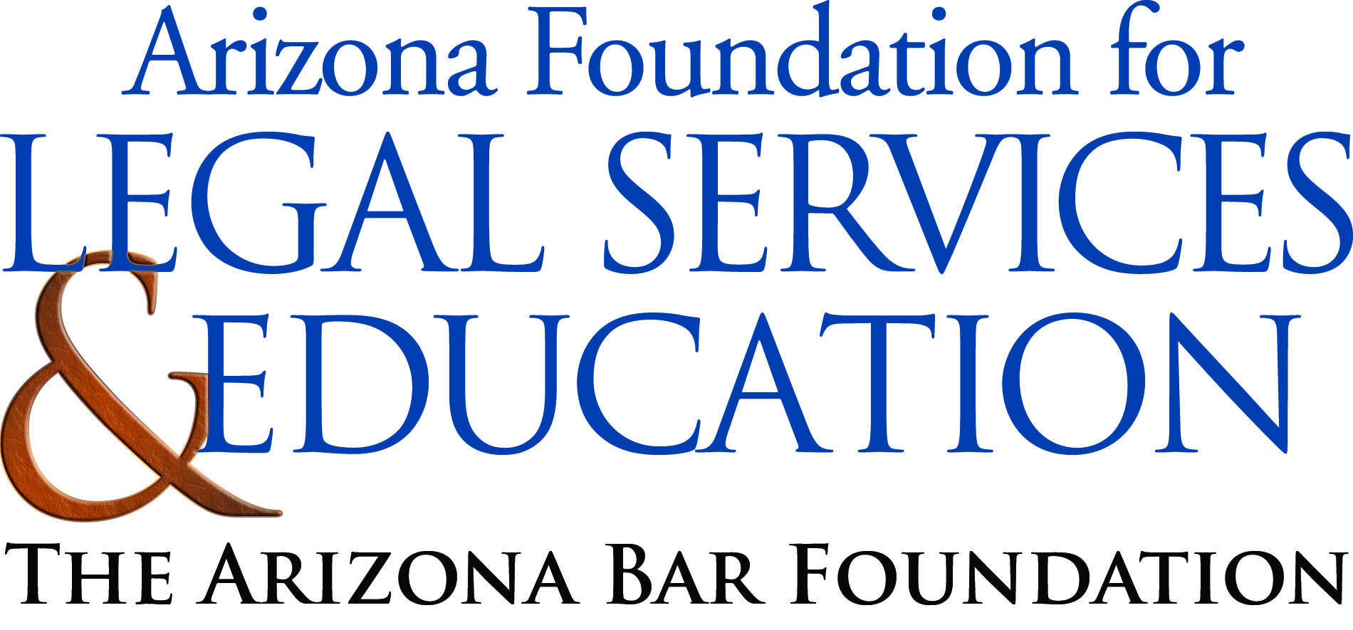

The Law-Related Education Academy is sponsored by the Arizona Foundation for Legal Services & Education with funding made possible by the Arizona Department of Education School Safety Program.

Illicit Use of Legal Drugs: What’s the Harm? Academy
“Legal Consequences of Alcohol Abuse” Lesson Plan
Middle/High School
Objectives:
- Learn the consequences to underage drinking
- Match behaviors to outcomes-legal or illegal consequences
- Create a pledge to remind them to stay sober

Materials:
- Poster paper and markers
- Underage Drinking Behaviors and Legal Consequences Cards
- Poster or construction paper

Timeframe: 45 minutes
Activity:
- Ask class to shout out what age were they/or are they looking forward to being. Facilitator writes on the board some of the ages mentioned.
- Have students count off: 1-2-3 and have the 1s-2s-3s sit together in a group.
- Assign each group a different age (1s-age 16, 2s-age 18, 3s age 21; multiple groups can be the same number to make smaller group sizes).
- Instruct groups to illustrate a mural on what can be done at that age on a large piece of paper; why would that be a great age to be?
- Have each group share their mural with the class.
- Discuss with class that different ages have exciting opportunities to look forward to, i.e., “mile stones” or “rites of passage”. You would not want to do anything to cause you to miss out on positive opportunities to enjoy your life. With added privileges come added responsibilities. And if you abuse your privileges you can lose them. Citizens who abuse alcohol run the risk of having serious consequences and having certain rights limited or taken away. Underage drinking is never allowed and also carries consequences that can limit or take away privileges obtained at certain ages.
- Next, tell the class that they are going to do an activity where they will be matching underage drinking behaviors with legal consequences.
- Randomly pass out the Underage Drinking Behavior and Legal Consequences cards to each student. Instruct students that they will be looking for the student that has the correct match. When they think they have found them stand next to each other.
- When students have paired up have each partnership read their cards to check for accurate matches. There are 4-5 sets so two or three partnerships will be the same (see facilitator key)
- Next have partners create and illustrate on construction paper a warning statement inspired by their matched cards to remind them of legal consequences of alcohol abuse.

(Asking someone to buy you liquor when you are underage is like asking your mom to drive you around. It’s not worth losing your driver’s license and independence. )

- Have partners post their warning statements and share with class.
- Debrief by asking the following questions:

- What are some ways underage drinking can keep you from enjoying your milestones such as age 16-18 or 21?
- What are some consequences for underage drinking?
- If your friend was underage drinking how would you help them?

The Law-Related Education Academy is sponsored by the Arizona Foundation for Legal Services & Education with funding made possible by the Arizona Department of Education School Safety Program.

Illicit Use of Legal Drugs: What’s the Harm? Academy
“Legal Consequences of Alcohol Abuse”
Behavior and Outcome Cards
http://www.lawforkids.org/Laws/Violence/

If you are under 21 years of age and are in possession of an alcoholic substance, you can be found guilty of a class 1 misdemeanor.  (A.R.S. § 4-244(34)). | You and your friends are 16 and are hanging out at the park. You have beer in your possession and get caught by the local authorities.  FACT: In 2011, NIDA* reported that underage drinking (ages 12-20) had declined. 75% of 12-20 year olds do NOT drink alcohol.  *NIDA- Natl. Institute on Drug Abuse
A person under 21 years old who asks someone else to purchase, sell or furnish them with alcohol is guilty of a class 3 misdemeanor and could receive a penalty of a maximum of 30 days in jail, a $500 fine plus surcharges (A.R.S. § 13-802) and suspension of a driver’s license or permit (A.R.S. § 4-241(D)) | You are 17 and ask your friend’s 22 year old brother to buy you some alcohol. You get caught by the local authorities.  FACT: In 2011, NIDA* reported that underage drinking (ages 12-20) had declined. 75% of 12-20 year olds do NOT drink alcohol.  *NIDA- Natl. Institute on Drug Abuse
A person under 21 years old who uses false identification to buy or be furnished with alcohol is guilty of a class 1 misdemeanor and could receive a penalty of 6 months in jail and a $2,500 fine plus surcharges (A.R.S. § 13-707) including suspension of a driver’s license or permit (A.R.S. § 4-241(C),(E)) | You are 18 and try to use a fake Id at the local convenience store. The store manager calls the local authorities.  FACT: In 2011, NIDA* reported that underage drinking (ages 12-20) had declined. 75% of 12-20 year olds do NOT drink alcohol.  *NIDA- Natl. Institute on Drug Abuse
If you are under 21 years of age, it is against the law to drive or be in physical control of a motor vehicle while there is any spirituous liquor in your body (A.R.S. § 4-244(34)). | You are 20 and driving home from a party where you have been drinking alcohol. You get stopped at a check point.  FACT: In 2011, NIDA* reported that 90% of people do NOT drink and drive.  *NIDA- Natl. Institute on Drug Abuse
The Law-Related Education Academy is sponsored by the Arizona Foundation for Legal Services & Education with funding made possible by the Arizona Department of Education School Safety Program.

Illicit Use of Legal Drugs: What’s the Harm? Academy
“Legal Consequences of Alcohol Abuse”
Correlations
AZ State Standards
Civics and Government | Comprehending Informational Text | Advanced Visual Arts
Explain the obligations and responsibilities of citizenship: obeying the law  (7-8 S3C4 PO4b) | Make relevant inferences about expository text, supported by text evidence.  (6-8 S3C1PO 10) | Demonstrate purposeful use of subject matter, symbols and/or themes in his or her own artwork.  (S1C1PO 301)

AZ College and Career Ready Standards

Key Ideas and Details | Production and Distribution of Writing
Read closely to determine what the text says explicitly and to make logical inferences from it;  (6-12. RH.1) | Produce clear and coherent writing in which the development, organization, and style are appropriate to task, purpose, and audience. (6‐12.WHST.4)

