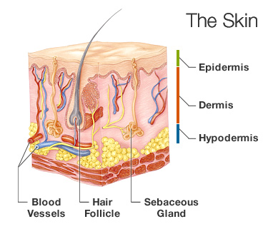
SKIN:
HEALTHY
FUNCTIONS

Image: Webmd.com

Provides Protection From:
- mechanical impact
- thermal impact
- chemical impact
- microorganisms (bacteria, viruses, fungi)
- UV-Radiation
- Water loss

Immune Function:
- Is a barrier for the body protecting it from micro organisms

Temperature Regulation:
- Through sweat producing glands and evaporation of sweat and water – the body’s temperature is controlled. Blood vessels also widen and constrict to cool the body or prevent heat loss

Sensation:
- Through nerve endings and receptors in the skin, sensations such as touch, pain, heat and cold are processed

Vitamin Production:
- Skin produces vitamin D through exposure to the ultraviolet radiation in sunlight

Social Interactive:
- Through paling, blushing and other expressions skin serves as a communication system
www.skincase,dermis.net
Image: webmd.com
SKIN:
Alcohol’s
Effect
Blotchy Redness:
- Broken capillaries in the face make the skin more susceptible to flushing and blushing

Dryness:
- Blood vessels in your face can become restricted and stop delivering amounts of oxygenated blood to your skin necessary to keep hydrated, causing skin to be undernourished and starving for proper hydration

Puffiness;
- Alcohol can cause weight gain and water retention

Breakouts:
- Acne, whiteheads and other skin lesions (linked to excess hormones in the body, those hormones activate the sebaceous glands that cause skin to overproduce oil on your skin, resulting in a broken out complexion

Bruising:
- Alcohol depletes the body of vitamin C which is necessary for quick healing. This depletion makes the skin more prone to bruising

www.Livestrong.com

Alcohol’s Path Through the Body
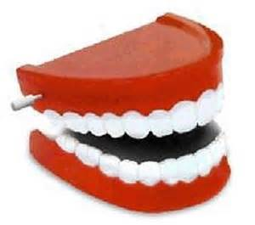
Stomach
Alcohol enters the body
Mouth
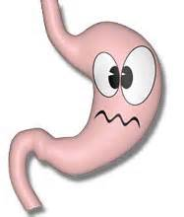
Small Intestine
Some alcohol gets into the blood steam in the stomach,
but most goes on to the small intestine
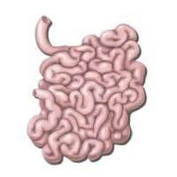
Heart
Alcohol enters the bloodstream through the walls
of the small intestine
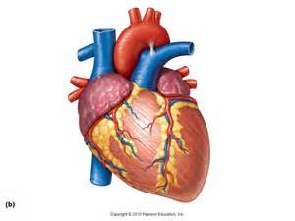
Brain
Alcohol reaches the brain
Pumps alcohol throughout the body
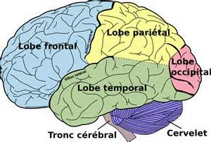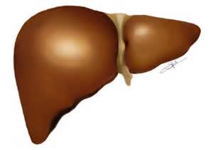
Alcohol is metabolized (broken down) by the liver
Liver
Alcohol is then converted into water, carbon dioxide and energy
Information from Collegedrinkingprevention.gov
Brain:
Alcohol’s
Effects

Frontal Lobe of the Brain:
- Damage to the frontal lobe will affect your personality and social behaviors and these may change drastically. You may interact differently with others. You may become impulsive, irritable, aggressive, passive or withdrawn. Depression or lack of interest in activities may occur. You may lose the ability to judge what behaviors are or are not socially inappropriate. You may experience difficulty with memory, concentration and problems solving. ~livestrong.com
Reduce Brain Size & Enlarge Ventricles:
- Cause an overall reduction in brain size and increase in the size of the ventricles. When the ventricles in your brain are enlarged, they fill with more Cerebrospinal fluid (fluid in your brain) and causes pressure in your brain. Symptoms may include: headache, difficulty in remaining awake or waking up, loss of coordination or balance, loss of bladder control or a frequent urge to urinate, impaired vision, decline in memory, concentration and other thinking skills. ~mayoclinic.com
Addiction:
- An addiction to alcohol will result in tolerance to the effects of alcohol and a variety of health and social problems ~Washington.edu
Liver Damage Affects the Brain:
- Alcoholic liver disease also damages the brain. The liver breaks down alcohol – and the toxins it releases. since the damaged liver cells no longer function as well as they should and allow too much of the toxic substances to travel to the brain. The substances proceed to damage brain cells. ~National Institute on Alcohol Abuse and Alcoholism
* There still is much we do not understand about how the brain works and how alcohol affects it. Researchers are constantly discovering more about how alcohol interrupts communication pathways in the brain and changes brain structure, and the resulting effects on behavior and functioning. ~National Institute on Alcohol Abuse and Alcoholism
Brain:
Healthy
Functions

Controls the body:
- The brain’s structure is complex. It includes multiple systems that interact to support all of your body’s functions – from thinking to breathing and moving ~National Institute on Alcohol Abuse and Alcoholism
Frontal Lobe of the Brain:
- The frontal lobe section of your brain is known as your “emotional center” and is also where your personality is formed. It plays a role in memory, controlling movement and judgement, as well as social behavior. The type and severity of symptoms you develop depend on exactly which section of the frontal lobe is damaged. ~livestrong.com
Brain Ventricles:
- Your brain floats in a bath of cerebrospinal fluid. This fluid also fills large open structures, called ventricles, which lie deep inside your brain. The fluid-filled ventricles help keep the brain buoyant and cushioned. ~mayoclinic.com

Heart:
Alcohol’s
Effects
Alcoholic Cardiomyopathy:
- Long-term heavy drinking weakens the heart muscle, causing Alcoholic Cardiomyopathy. A weakened heart droops and stretches and cannot contract effectively. As a result it cannot pump enough blood to sufficiently nourish the organs…which results in a blood flow shortage that causes severe damage to organs and tissues. It can lead to heart failure. ~National Institute on Alcohol Abuse and Alcoholism
Arrhythmias:
- Both binge drinking and long-term drinking can affect how quickly a heart beats and disturb the proper rhythm of your heart. An arrhythmia can cause blood to collect or even clot in the upper chambers of the heart. If the clot travels from the heart to the brain, a stoke can occur: travel to other organs such as the longs a blood vessel blockage can occur. An arrhythmia can also case the heart to beat too quickly and not allow the lower chambers of the heart to fill with enough blood between each beat resulting in the body not getting enough blood…this may cause dizziness, lightheadedness, unconsciousness, cardiac arrest, and even sudden death. ~National Institute on Alcohol Abuse and Alcoholism
Hypertension:
- Chronic alcohol use as well as binge drinking can cause high blood pressure, or hypertension. ~Washington.edu

Heart:
Healthy
Functions
Pumps Blood Constantly Through Your Body:
- Your cardiovascular system consists of your heart, blood vessels, and blood. This system works constantly- every second of your life- delivering oxygen and nutrients to your cells and carrying away carbon dioxide and other unnecessary material. Your heart drives this process. Your heart beats about 100,000 times each day, pumping the equivalent of 2,000 gallons of blood throughout your body. ~National Institute on Alcohol Abuse and Alcoholism

Liver:
Healthy
Functions

Keeps Your Body Productive and Healthy:
- The liver stores energy and nutrients, generates proteins and enzymes your body uses to function and ward off disease. It also rids your body of substances that can be dangerous – including alcohol. ~National Institute on Alcohol Abuse and Alcoholism
Plays a Vital Role in Alcohol Detoxification:
- Because the liver detoxifies your body, it is especially vulnerable to damage from excessive alcohol ~National Institute on Alcohol Abuse and Alcoholism

Liver:
Alcohol’s
Effects
Liver Damage:
- The liver breaks down most of the alcohol a person consumes. The process of breaking down alcohol generates toxins even more harmful than alcohol itself. These by-products damage liver cells, promote inflammation, and weaken the body’s natural defenses. Eventually, these problems can disrupt the body’s metabolism and impair the function of the other organs.
Steatosis:
- Heavy drinking – even for just a few days at a time – can cause fat to build up in the liver. This condition, called steatosis, or fatty liver, is the earliest stage of alcoholic liver disease and the most common alcohol-induced liver disorder. The excessive fat makes it more difficult for the liver to operate and leaves it open to developing dangerous inflammations, like alcoholic hepatitis.
Alcoholic Hepatitis:
- Can cause fever, nausea, appetite loss, abdominal pain, and even mental confusion. As it increases in severity, alcoholic hepatitis dangerously enlarges the liver, and causes jaundice, excessive bleeding, and clotting difficulties.
Fibrosis:
- Causes scar tissue to build up in the liver. Alcohol alters the chemicals in the liver needed to break down and remove this scar tissue. As a result, liver function suffers.
Cirrhosis:
- If you continue to drink, the excessive scar tissue builds up and creates a condition called cirrhosis, which is a slow deterioration of the liver. Cirrhosis prevents the liver from performing critical functions, including managing infections, removing harmful substances from the blood and absorbing nutrients. Complications can include jaundice, insulin resistance, type 2 diabetes and cancer.
~National Institute on Alcohol Abuse and Alcoholism

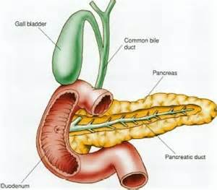
Pancreas:
Healthy
Functions

Food Digestion and Energy Conversion:
- It sends enzymes into the small intestine to digest carbohydrates, proteins, and fat. Secretes insulin and glucagon, hormones that regulate the process of utilizing flucose, the body’s main source of energy.

~National Institute on Alcohol Abuse and Alcoholism
Pancreas:
Alcohol’s
Effect
Inflammations:
- Alcohol damages pancreatic cells and influences metabolic processes involving insulin, this process leaves the pancreas open to dangerous inflammations.
Jumbled Functions:
- Alcohol jumbles the process of sending enzymes out to the small intestine to metabolize food. It causes the pancreas to secrete its digestive juices internally, rather than sending them to the small intestine. These enzymes are harmful to the pancreas.
Pancreatitis:
- The inflammation caused by the ‘jumbled functions’ is pancreatitis, which prevents the pancreas from working properly. It occurs as a sudden attack called acute pancreatitis or as excessive drinking continues, the inflammation can become constant and is called chronic pancreatitis. Pancreatitis is also a factor for the development of pancreatic cancer.
Acute Pancreatic Attack Symptoms:
- Abdominal pain, nausea, vomiting, fever, rapid heart rate, diarrhea, sweating
Chronic Pancreatitis Symptoms:
- Above symptoms…plus significant reduction in pancreatic function and digestion and blood sugar problems. It can slowly destroy the pancreas and lead to diabetes or even death.

~National Institute on Alcohol Abuse and Alcoholism

Immune System:
Healthy
Functions

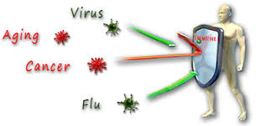

Your Personal Army:
- Your immune system is like an army that defends your body from infection and disease. Your skin and the mucous that lines your respiratory and gastrointestinal tracts help block bacteria from entering or staying in your body. If foreign substances somehow make it through these barriers, our immune system kicks into gear with two defensive systems: Innate and adaptive
Innate Defensive System:
- This system exists in your body before you are exposed to foreign substances like bacteria, viruses, fungi, or parasites. These substances, which are called antigens, can invade your body and make you sick. The components of the innate system include white blood cells (your first line of defense against infection, they surround and swallow foreign bodies quickly). They also include Natural Killer (NK) Cells which are special white blood cells that detect and destroy cells infected with cancer or viruses.
Adaptive Defense System:
- This system kicks in after you are exposed to an infection for the first time. The next time you encounter the same infection, your adaptive system fights it off even faster and more efficiently than the first time. This system includes T-cells which reinforce the work of white blood cells by targeting individual foreign substances. B-cells are also part of this system and produce antibodies that fight off harmful substances by sticking to them and making them stand out to other immune cells. They then produce antibodies, which are proteins that target specific antigens and then remember how to combat the antigen
~National Institute on Alcohol Abuse and Alcoholism

Immune System:
Alcohol’s
Effect

Suppression:
- Alcohol suppresses both the innate and the adaptive immune systems. Chronic alcohol use reduces the ability of white blood cells to effectively engulf and swallow harmful bacteria.
Compromised Immune System:
- Chronic drinkers are more liable to contract diseases like pneumonia and tuberculosis than people who do not drink too much.
Binge Drinking:
- Drinking a lot on a single occasion also can compromise your immune system. Drinking to intoxication can slow your body’s ability to ward off infections by causing inflammations, thus your body’s ability to defend itself against bacteria is significantly reduced.
~National Institute on Alcohol Abuse and Alcoholism

Intoxication

Alcohol is a central nervous system depressant. Virtually every organ system is affected by alcohol. Drinking in moderation may cause problems to one’s body and drinking heavily over the years can cause irreversible damage.
Factors that influence how alcohol will affect a person include: age, gender, and physical condition, amount of food eaten and other drugs or medicines taken.
Your body can only metabolize a small amount of alcohol at a time. Consuming more alcohol in a short time frame than creates more than your body can metabolize causing the system to become saturated and additional alcohol will accumulate in the blood and body tissue until it can be metabolized. This is why heavy consumption such as what occurs during drinking games can result in a high blood alcohol concentrations and alcohol poisoning.
Below is a pyramid of intoxication, as one consumes more alcohol, the body becomes more intoxicated and these symptoms may be present and intensified. When one reaches these levels depends on various factors mentioned above:
High Doses

Mental confusion
Lack of motor skills
Need medical assistance
Vomiting
Breathing difficulties
Alcohol poisoning
Moderate Doses

Slurred speech
Cause drowsiness
Disturbance of balance
Impaired motor coordination
Impaired hearing
Impaired vision
Feeling of elation or depression
Low Doses

Lowered inhibitions
Impaired concentration
Slowed reflexes
Impaired reaction times
Reduced coordination
Intensification of mood
Impaired judgment
Exaggeration of emotion
Exaggeration of behavior


Cancer

Genetics, environment, and lifestyle habits can all heighten your risk of getting cancer. Drinking too much alcohol is one lifestyle habit that can increase your risk of developing certain cancers.
The National Cancer Institute identifies alcohol as a risk factor for the following types of cancer:
- Mouth
- Esophagus
- Pharynx
- Larynx
- Liver
- Breast
Mouth Cancer:
- At least 7 out of 10 people with mouth cancer drink heavily
Why:
- Scientists are still trying to figure out exactly how and why alcohol can promote cancer. There are a variety of possible explanations. One explanation is that alcohol itself is not the primary trigger for cancer. We know that metabolizing, or breaking down, alcohol results in harmful toxins in the body. These toxins damage the genetic material in cells and render the cells incapable of repairing the damage. It also causes cells to grow too quickly, which makes conditions ripe for genetic changes and mistakes. Cancer can develop more easily in cells with damaged genetic material.
- Hormones may be the link between alcohol and breast cancer. Alcohol can increase the amounts of some hormones in the body, including estrogen, an excess of estrogen may lead to breast cancer.

~National Institute on Alcohol Abuse and Alcoholism

