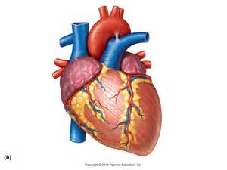  Heart | Heart
Heart | Heart
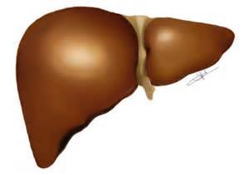  Liver | Liver
Liver | Liver
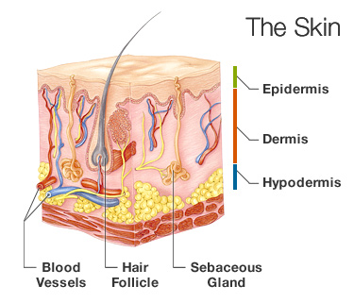  Skin | Skin
Skin | Skin
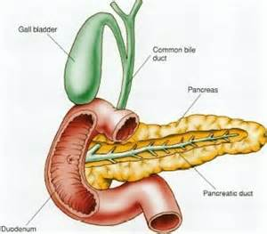  Pancreas | Pancreas
Pancreas | Pancreas
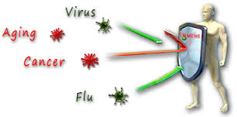  Immune System | Immune System
Immune System | Immune System
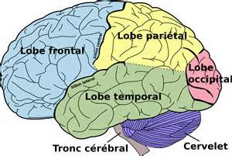  Brain | Brain
Brain | Brain

