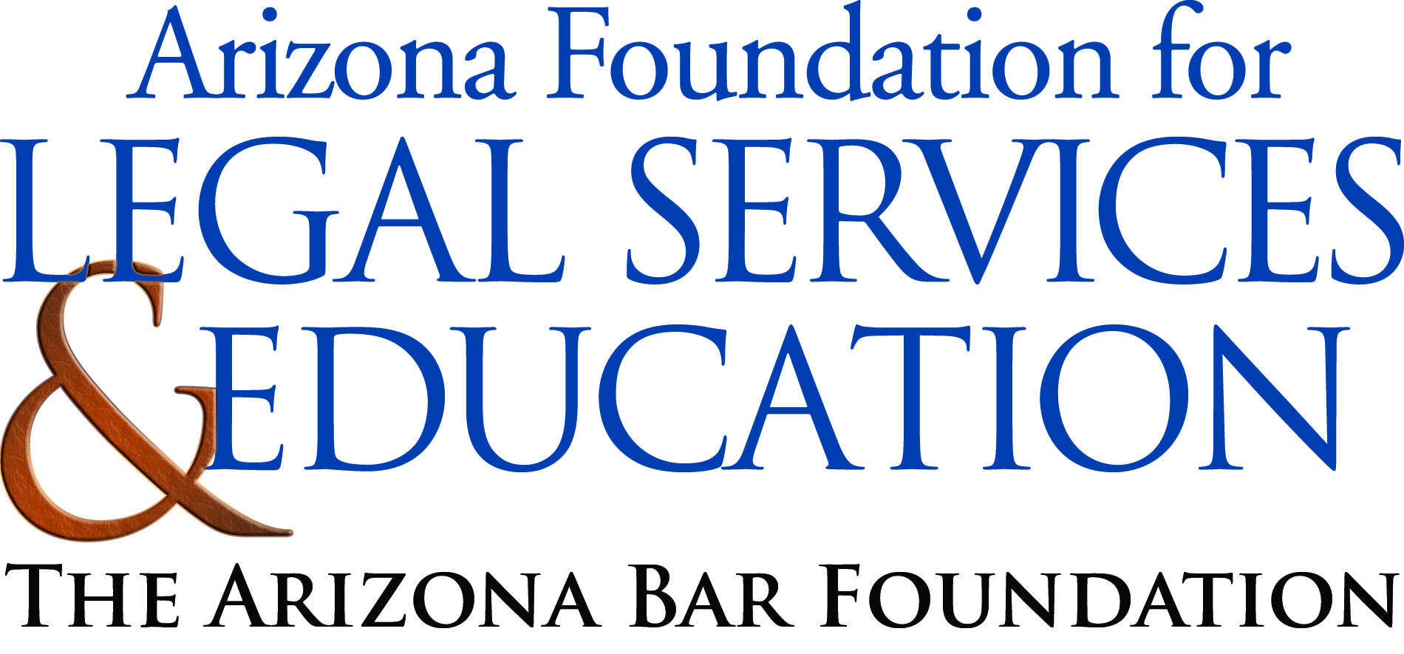

The Law-Related Education Academy is sponsored by the Arizona Foundation for Legal Services & Education with funding made possible by the Arizona Department of Education School Safety Program.

Illicit Use of Legal Drugs: What’s the Harm? Academy
“Legal Use and intent of Prescription Drugs and the Negative Effects of Abuse”
Lesson Plan

Objectives: As a result of this lesson students will be able to…
- Understand the side-effects associated with prescription drug abuse
- Learn facts regarding prescription drug abuse amongst teens
- Create a visual for an awareness campaign on the legal consequences of abusing prescription drugs

Materials:
- Prescription Drug Each-One Teach-One Strips (1per student)
- Did You Know? Cards
- Poster Paper
- Markers

Timeframe: 45 minutes
Activity:
- Mix up the Each-one-Teach-one cards and pass out one card to each student. Have them walk around the room and share their fact strips with at least 5 other people. They should teach their fact to one person at a time; no group teaching.
- After 5-7 minutes have passed, ask students to find and team up with students who have the same category of Each-One-Teach-One strip (i.e., Pain Relievers, Prescription Sedatives, Prescription Drugs and Prescription Stimulants)
- Once students have found their group members, have each group sit down at four different tables. Next, ask students to share one or two facts that they learned from others. Facilitator or volunteer from each table should write their facts on the board
- Then pass out “Did You Know Cards” –one to each group. Explain to the students that each group will create a poster, skit, brochure, or radio ad for their school campus based on their negative effects of their group drug. They must also incorporate their “did you know” legal fact.( Facilitator can assign the groups a format or let groups chose until all choices are taken so each group will be presenting in a different format) After groups are finished have each group present their awareness campaign and provide any feedback.
- A prize may also be awarded to the group with is the most creative presentation with the best impact.
- Debrief lesson by asking the following:
- What are some internal pressures that might cause teens to abuse drugs? Ex. Anxiety;
- What are some external pressures that might cause teens to abuse drugs? Ex. Peer attitudes?
- What are some healthy activities that teens can do to cope with pressures of life?

The Law-Related Education Academy is sponsored by the Arizona Foundation for Legal Services & Education with funding made possible by the Arizona Department of Education School Safety Program.

Illicit Use of Legal Drugs: What’s the Harm? Academy
“Legal Use and intent of Prescription Drugs and the Negative Effects of Abuse”

Correlations

AZ State Standards

Civics and Government | Theater | Visual Art
Explain the obligations and responsibilities of citizenship: obeying the law.  (7-8 S3C4 PO4b) | Opt1: Collaborate in informal performances.  (S1C1PO 204) | Opt 2: Create artwork that communicate substantive meanings or achieve intended purposes (e.g., cultural, political, personal, spiritual, and commercial).  S1C4PO 302

AZ College and Career Ready Standards

Key Ideas and Details | Presentation of Knowledge and Ideas
Determine the central ideas or information of a primary or secondary source; provide an accurate summary of the source. (6-12. RH.2) | Present information, findings, and supporting evidence such that listeners can follow the line of reasoning and the organization, development, and style are appropriate to task, purpose, and audience. (6-12 SL.4)

