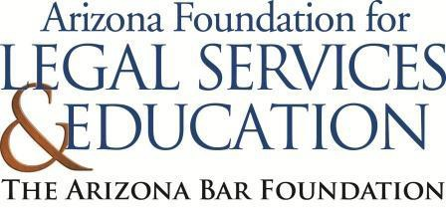

The Law-Related Education Academy is facilitated by the Arizona Foundation for Legal Services & Education with funding made possible by the Arizona Department of Education School Safety Program.

“Learning the Law Through Mock Trial” Academy
(Grades 3-5)

Why Do We Have Rules and Laws? Lesson Plan
Please obtain administrator approval prior to implementing this lesson.

Objectives:
- Students should be able to identify the benefits of rules.
- Students should learn how rules help them to be better community members.

Protective Factor Developed: Connection/Commitment to school

Materials:
- 1 Large paper and 1 marker, per group
- That Rule Doesn’t Apply to Me! By Julia Cook, illustrated by Anita Dufalla, 1 per facilitator
- Sheet of paper, 1 per group
- School rule example cards, 1 per student
- 1 Soft object (ex: stuffed animal or plush ball)
- Sticky Notes 1 per student

Timeframe: 40 Minutes

Team Teaching: For effective implementation of Law Related Education (LRE), team teach with the classroom
teacher by…
- Having both the officer and teacher rotate among students and to different groups. Both instructors will provide positive feedback and engage in friendly conversations with students. This procedure will help reduce classroom disruptions, increase student engagement, and build supportive relationships with students.
- Encouraging classroom teachers to participate in all activities by injecting clarification statements by relating relevant content to their curriculum. In this method, students will see more connections to their student life and be willing to carry over concepts and skills learned in LRE.
- Assigning the classroom teacher part of the lesson instructions. Team teaching with the classroom teacher enables the students to further see the importance of LRE lessons. It also provides an opportunity for the classroom teacher to demonstrate teaching skills conducive for effective teaching. Student attention can be maintained more easily with different voices and personalities experienced throughout the lesson.

Lesson:

Arizona Foundation for Legal Services and Education (October 2024) Page 1

- Divide the class into small groups of 3-4 students in each group and give each group one large paper and 1 marker.
- Instruct the students to think about what rules they must follow at school. Give students 30 seconds to think silently. After 30 seconds, instruct the students to turn to their group members and share 3 rules that they must follow at school.
- Each group should decide on one rule that they want to share with the class and write it on their large paper. They should also discuss why they think this rule is in place.
- Have students share with the class their rule and why they think it is in place.
- Explain to the class that you are going to read the book That Rule Doesn’t Apply to Me! By Julia Cook, illustrated by Anita Dufalla.
- Begin reading the story, stopping periodically to ask questions to keep the students engaged. For example:
  - Page 9: after reading the page, ask the students to discuss in their small group what they think would happen if there wasn’t a rule to raise your hand to talk. Allow a volunteer from 1 of the groups to explain. FACILITATOR NOTE: if students did not reflect on learning not taking place because everyone is interrupting, ask questions to help them reach that conclusion.
  - Page 19: after reading the page, ask the students to discuss in their small group, 1 playground rule that is meant to keep them safe. Allow a volunteer from 1 of the groups to explain (make sure it is a different group than step a.)
- At the conclusion of the story, ask the students to discuss in their small groups what Noodle learned about why rules are in place. Each group should report their answer. If they did not reach that rules keep them safe and help ensure learning, ask additional questions to help them get to that point.
- ass out school rule example cards, 1 per student (it is okay if there are some duplicates)
- Have students think about their rule and answer the questions: 1) Who does it help? 2) How does it help?
- Have students teach their rule including who does it help and how does it help to their group members.
- After they have completed their individual rules with their small group, they should return to the rule from step 4. They should answer the same questions for that rule, “Who does it help?” and “How does it help?”
- Have each small group report out on just their rule from step 4.
- Toss a soft object (ex: stuffed animal or plush ball) to a willing participant and ask them to share a school rule and who it helps and how. That student can pass to another willing student who will share another rule and why. Repeat at least 3 times.

Arizona Foundation for Legal Services and Education (October 2024) Page 2

The Law-Related Education Academy is facilitated by the Arizona Foundation for Legal Services & Education with funding made possible by the Arizona Department of Education School Safety Program.

“Learning the Law Through Mock Trial” Academy
(Grades 3-5)

Why Do We Have Rules and Laws Lesson Plan Arizona State Standards Correlations

Civics

Process, rules, and laws direct how individuals are governed and how society addresses problems
- Use a range of deliberative and democratic procedures to make decisions about and act on issues and civic problems in their classrooms and schools. (5.C4.2)

Reading

Refer to details and examples in a text when explaining what the text says explicitly and when drawing inferences from the text. (4.Rl.1)

Writing

Draw evidence from literary or informational texts to support analysis, reflection, and research. a. Apply grade 4 Reading standards to literature (4.W.9)

Comprehension and Collaboration

Engage effectively in a range of collaborative discussions (one-on-one, in groups, and teacher-led) with diverse
partners on grade 4 topics and texts, building on others’ ideas and expressing their own clearly

a. Come to discussions prepared having read or studied required material; explicitly draw on that preparation and other information known about the topic to explore ideas under discussion

Arizona Foundation for Legal Services and Education (October 2024) Page 3

Learning the Law Through Mock Trial Academy
(Grades 3-5)
L1: Why Do We Have Rules? School Rule Example Cards

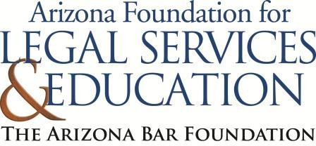

Raise your hand before speaking in class.

1.Who does it help?

2.How does it help?

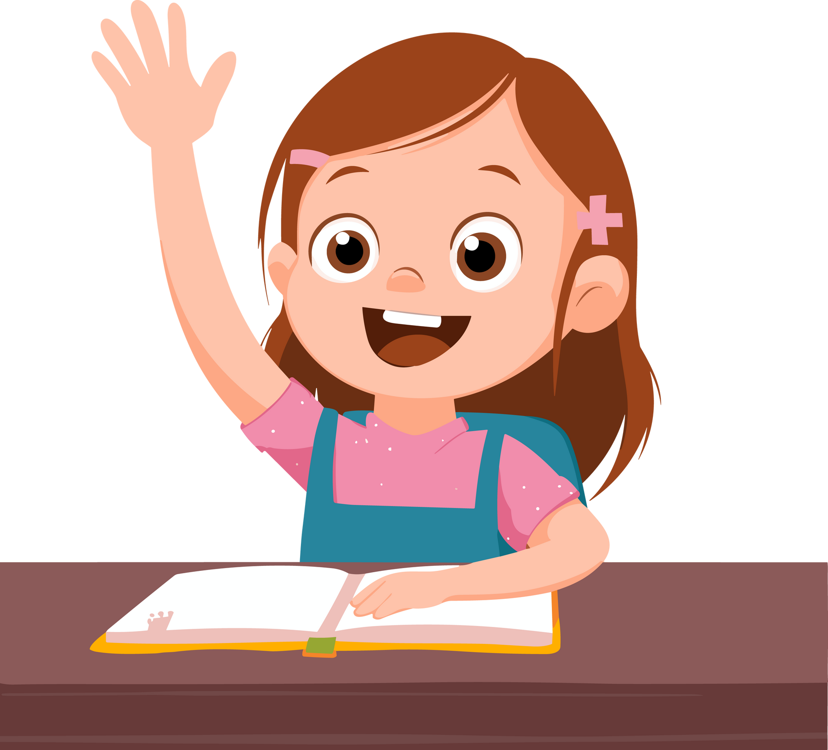

Walk, don’t run, in the hallways.

- Who does it help?

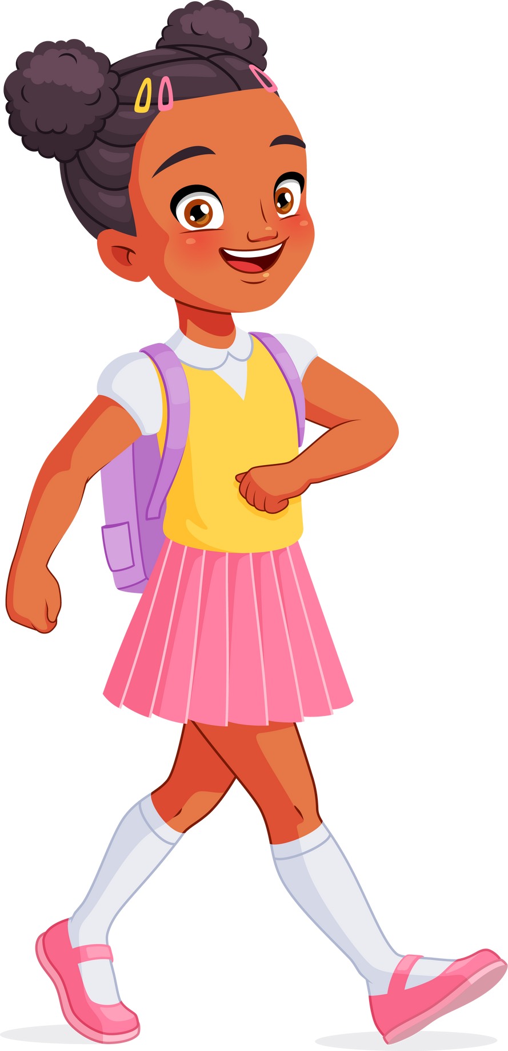
2.How does it help?

Keep your hands and feet to yourself.

- Who does it help?

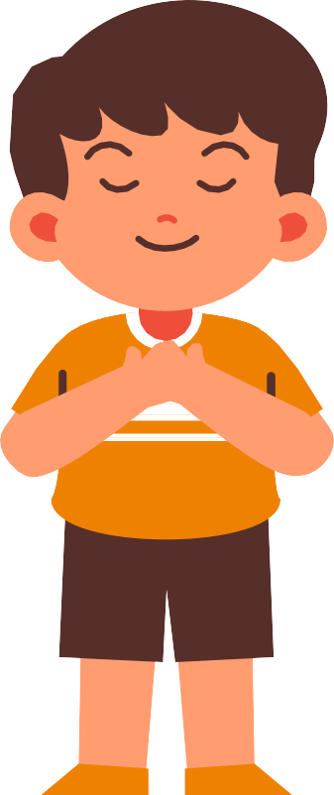
- How does it help?

Ask for permission before leaving the classroom.

1.Who does it help?

2.How does it help?
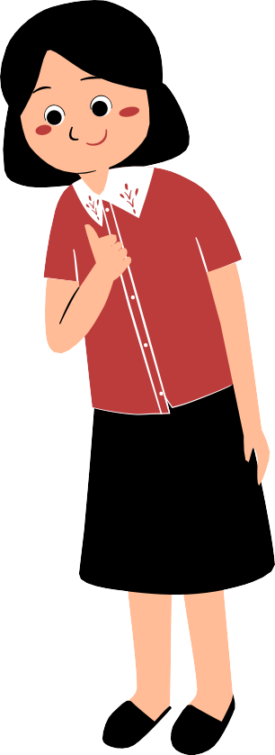

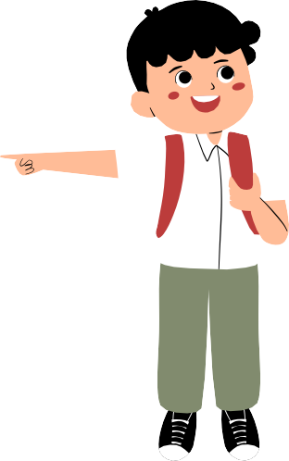

Respect school property and others’ belongings.

- Who does it help?

2.How does it help?


Students are not allowed to push, shove, or play rough games
in the gym or playground.

- Who does it help?
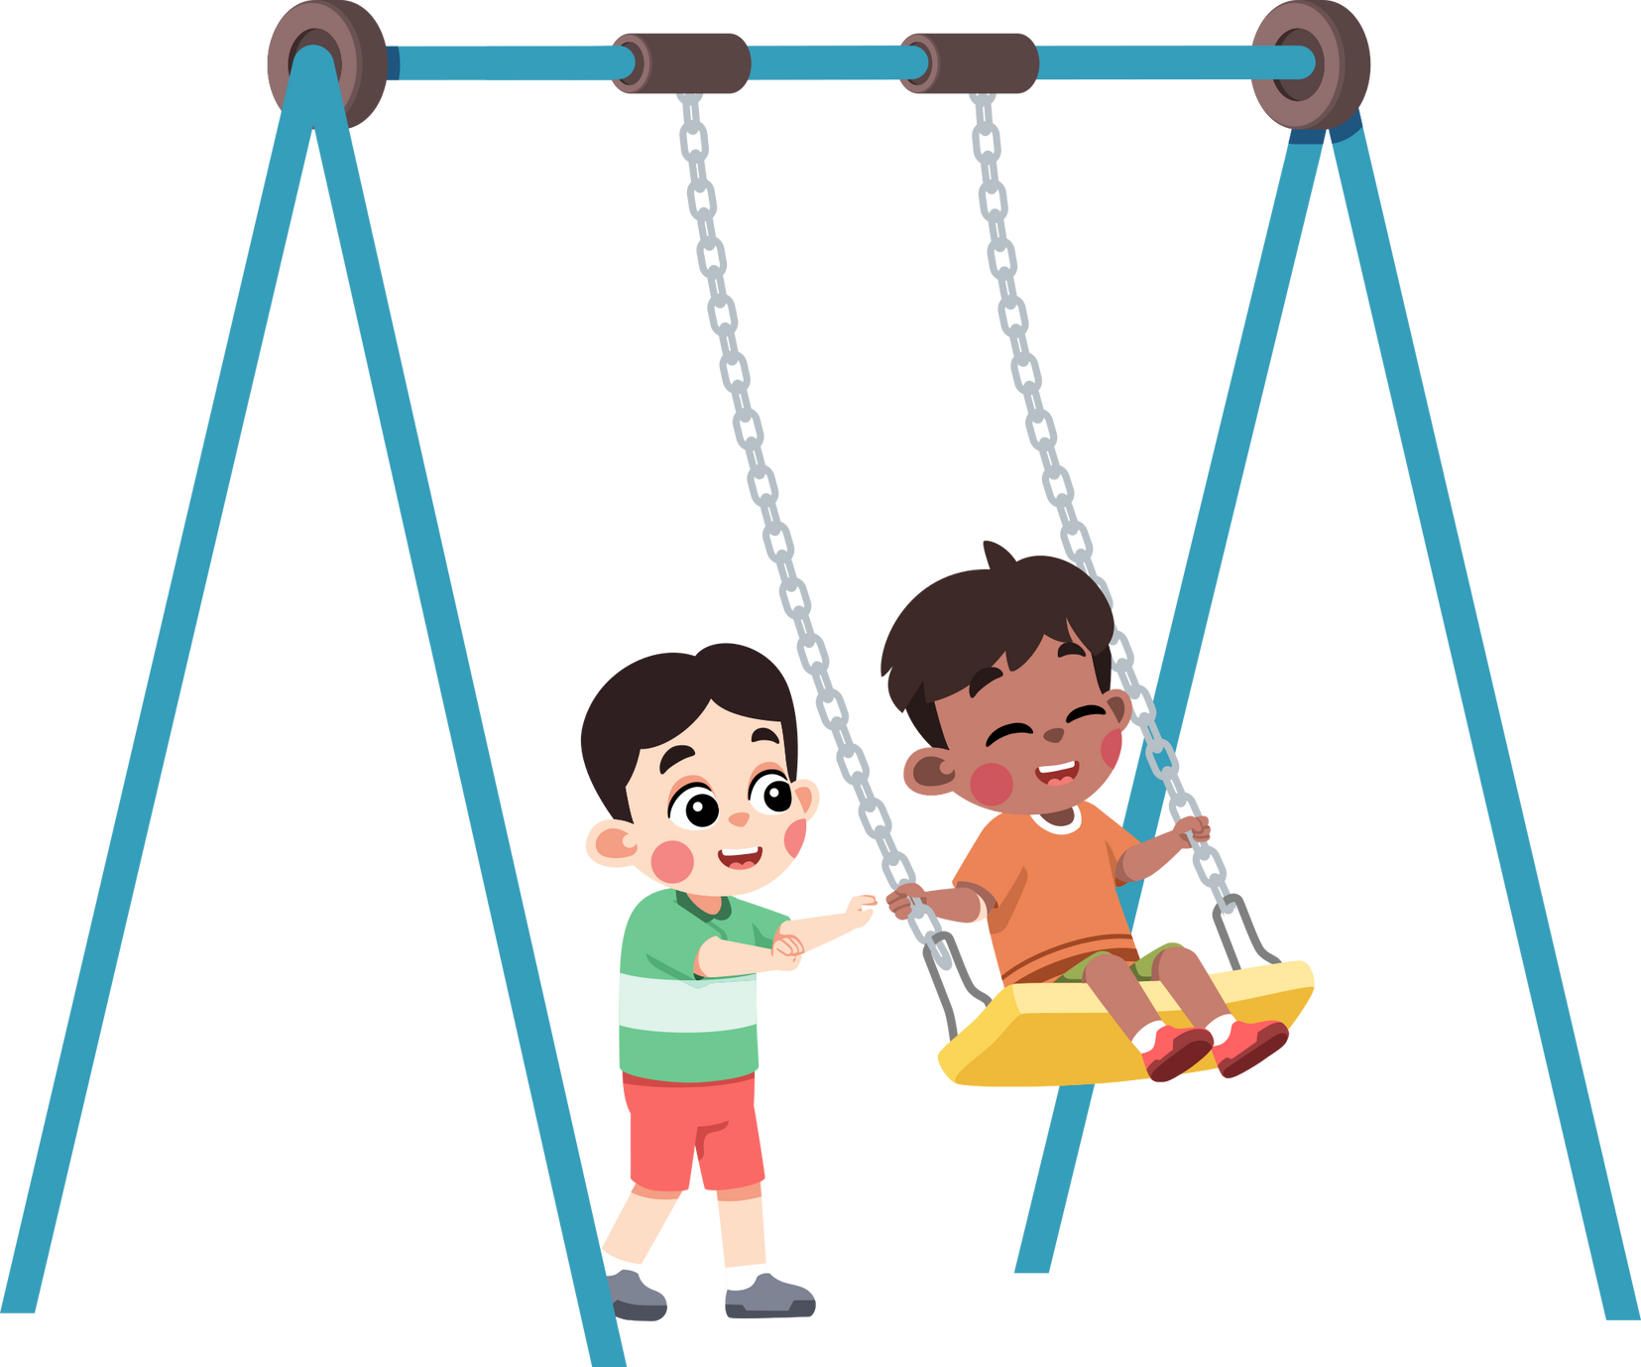
- How does it help?

Students are responsible for returning all
borrowed library books.

- Who does it help?

- How does it help?

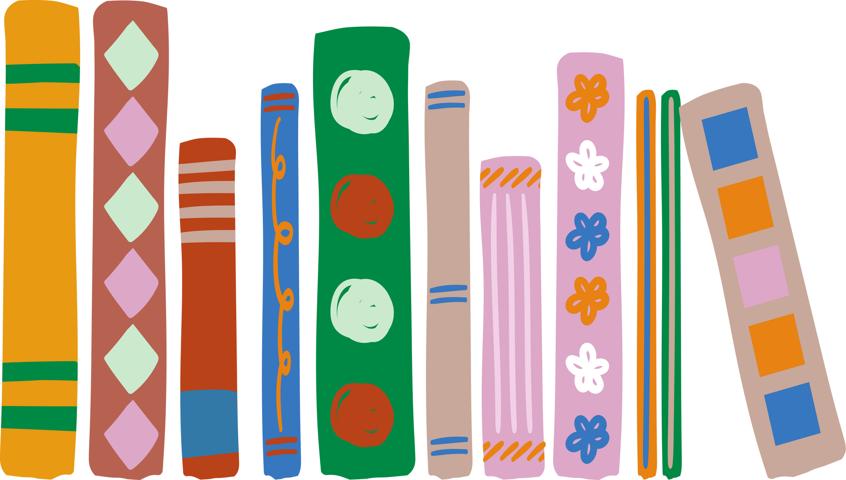

Use appropriate language at all times.

- Who does it help?

- How does it help?

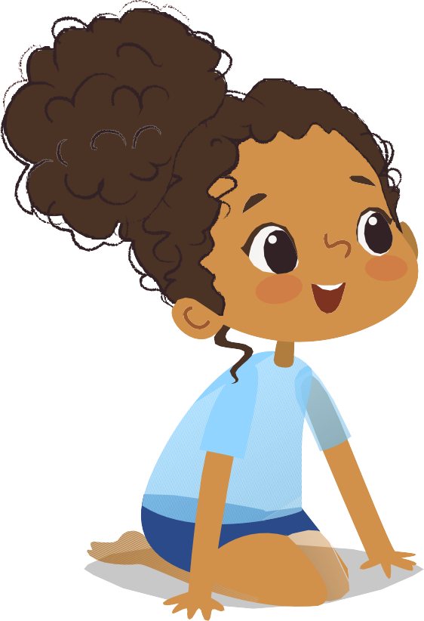
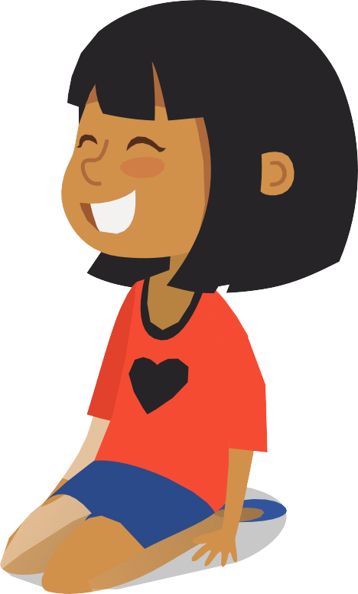

Follow playground safety rules.

1.Who does it help?

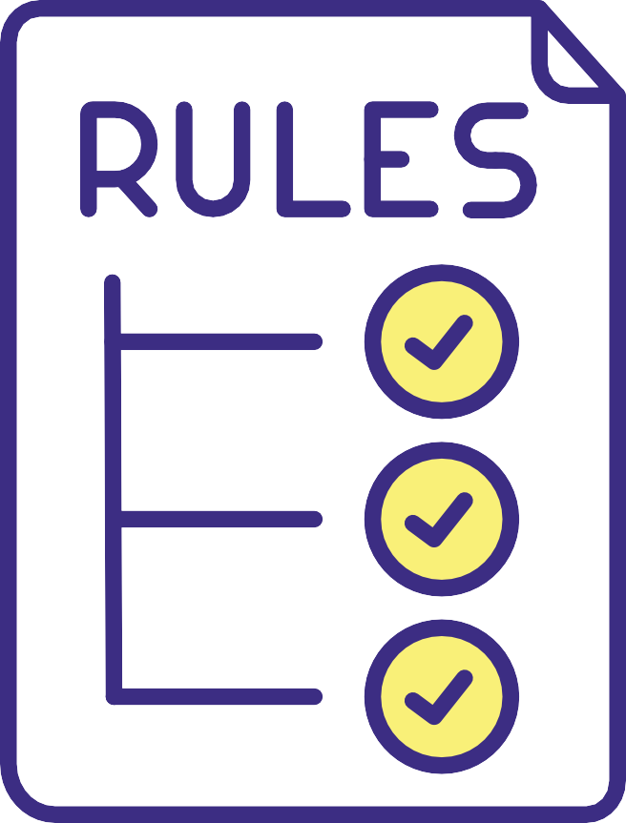
2.How does it help?

Use indoor voices when inside the school building.

- Who does it help?

2.How does it help?

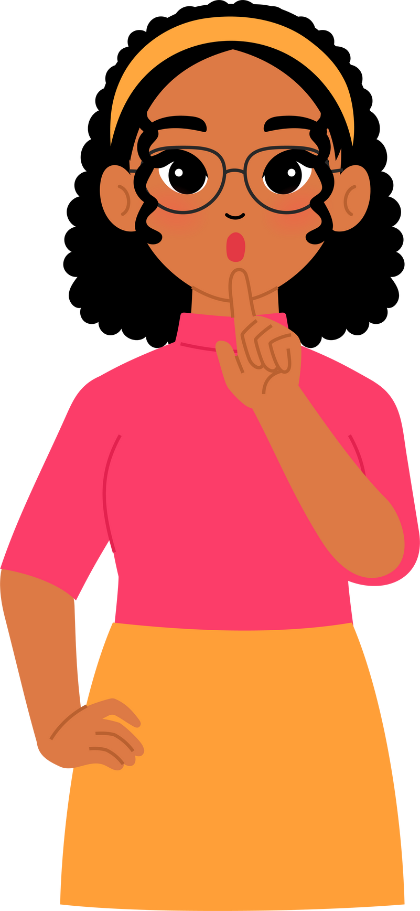
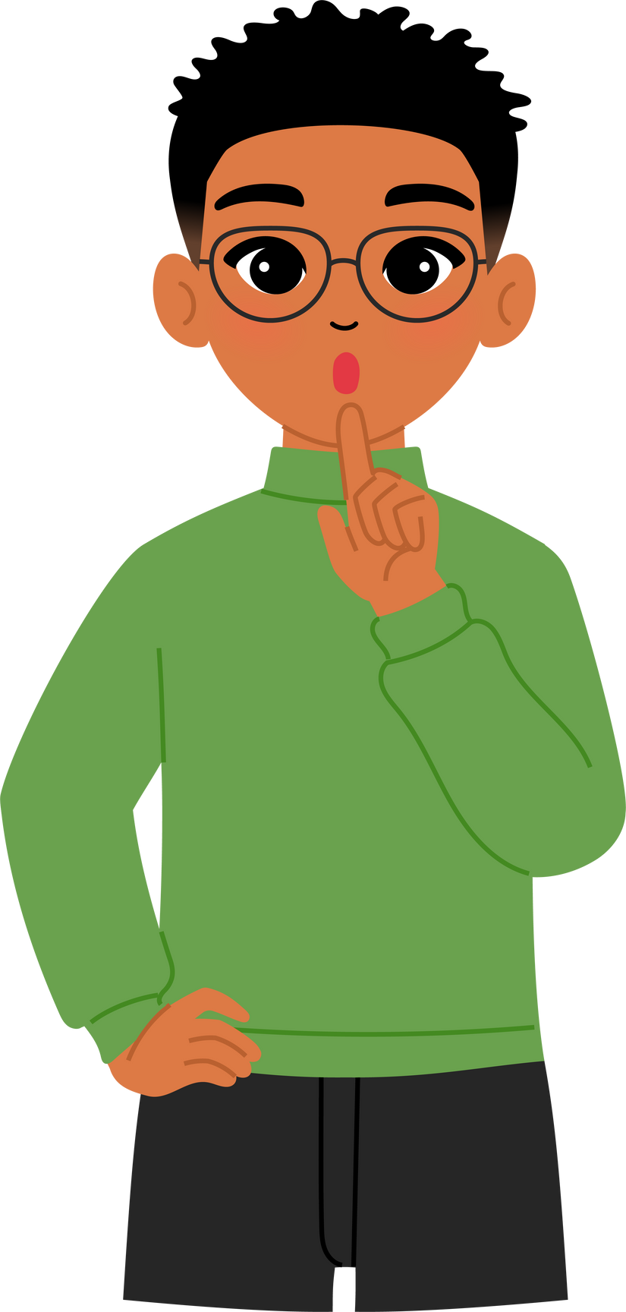

Follow the rules for the library
- Soft voices
- Treat books with care

- Who does it help?

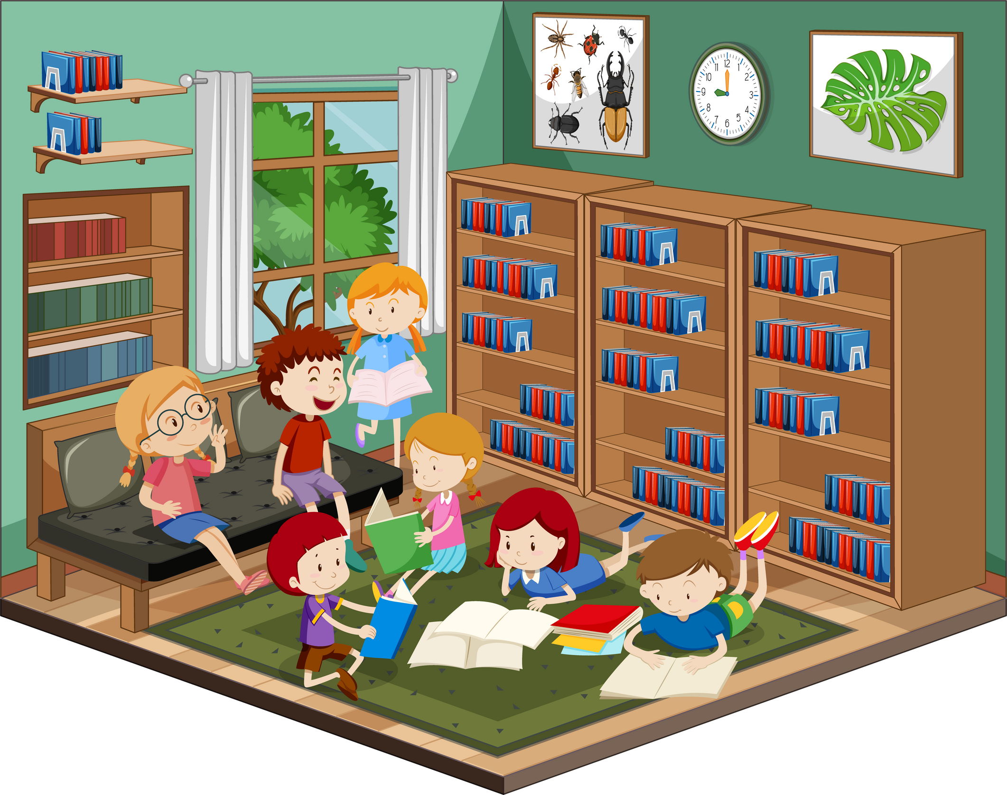
- How does it help?

Keep your desk and workspace tidy.

1.Who does it help?

2.How does it help?
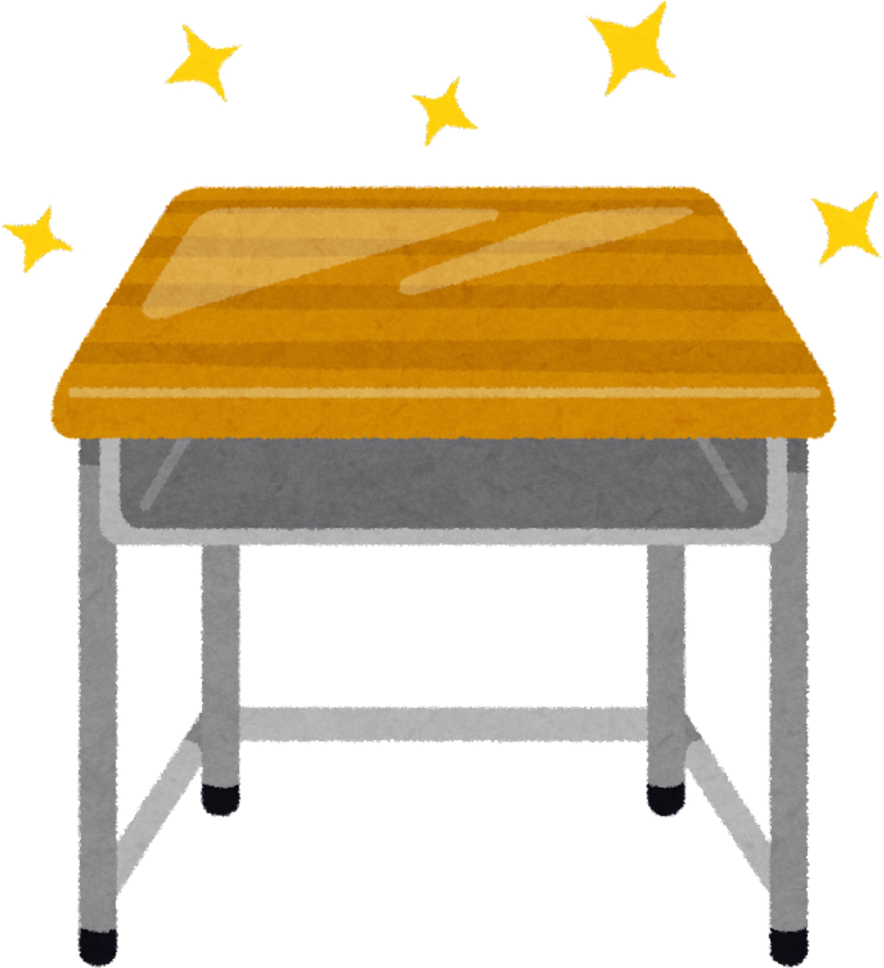

When using computers students must only use approved websites.

- Who does it help?

- How does it help?

During fire drills or emergencies, students must remain silent
and follow the teacher’s instructions.

- Who does it help?

- How does it help?
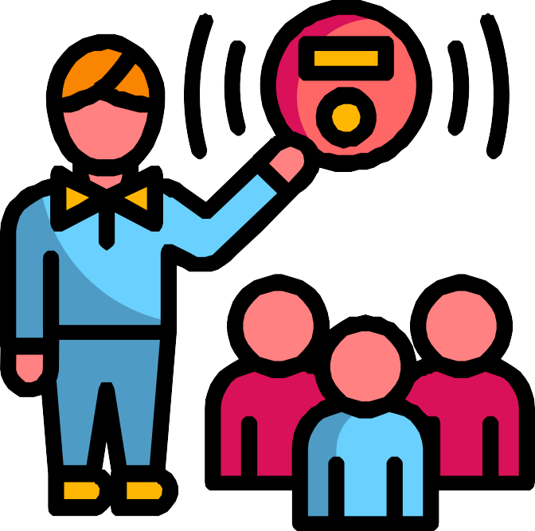

Students are not allowed to use the teacher's desk or personal belongings without permission.

1.Who does it help?

2.How does it help?


Students may only bring nut-free snacks to school.

- Who does it help?

- How does it help?
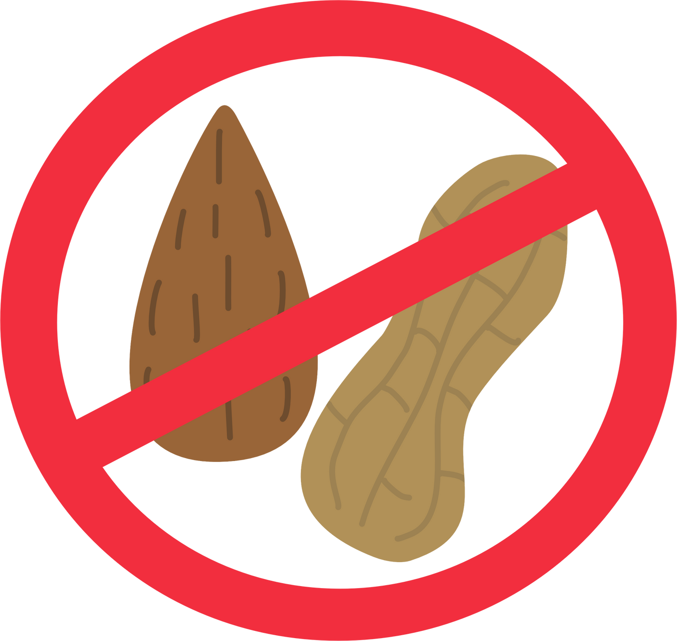

Students must ask for permission before using any classroom supplies.

- Who does it help?

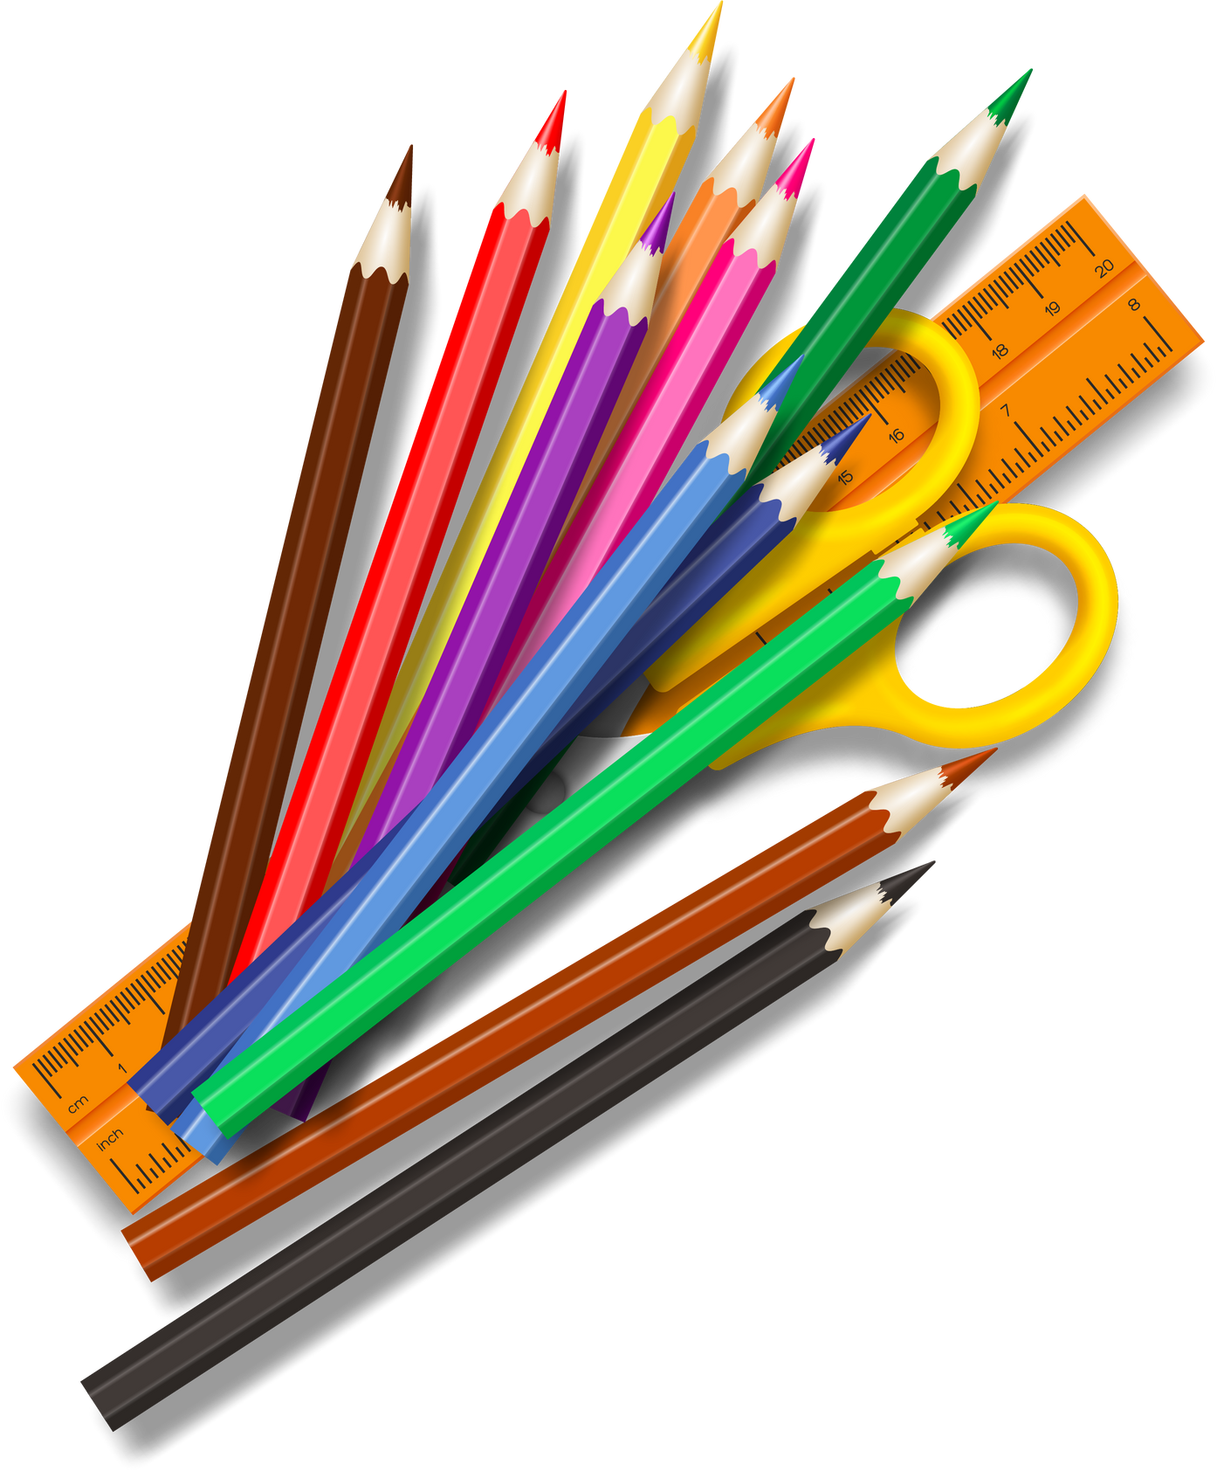
- How does it help?

No drawing or writing on desks, walls, or any other school property.

1.Who does it help?

2.How does it help?


In group work, students must contribute equally,
listen to their peers and take turns speaking.

1.Who does it help?

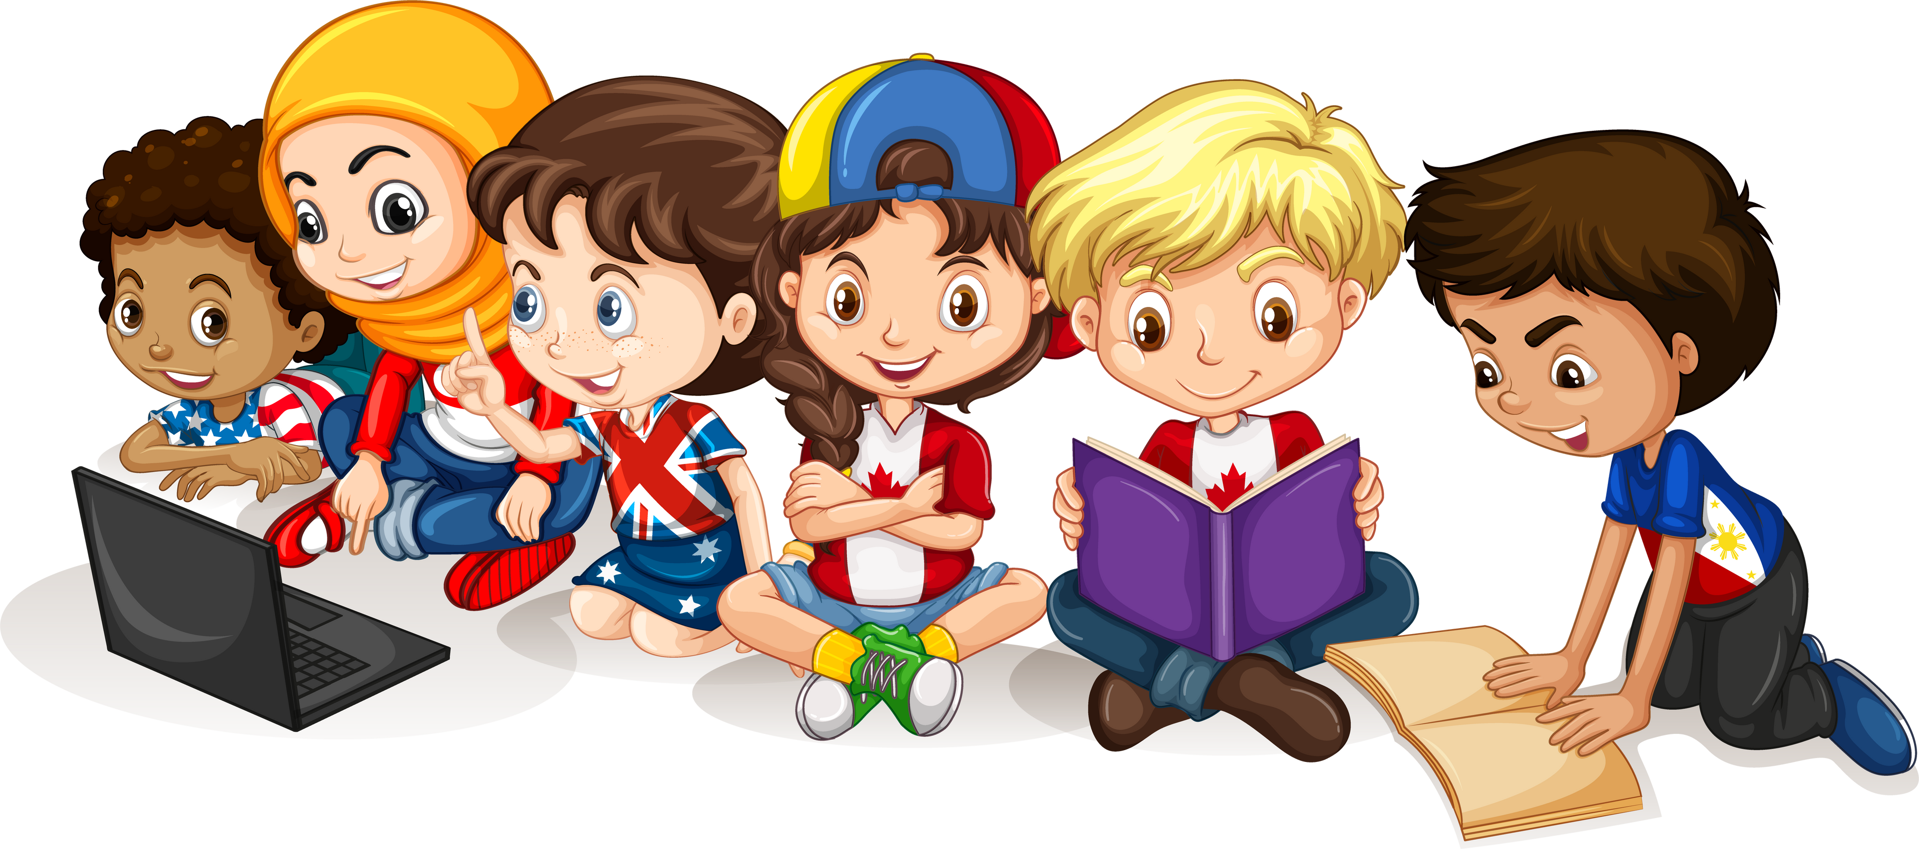
2.How does it help?

No running or shouting in the restroom.
Only two students are allowed in the restroom at a time.

1.Who does it help?

2.How does it help?

Backpacks and lunch boxes must be stored in cubbies or lockers all day.

1.Who does it help?

2.How does it help?


Students must clean up their area after lunch.

1.Who does it help?

2.How does it help?

