Learning the Law Through Mock Trial
(Grades 3-5)

L2: Conflict Scenario Cards



Peer

Two friends are arguing over who gets to use the swing on the playground first. They each want to use it for a long time and are getting upset with each other.

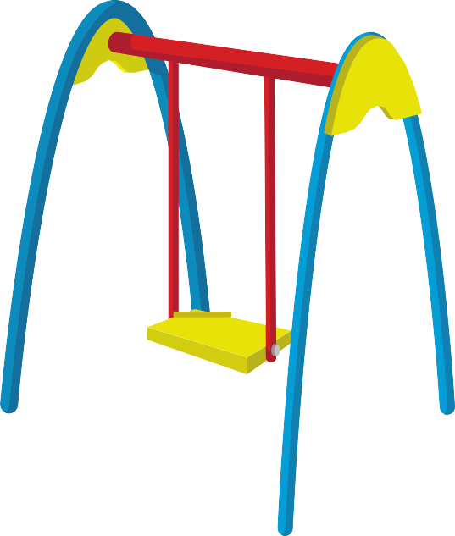

During group work, two students disagreed with their project. One student wants to do
it one way, while the other has a different idea.



A student borrowed a classmate’s game
but didn’t return it on time. The classmate
is upset and feels their trust was broken.

Two friends are upset because one of them
accidentally spilled juice on the other's homework. The friend whose homework
was ruined is angry and the other feels guilty but doesn’t know how to fix it.

Authority

A student is unhappy with a grade they
received on a test and argues with the teacher, claiming the grade isn’t fair.



A student feels that a teacher's rule about no food in the classroom is too strict. They argue with the teacher that eating in class isn’t a big deal if it doesn’t disrupt others.

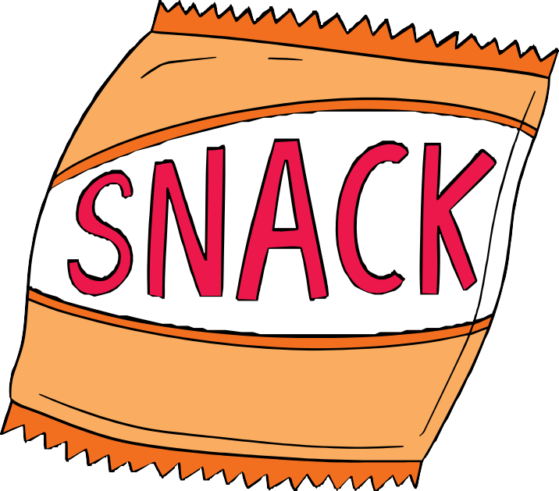

A student has to sit out for recess for being
late to class. They think this is unfair because they were late for a good reason.



A student is angry that their teacher told
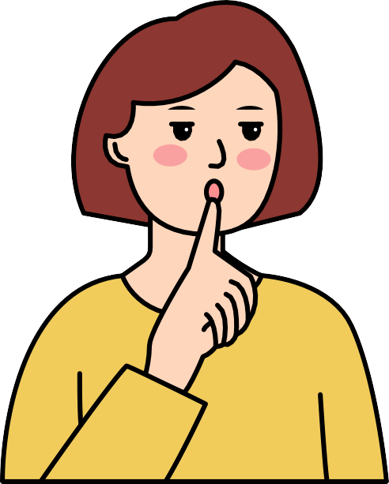
them to be quiet in front of everyone. They were not the person talking!

