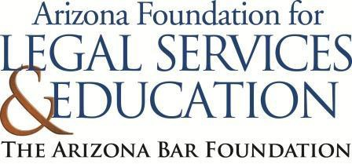

The Law-Related Education Academy is facilitated by the Arizona Foundation for Legal Services & Education with funding made possible by the Arizona Department of Education School Safety Program.

“Learning the Law Through Mock Trial” Academy
(Grades 3-5)

What is Vandalism? Lesson Plan
Please obtain administrator approval prior to implementing this lesson.

Objectives:
- Students should be able to identify vandalism.
- Students should learn the consequences of vandalism.

Protective Factor Developed: Decision making skills

Materials:
- Small whiteboard and dry erase marker, 1 per group
- Large poster paper and marker, 1 per group
- Vandalism Scenario Cards, 1 set per group
- Glue stick, 1 per group
- Sticky notes, 1 per student

Timeframe: 40 Minutes

Team Teaching: For effective implementation of Law Related Education (LRE), team teach with the classroom
teacher by…
- Having both the officer and teacher rotate among students and to different groups. Both instructors will provide positive feedback and engage in friendly conversations with students. This procedure will help reduce classroom disruptions, increase student engagement, and build supportive relationships with students.
- Encouraging classroom teachers to participate in all activities by injecting clarification statements by relating relevant content to their curriculum. In this method, students will see more connections to their student life and be willing to carry over concepts and skills learned in LRE.
- Assigning the classroom teacher part of the lesson instructions. Team teaching with the classroom teacher enables the students to further see the importance of LRE lessons. It also provides an opportunity for the classroom teacher to demonstrate teaching skills conducive for effective teaching. Student attention can be maintained more easily with different voices and personalities experienced throughout the lesson.

Lesson:
- Divide students into small groups of 3-4 students.

Arizona Foundation for Legal Services and Education (October 2024) Page 1

- Tell the students that everyone in the small group should contribute to the answers. However, each person will serve a specific role. Instruct each small group to pick one group member for each small group role:
  - Recorder: this person will be the writer/gluer and will write the group’s responses
  - Reporter: this person will be the one who shares the group’s answers with the whole class
  - Timekeeper: this person will watch the clock and ensure the group finishes in time
  - Task keeper: this person will ensure they stay on task and complete the project
If only 3 in a group, the timekeeper and task keeper can be the same person

Pass out a small whiteboard and dry erase marker, 1 per group.
- Have each student think about their school and identify places they often see or use (e.g., bathrooms, desks, hallways). Have them consider and discuss how they would feel if these areas were damaged.
- As a group, students draw 1 emoji that represents the group’s feelings about these acts of vandalism.
- After 3 min, one student reports out their emoji and why they chose to draw that emoji to represent their feelings.
- Provide students with the following definition of vandalism: the act of damaging property that belongs to someone else or the school/community on purpose.
- Pass out large poster paper and marker.
- In their same groups, students draw a T-Chart on their large poster paper with the categories: example and not an example.
- Give each group 4 of the vandalism scenario cards. Try to give each group different scenarios.
- Explain to students that as a group, they will discuss each scenario and decide if that scenario is an example of vandalism or is not an example of vandalism and place the strip on the T-chart.
- After all the groups are done, have the group reporter share out.
- Pass out 1 glue stick per group
- On the back of their large poster paper, students glue examples of vandalism from the previous activity. Instruct students to leave space under each strip to write a possible school consequence for their peers. For example, if they write on the walls of the bathroom, maybe the school will not allow them to use the bathroom unchaperoned and/or the school will need to spend money to fix it and less money will go to student activities.
- Allow each group to report out. Elaborate and/or correct where needed.
- As each group finishes their report, ask the whole class if any of the acts are illegal. Have the reporting group circle the scenario that is illegal and could cause legal consequences.
- On a sticky note, students write their name and 1 thing they learned about consequences of vandalism.
- Collect sticky notes to review later and check for student understanding
- Remind students that respecting school property helps everyone feel safe and proud of their school. Encourage students to think about how their actions can impact others and the importance of making good choices.

Arizona Foundation for Legal Services and Education (October 2024) Page 2

The Law-Related Education Academy is facilitated by the Arizona Foundation for Legal Services & Education with funding made possible by the Arizona Department of Education School Safety Program.

“Learning the Law Through Mock Trial” Academy
(Grades 3-5)

What is Vandalism? Lesson Plan

Arizona State Standards Correlations

Civics

Process, rules, and laws direct how individuals are governed and how society addresses problems
- Use a range of deliberative and democratic procedures to make decisions about and act on issues and civic problems in their classrooms and schools. (5.C4.2)

Reading

Refer to details and examples in a text when explaining what the text says explicitly and when drawing inferences from the text. (4.RI.1)

Writing

Recall relevant information from experiences or gather relevant information from print and digital sources; take notes, categorize information, and provide a list of sources (4.W.8)

Comprehension and Collaboration

Engage effectively in a range of collaborative discussions (one-on-one, in groups, and teacher-led) with diverse
partners on grade 4 topics and texts, building on others’ ideas and expressing their own clearly

a. Come to discussions prepared having read or studied required material; explicitly draw on that preparation and other information known about the topic to explore ideas under discussion

Arizona Foundation for Legal Services and Education (October 2024) Page 3

Learning the Law Through Mock Trial (3-5)

L3: What is Vandalism?

Vandalism Scenario Cards

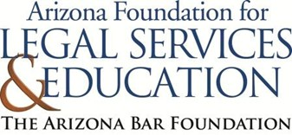

Writing on a bathroom wall with a marker on purpose.


Drawing on the classroom whiteboard with an erasable marker.

Accidentally knocking over a chair and breaking it.


Removing a poster from the classroom wall without
permission on purpose.

Breaking a pencil in frustration.

Painting over a mural in the school hallway without permission on purpose.


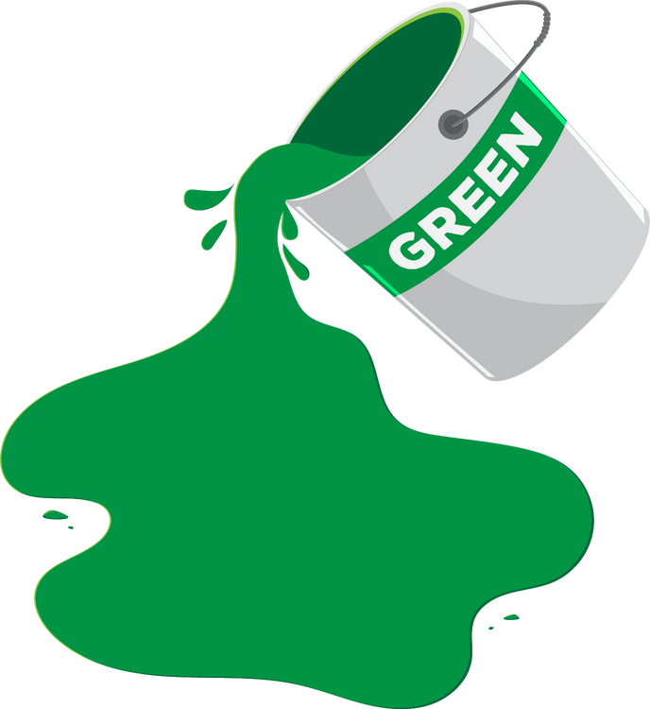Accidentally spilling paint on the floor during art class.

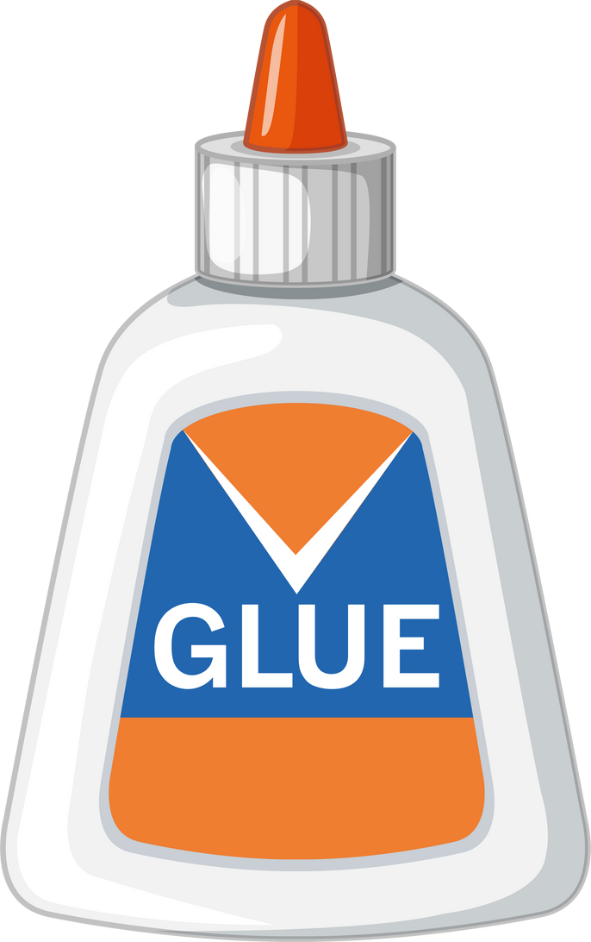Gluing paper to a desk on purpose.

Purposefully throwing a ball against a school window and breaking it.

Covering a classroom bulletin board with stickers.

Tearing a page out of a library book on purpose.

Placing gum on a desk on purpose.

Hitting a desk with a pencil repeatedly until it breaks.

Accidentally dropping a textbook on the floor and causing a small tear.

