
The Law-Related Education Academy is facilitated by the Arizona Foundation for Legal Services & Education with funding made possible by the Arizona Department of Education School Safety Program.

Marijuana and Hallucinogens Awareness Academy
(Middle/High School)
Marijuana Laws for Youth Lesson Plan
Please obtain administrator approval prior to implementing this lesson.

Objectives:
- Students will understand that marijuana laws may differ for adults.
- Students will learn the purpose of laws for underage use of marijuana.

Protective Factor Developed: Critical Reasoning Skills

Materials:
- Large poster paper and markers for each group
- Large Whiteboard- 1 per group, hang on the wall near each group
- Marijuana Laws Handout, 2 copies per group
- What Would You Do Handout, 1 copy per pair

Timeframe: 40 Minutes

Team Teaching: For effective implementation of Law Related Education (LRE), team teach with the classroom teacher by…
- Having both the officer and teacher rotate among students and to different groups. Both instructors will provide positive feedback and engage in friendly conversations with students. This procedure will help reduce classroom disruptions, increase student engagement, and build supportive relationships with students.
- Encouraging classroom teachers to participate in all activities by injecting clarification statements by relating relevant content to their curriculum. In this method, students will see more connections to their student life and be willing to carry over concepts and skills learned in LRE.
- Assigning the classroom teacher part of the lesson instructions. Team teaching with the classroom teacher enables the students to further see the importance of LRE lessons. It also provides an opportunity for the classroom teacher to demonstrate teaching skills conducive to effective teaching. Student attention can be maintained more easily with different voices and personalities experienced throughout the lesson.

Lesson:
- Divide the class into small groups of 3-4 students each. Provide each group with large poster paper, sticky notes, and markers.
- Inform students that today’s lesson is about being informed on how the passing of proposition 207 to legalize recreational marijuana affects youth. Explain that the legislation does not change the laws regarding minors, that is those under 18. Prop 207 makes it illegal for anyone under 21 to use, possess, buy, sell, or grow recreational marijuana.
- Model on the whiteboard the Compare and Contrast graphic organizer below for groups to copy on their large whiteboard.
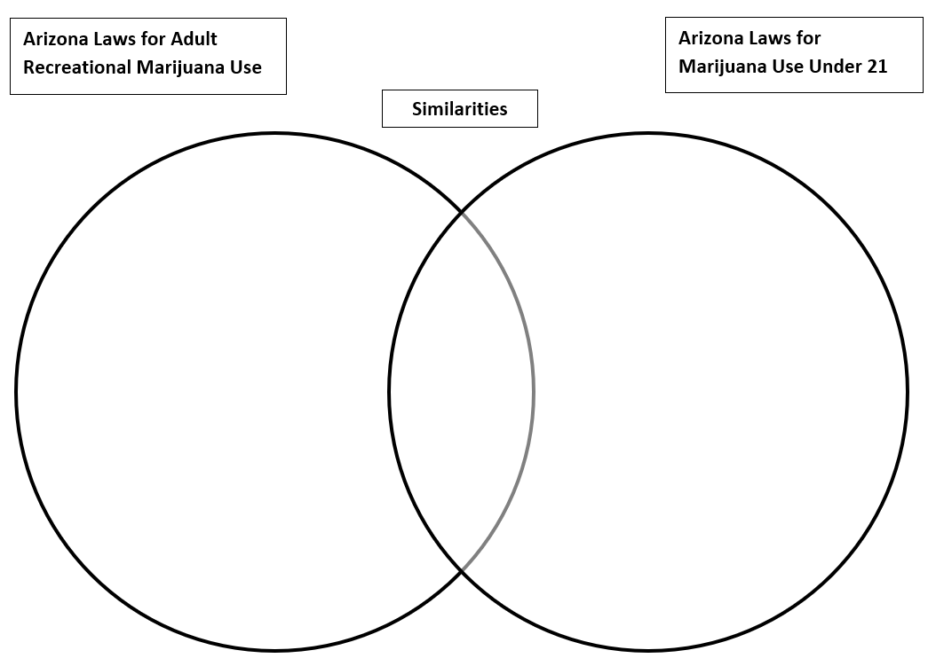
- Provide each group with two copies of the Marijuana Laws handout. Instruct groups to sort the information from the handout into three categories by writing the letter on their compare and contrast graphic in the appropriate sections. The left side of the graphic organizer is for information regarding the adult use of recreational marijuana only, the right side of the graphic organizer is for information regarding minors and marijuana; and the middle is for any information that may be shared by both adults and minors.
- The facilitator will move around to each group, checking on understanding, answering questions and providing positive feedback.
- When groups are finished, call on groups to report out a letter from the left side. Once all the appropriate items have been reported on the left side, call on groups to report a letter from the right side. Once all the appropriate items have been reported on the right side then move to the middle and call on groups to report out a letter from the middle.
Facilitator Guide:
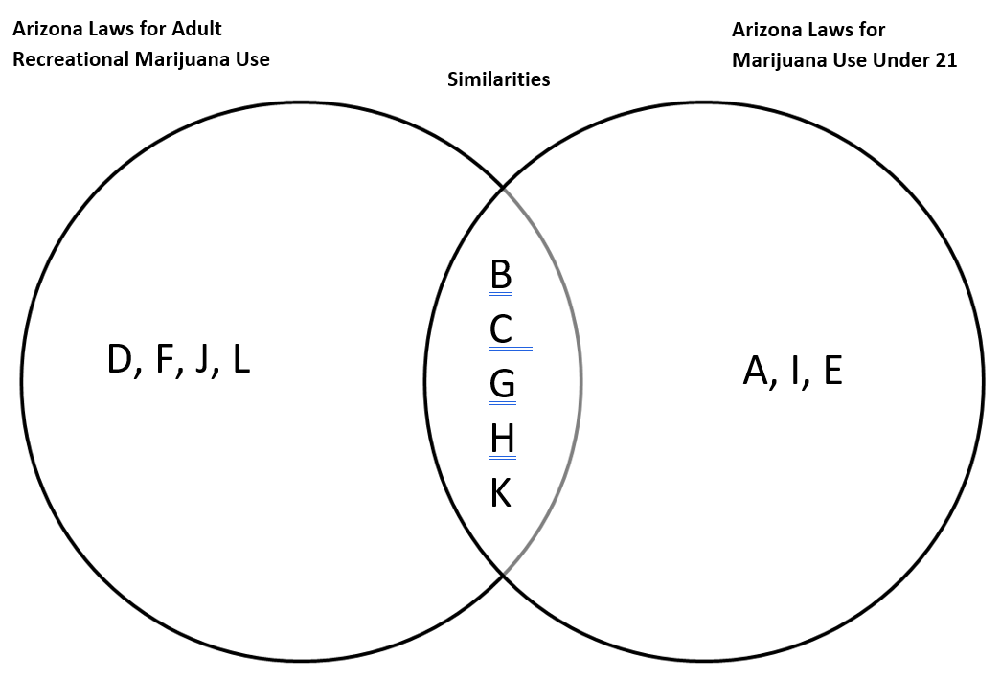

- Next, ask students to brainstorm with their groups things they could say when they want to refuse a peer if asked to participate in an activity they do not want to.
- Call on groups to share their ideas with the class. If groups didn’t share the ideas below, the facilitator will share the following:
- State your position
- Suggest alternatives
- Act on your response with body language, tone of voice and /or movement such as walking away
- Next, group students into pairs. Provide each pair with a copy of the What Would You Do Handout. Instruct the pairs to take turns reading each scenario and then collaborate to record specific things they could say or do if they wanted to refuse the offer. They should include information they learned from this lesson or previous lessons in their responses. *FACILITATOR NOTE: if short on time, give each pair one scenario but make sure all scenarios are used by giving a different one to each pair. It is okay if some pairs are working on the same scenario.
- Call on pairs to report out one scenario, allowing other students to add any additional ideas after each scenario.
- Debrief the lesson by asking all students to add one Marijuana Fact to their What Would You Do Handout. Collect the handout as students exit the class and review the fact to ensure they understand the content.

The Law-Related Education Academy is facilitated by the Arizona Foundation for Legal Services & Education with funding made possible by the Arizona Department of Education School Safety Program.

Marijuana and Hallucinogens Academy
(Middle/High School)
Marijuana Laws for Youth Lesson Plan

Arizona State Standards Correlations

Civics
7.C4.2 Assess specific rules and laws (both actual and proposed) as a means of addressing public problems.
8.C2.2 Explain specific roles, rights, and responsibilities of people in a society.
HS.C2.4 Analyze the responsibility of citizens.

Reading:
R.1 Read carefully to determine what the text says explicitly and to make logical inferences from it.
R.4 Interpret words and phrases as they are used in a text, including determining technical, connotative, and figurative meanings, and analyze how specific word choices shape meaning or tone.

Writing:
6‐12. WHST.4 Produce clear and coherent writing in which the development, organization, and style are appropriate to task, purpose, and audience.

Speaking and Listening:
SL.1 Prepare for and participate effectively in a range of conversations and collaborations with diverse partners, building on others’ ideas and expressing their own clearly and persuasively.
SL.4 Present information, findings, and supporting evidence such that listeners can follow the line of reasoning and the organization, development, and style are appropriate to task, purpose, and audience.

Health:
6-12 S1C6 PO2 Examine the likelihood of injury or illness if engaging in unhealthy behaviors.
6-12 S1C4 PO1 Describe ways to reduce or prevent injuries and other adolescent health problems.
6-12 S4C1 PO2 Demonstrate refusal and negotiation skills that avoid or reduce health risks.
6-12 S4C1 PO1 Apply effective verbal and nonverbal communication skills to enhance health.
6-8 S5C2 PO1 Determine when health related situations require the application of a thoughtful decision-making process.
6-8 S5C2 PO6 Analyze the outcomes of a health-related decision.
6-12 S8C1 PO2 Demonstrate how to influence and support others to make positive health choices.

