
The Law-Related Education Academy is sponsored by the Arizona Foundation for Legal Services & Education with funding made possible by the Arizona Department of Education.

“Fentanyl Awareness and Prevention” Academy
(Middle/High School)
Social Media’s Impact with Drug Use Lesson Plan
Please obtain administrator approval prior to implementing this lesson.

Objectives: Students will…
- understand the influence social media may have on teen life.
- learn consequences for being influenced by social media regarding drug use.
- share tips for media literacy.

Protective Factor Developed: Resistance Skills

Materials:
- Teens and Social Media handout pg. 4
- Reflection Questionnaire pg. 5
- Signs: AGREE and DISAGREE, pg. 6
- Social Media Literacy Tips pg. 7, cut apart, 1 tip per group

Timeframe: 50 Minutes

Team Teaching: For effective implementation of Law Related Education (LRE), team teach with the classroom teacher by…
- Having both the officer and teacher rotate among students and to different groups. Both instructors will provide positive feedback and engage in friendly conversations with students. This procedure will help reduce classroom disruptions, increase student engagement, and build supportive relationships with students.
- Encouraging classroom teachers to participate in all activities by injecting clarification statements by relating relevant content to their curriculum. In this method, students will see more connections to their student life and be willing to carry over concepts and skills learned in LRE.
- Assigning the classroom teacher part of the lesson instructions. Team teaching with the classroom teacher enables the students to further see the importance of LRE lessons. It also provides an opportunity for the classroom teacher to demonstrate teaching skills conducive for effective teaching. Student attention can be maintained more easily with different voices and personalities experienced throughout the lesson.

Activity:
- Divide students into small groups of 3 or 4 students each.
- Ask the class to brainstorm with you possible influencers when it comes to teens and substance abuse. Allow students to call out ideas as you record them on the board.
Possible Responses: peers, social media, culture, acceptance, etc.
- Provide each group with the Teens and Social Media handout (pg. 4). Instruct the groups to review the data and discuss their personal take on the information. Call on each group to share comments.
- Ask the class to show with thumbs up or down if they feel that Arizona’s data would be higher or lower and/or their school?

Lesson:
- Next, provide each student with a personal copy of the Reflection Questionnaire (pg. 5). Instruct each student to record their own responses on their personal handout or paper.
- Instruct the groups to discuss their responses. One group member should add up the ratings.
- Call on each group to share a few highlights of the group’s discussions such as commonalities or differences. Ask the group for their rating and post it on the class board.
- Comment on the range and how the research indicates that social media plays a significant role in the life of today’s youth.
- Instruct the groups to list some of the advantages from the influence of social media on teen life. Call on each group to share one idea.
Possible Responses: information, education, connection to the peers-the world, etc.
- Now, instruct the groups to list some disadvantages from the influence of social media on teen life. Call on each group to share one idea.
Possible Responses: dis/misinformation, connection to predators-drug-dealers-bullies, consume too much time that could be spent on physical activity and in-person social interactions, etc.
- Explain that drug-dealers may use social media to push their illegal product. This cohort is about bringing awareness and education about the truth concerning fentanyl. Fentanyl abuse is concerning to the community. One reason is it is a lab created drug made to look like other prescribed or over the counter medication. When it is illegally made, the consumer cannot be sure how much a pill could contain or if what they are purchasing illegally has fentanyl in it. (“Youth at Risk: The Arizona High Intensity Drug Trafficking Area (HIDTA) conducted an analysis of Pima County which found that fentanyl is the 2nd highest in number of deaths of youth 15-17 years of age. The AZ HIDTA has also found that youth are accessing illegal substances through the social media platforms”)
- Teen substance abuse has declined in recent years. (During 2017–2019, the annual average prevalence of past-month illicit drug use in Arizona was 5.1% (or 29,000), lower than both the regional average (9.0%) and the national average (8.2%).
- Instruct the groups to discuss reasons why this trend may have reduced in the last years. Call on each group to share their ideas.
Possible Responses: increased awareness and education, decrease in social interactions with peers, etc.
- Inform the class that this next activity is a continuum. Explain that you will post 2 signs on opposite sides of the room: AGREE and DISAGREE (pg. 6).
- Instruct students to stand in the middle between the two signs and listen while you read a statement. Then they should move between the two signs along a continuum that indicates how strongly they feel and be ready to explain their reasoning.
- Call on students at different points along the continuum. After students hear their peers explain their reasoning, they may move along the continuum that expresses a new viewpoint. Elaborate if necessary. (see in parenthesis beside each statement below).
- Social media portrays drug use as exciting and fun. (Teen drug use produces signs such as loss of interest in friends and activities that used to be enjoyed, aggression, sleeping more, withdrawn, decreased cash flow, health concerns, poor hygiene, and appearance, etc. DrugFree.org)
- Social media makes drug use seem normal. (“More than one-third of students reported they have never heard of fentanyl (37.8%) and 2% reported that they have used fentanyl in their lifetime. 26% of students reported they have seen or heard advertisements warning of the dangers of fentanyl, and 17.1% reported they talked to a parent or guardian about the dangers of fentanyl. Among the surveyed youth who have heard of fentanyl, 70.3% reported that they think people who use fentanyl are at “great risk” of harming themselves and 10.2% reported that it would be easy or very easy to get fentanyl.” AYS 2022)
- Social media doesn’t show the truth about drug use. (Social media may be utilized to sell, promote, and glamorize drug use but is also a platform to be educated on facts, seek help and resources to make good decisions.)
- Teens are more willing to use drugs if they see others using drugs on social media. (Studies show that there could be an increase to drug use when teens see others using drugs and perceive they are more popular and are having more fun both in-person and online.
- Teens are targeted for drug use on social media. (Research indicates that a great number of teens are online so marketers may want to utilize this platform to sell to teens. It is illegal to buy or sell illegal substances: 13-3406. Possession, use, administration, acquisition, sale, manufacture, or transportation of prescription-only drugs; misbranded drugs; classification; definition and 3-3408. Possession, use, administration, acquisition, sale, manufacture or transportation of narcotic drugs; classification; Minors could be charged with a felony drug possession; ordered drug counseling, probation or diversion program, community service; academics may suffer, loss of privileges at home such as use of car, internet and social life, loss of jobs, scholarships, extracurricular activities or position in school sports and clubs, may affect ability to graduate with class in ceremony or driver’s license.)
- Debrief the lesson by providing each group 1 Social Media Literacy Tips (pg. 7). Instruct each group to collaborate and create 1 additional tip. Call on each group to read the tip provided and their additional tip to the class.

The Law-Related Education Academy is sponsored by the Arizona Foundation for Legal Services & Education with funding made possible by the Arizona Supreme Court.

“Fentanyl Awareness and Prevention” Academy
(Middle/High School)
Social Media’s Impact with Drug Use
Teens and Social Media
Handout

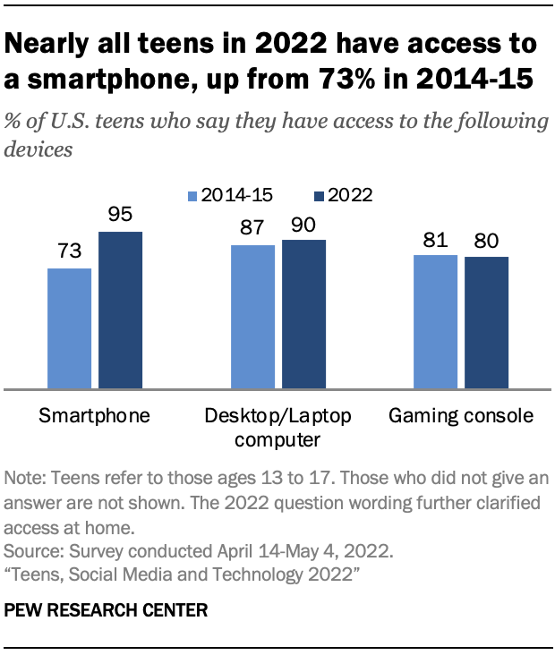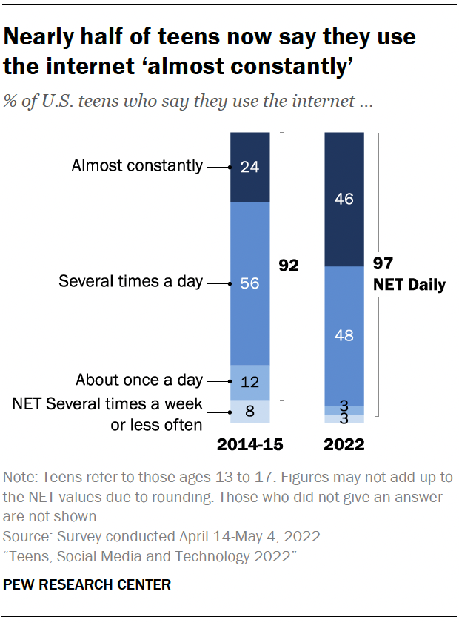

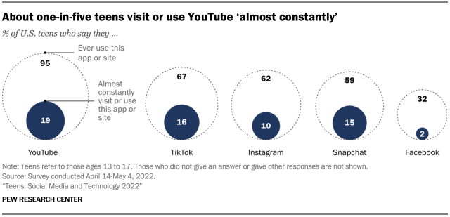
The Law-Related Education Academy is sponsored by the Arizona Foundation for Legal Services & Education with funding made possible by the Arizona Supreme Court.

“Fentanyl Awareness and Prevention” Academy
(Middle/High School)
Social Media’s Impact with Drug Use
Reflection Questionnaire

- When looking at other peers on social media, how do you feel about yourself?
- Does your time on social media keep you from getting enough sleep to feel rested at school?
- Does your schoolwork ever suffer because you spent too much time on social media platforms?
- Do you believe that a person’s life is accurately reflected on their social media page?
- Do you overshare your personal life or information on social media?
- What is your opinion of your peers when you see them under the influence of drugs online?

- Which word best describes what you think when you see celebrities using illegal drugs on online platforms?

- How often do you see peers having fun with no visible evidence of drug use?
- Have you seen awareness and/or educational information about teens and substance abuse prevention?

- Have you seen peers speak out against teen substance abuse online?
How would you rate the impact social media may have on teen substance abuse on a scale from 1 to 10, 1 being the lowest impact and 10 being the highest impact? ______

AGREE

DISAGREE
The Law-Related Education Academy is sponsored by the Arizona Foundation for Legal Services & Education with funding made possible by the Arizona Supreme Court.

“Fentanyl Awareness and Prevention” Academy
(Middle/High School)
Social Media’s Impact with Drug Use
Social Media Literacy Tips

- Use a fact checking tool like FactCheck.org.
- Use reliable sources from reputable sites.
- Look for other collaborative views.
- Look for opposing views.
- Discuss the content with parents and other trusted adults.
- Verify the author of the content.
- Question motives for the post.
- Analyze techniques to attract attention.
- Question logic, have you or others you trust experienced this to be true.
- Think about the consequences if you participate.

The Law-Related Education Academy is sponsored by the Arizona Foundation for Legal Services & Education with funding made possible by the Arizona Department of Education.

“Fentanyl Awareness and Prevention” Academy
(Middle/High School)
Social Media’s Impact with Drug Use
Correlations

Civics and Government
Explain the obligations and responsibilities of citizenship: obeying the law.
(7-12 S3C4 PO4b-c)

Key Ideas and Details
R.1 Read carefully to determine what the text says explicitly and to make logical inferences from it.

Types and Purposes
Write informative/explanatory texts to examine a topic and convey ideas, concepts, and information through the selection, organization, and analysis of relevant content.
(7-12. W. 2)

Comprehension and Collaboration
SL.1 Prepare for and participate effectively in a range of conversations and collaborations with diverse partners, building on others’ ideas and expressing their own clearly and persuasively.

Health
Examine the likelihood of injury or illness if engaging in unhealthy behaviors.
(6-12 S1C6 PO2)
Describe ways to reduce or prevent injuries and other adolescent health problems.
(6-12 S1C4 PO1)
Apply effective verbal and nonverbal communication skills to enhance health.
(6-12 S4C1 PO1)
Determine when health related situations require the application of a thoughtful decision-making process.
(6-8 S5C2 PO1)
Analyze the outcomes of a health-related decision.
(6-8 S5C2 PO6)

Technology
Ask questions and investigate a problem from different perspectives and formulate inferences from known facts. (7-12 S1C3PO 2)

Assess situations in which it is appropriate and safe to use a personal digital device in the home, school, community, and in the workplace. (7-12 S5C1 PO1)

https://goyff.az.gov/sites/default/files/meeting-documents/materials/asap-_counterfeit_fentanyl_in_arizona_1.pdf
https://www.samhsa.gov/data/sites/default/files/reports/rpt32819/Arizona-BH-Barometer_Volume6.pdf
https://drugfree.org/article/signs-of-drug-use-in-teens/
https://www.azcjc.gov/Portals/0/Documents/pubs/AYSReports/2022/AYS_2022%20_State_Report_FINAL_09072022.pdf
https://www.addictioncenter.com/community/social-media-teen-drug-use/
https://www.pewresearch.org/internet/2022/08/10/teens-social-media-and-technology-2022/

