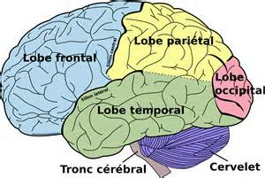
Brain:
Heroin’s
Effects

The brain’s structure is complex. It includes multiple systems that interact to support all of your body’s functions – from thinking to breathing and moving ~National Institute on Alcohol Abuse and Alcoholism
How it works on the brain:
- When heroin enters the blood stream it is delivered to the brain within minutes. Heroin binds to and activates specific receptors in the brain called mu-opioid receptors (MORs). Neurotransmitters in the brain bind these receptors throughout the brain and body to regulate pain, hormone release, and feeling of well-being. When MORs are activated in the reward center of the brain, they stimulate the release of the neuro transmitter dopamine, causing a sensation of pleasure. Once heroin enters the brain, it is converted to morphine and binds rapidly to opioid receptors, causing a “rush” or surge of pleasurable sensation. ~NIDA.gov
Short term effects:
- Drowsy for several hours
- Mental function is clouded
- Breathing is slowed which can lead to permanent brain damage
~NIDA.gov
Long term effects:
- Repeated use changes the physical structure and physiology of the brain
- Imbalances in neuronal and hormonal systems (not easily reversed)
- Deterioration of the brain’s white matter, which may affect decision making abilities, ability to regulate behavior and responses to stressful situations
- Addiction: heroin is extremely addictive, beyond physical dependence. Using the drug becomes the addicts primary purpose in life
Mental disorders develop (such as depression and antisocial personality disorder) -NIDA.gov

Heart and Vascular System:
Heroin’s
Effects
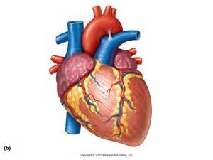
Your cardiovascular system consists of your heart, blood vessels, and blood. This system works
constantly- every second of your life- delivering oxygen and nutrients to your cells and carrying away carbon dioxide and other unnecessary material. Your heart drives this process. Your heart beats about 100,000 times each day, pumping the equivalent of 2,000 gallons of blood throughout your body. ~National Institute on Alcohol Abuse and Alcoholism
Heart:
- Heart functions slows (short term effect)
- Infection of heart lining and valves (long term effect)
~NIDA.gov
Veins:
- Collapsed veins and bacterial infection of the blood vessels can occur
- Many of the additives in street heroin may include substances that do not readily dissolve and result in clogging the blood vessels that lead to the lungs, liver, kidneys, or brain
~NIDA.gov
Blood-borne viruses:
- Sharing of injection equipment or fluids can lead to contraction of a blood-borne virus, such as: hepatitis B and C, HIV, and a host of other blood-born viruses. These viruses can then be passed on to their sexual partners, children or others who come in contact with their body fluids that contain the virus. ~NIDA.gov

Liver and Kidney:
Heroin’s Effects
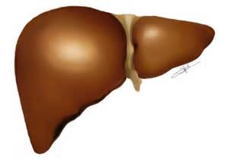

Liver:
- Keeps your body productive and healthy. The liver stores energy and nutrients, generates proteins and enzymes your body uses to function and ward off disease. It also rids your body of substances that can be dangerous. - National Institute on Alcohol Abuse and Alcoholism
- Plays a vital role in detoxification
Kidney:
- Cleanses the body. The kidneys perform the essential function of removing waste products from the blood and regulating the water fluid levels. –UMICH.edu
Heroin’s Affect:
- Because both the liver and the kidney process toxins in the body, repeated use of Heroin can cause liver and kidney disease -NIDA.gov

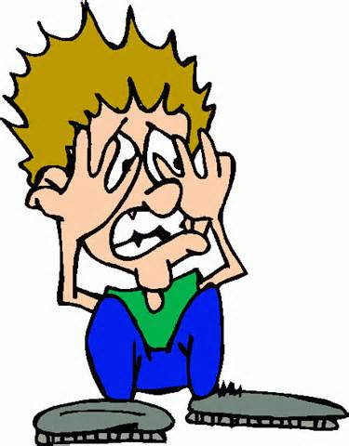
Heroin’s
Effects on Other
Body Functions
Short Term Effects:

- Warm flushing of the skin
- Dry mouth
- “rush”
- Heavy feeling in the extremities
- Nausea
- Vomiting
- Severe Itching

- Slowed breathing (sometimes enough to be life threatening
Long Term Effects:
- Immune reactions to contaminants/additives in street heroin can case arthritis and other rheumatologic problems. (long term effect)
- Men often experience sexual dysfunction (long term effect)
- Women’s menstrual cycles often become irregular (long term effect)
- Profound degrees of tolerance dependence to the drug (tolerance occurs when more and more of the drug is required to achieve the same effects)
- Physical dependence to the drug (the body adapts to the presence of the drug and withdrawal symptoms occur if use is reduced abruptly)
- Damage to the mucosal tissues in the nose as well as perforate the nasal septum
Withdrawal Symptoms
- Can occur within a few hours after the last use and peak between 24-48 hours and subside after about a week…some last for many months.

- Restlessness
- Muscle and bone pain
- Insomnia
- Diarrhea
- Vomiting
- Cold flashes
- Leg movements

