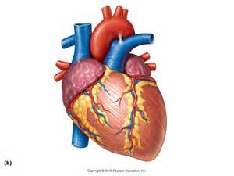  Heart | Heart
Heart | Heart
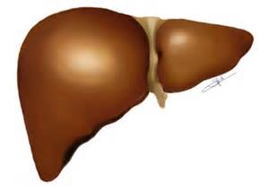  Liver | Liver
Liver | Liver
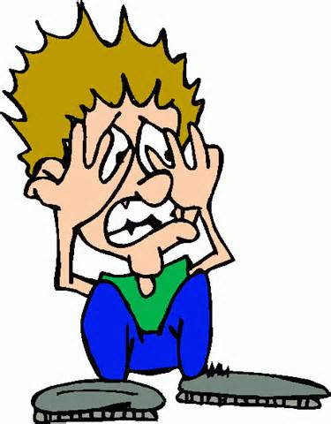  Body | Body
Body | Body
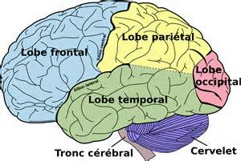  Brain | Brain
Brain | Brain

