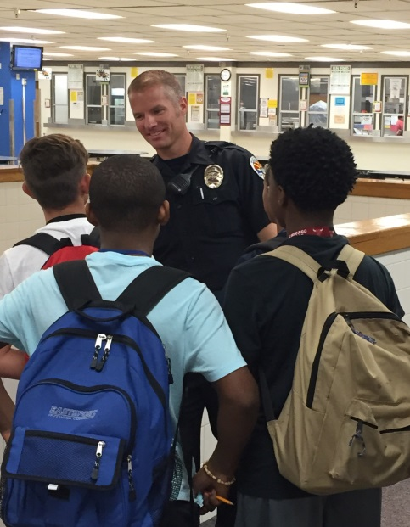
Pueblo Urban Assault Team

School Resource Officer Dieu created the Pueblo Urban Assault Team also know on the Pueblo Middle School campus as “The A Team”. It came about when students from challenging back grounds needed an outlet or focus for energy which would otherwise be used in negative ways.
One day during lunch, four student had idle time on their hands and started challenging each other to jump up and touch an exterior commercial light attached to the side of one of the brick school buildings. The students were able to reach up and touch the light by running toward the wall and using their momentum to take a step up the wall and smack the light. The challenged evolved into who could reach the top. The game ended when one of them reached the top and applied enough pressure to rip the entire light off of the wall causing it to shatter as it hit the concrete below. The four eighth graders were subsequently located and the incident was investigated. Three of the four were failing just about every class. Two of the students came from backgrounds in which there was no money to pay for a new light. Suspending them would have been a vacation with no supervision. Arresting them for criminal damage would further separated them from the school community and start their path into the juvenile justice system, which did not seem to fit the crime.
The principal, Sheryl Houston, did not want the student to miss instructional time due to an out of class incident, so she suggested they spend three days picking up trash during their lunch time. Principal Houston looked toward Officer Dieu, hoping he would be willing to facilitate the three day “chain gang”. Parents and guardians were contacted and were supportive of the idea. The four students received their sentence to perform community service around the school during their lunch as restitution for damage caused by their recklessness.
The first day included trash pickup throughout the campus of 1100 students. The second and third day involved pulling weeds and grass in raised planters on campus. The students devoured the opportunity to be part of a team and take ownership of their environment. The boys took pride in the work they were performing and could be heard talking about running their own landscaping businesses and working together on other projects. After the final day of community service, Officer Dieu turned to express his appreciation for what they were able to accomplish and the boys asked, “What are we doing tomorrow?” The teens wanted more and the “A Team” was born.
The team grew to about 12 eight grader members and eventually 14 seventh graders who participated in many activities around the school. The team cleaned up weeds from planters, scraped gum off sidewalks, cleaned up storage areas, put equipment together for P. E. and sports teams, moved items as needed, assisted in preparations for after school activities, and even shoveled 14 tons of rock to an interior portion of campus
For some of the students, this team gave them a reason to come to school. Teachers at the school remarked about the improved effort and attitude of A-Team members. Members even put together a presentation for the PTO and were able to acquire funds for tools and equipment to continue cleaning up their campus. The A-Team provide an alternative outlet which fostered school community connection and ownership.

