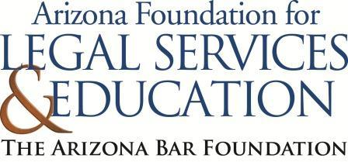
The Law-Related Education Academy is sponsored by the Arizona Foundation for Legal Services & Education with funding made possible by the Arizona Department of Education.

“Screen Time Skills” Academy
(Elementary Grades K-3)
Being Nice Online Lesson Plan
Please obtain administrator approval prior to implementing this lesson.

Objectives: Students will…
- understand what mean behavior looks and feels like online.
- reflect on why it is important to be nice online.
- illustrate ways to be nice online.

Protective Factor Developed: Empathy for Others
SEL Competency: Social Awareness

Materials:
- Charade Pictures pgs. 3-4, cut apart
- Happy Face and Sad Face Pictures pg. 5
- Large poster paper, markers and/or crayons for each group

Timeframe: 40 Minutes

Team Teaching: For effective implementation of Law Related Education (LRE), team teach with the classroom teacher by…
- Having both the officer and teacher rotate among students and to different groups. Both instructors will provide positive feedback and engage in friendly conversations with students. This procedure will help reduce classroom disruptions, increase student engagement, and build supportive relationships with students.
- Encouraging classroom teachers to participate in all activities by injecting clarification statements by relating relevant content to their curriculum. In this method, students will see more connections to their student life and be willing to carry over concepts and skills learned in LRE.
- Assigning the classroom teacher part of the lesson instructions. Team teaching with the classroom teacher enables the students to further see the importance of LRE lessons. It also provides an opportunity for the classroom teacher to demonstrate teaching skills conducive for effective teaching. Student attention can be maintained more easily with different voices and personalities experienced throughout the lesson.

Activity: “Being Nice: Charades
- Gather students in a large, open area of the room. Ask for a volunteer who would like to act out something they see in a picture about being nice. Show that student the Charade picture with words (pgs. 3-4) and have them act it out for their classmates.
- Instruct the other student to guess by calling out what they think the volunteer is acting out. The first student who came closest to guessing correctly can be the next one to act out a charade. If they do not want to, you can pick another volunteer.

Lesson:
- Inform students that the opposite of being nice is being mean. Ask students to raise their hands and share an example of being mean but tell them not to use any names.
Possible Responses: cutting in line, not taking turns on the swings, interrupting others, etc.
- Explain that we have school rules on how to treat each other. Instruct the students to talk to a shoulder partner and brainstorm some school rules in the classroom or out of the classroom that tell how you should treat each other.
- Call on students to share one rule. Record rules on the class board.
Possible Rules: take turns, share classroom supplies, say kind words, keep your hands to yourself, etc.
- Explain that rules help keep us safe and protect our rights to enjoy and learn at school. Now ask students to pat their head if they use a computer. Explain that there are also rules for how to treat each other online.
- Instruct the students to talk to their shoulder partner and share some rules for treating each other respectfully on school computers. Call on students to share one rule. You may want to read any rules posted in the computer lap or school handbook.
Possible Rules: share the computer, take turns, use kind words, use kind online reactions, etc. (If students engage in online classrooms, rules can be adjusted for those interactions.)
- Now, ask students to shake their hands in the air if they have rules at home for using computers. Call on volunteers to share one rule from home.
- Explain to students that they will have an activity where they can determine if an action online with others is nice or mean. Post a happy face on one side of the room and a sad face on the other side of the room, (pg. 5).
- Instruct students to gather in the middle of the two signs and listen to an example you will give. If they think that will make someone feel sad, they should go stand near the sad face. If they think the action will make someone feel happy, they should go stand near the happy face.
Examples:
- receiving a message that says mean things (Sad)
- receiving a message that says they like your idea (Happy)
- being laughed at when you misspell on the computer (Sad)
- having other players gang up on your avatar in a game (Sad)
- receiving a funny picture (Happy)
- getting heart emojis when you share your online project (Happy)
- having someone put down something you said you like (Sad)
- having your class peer invite you to play a game online (Happy)
- Divide students into small groups of 3 or 4 students in each. Provide large poster paper and crayons and/or makers. Instruct students to draw a picture of something nice to say, see or do online that would make others happy. Explain that their drawing will be for another charades game the class could play.
- The teacher and you can help students think of an idea and write a word or phrase for their illustration.
- Call on each group to act out their idea and see if the class can guess.
- Ask students to share reasons for being nice online. Then, ask students to show on their face how they feel when others are nice to them online.
- Debrief the lesson by asking each group to share one reason why it is important to be nice to others online.
The Law-Related Education Academy is sponsored by the Arizona Foundation for Legal Services & Education with funding made possible by the Arizona Department of Education.

“Screen Time Skills” Academy
(Elementary Grades K-3)
Being Nice Online
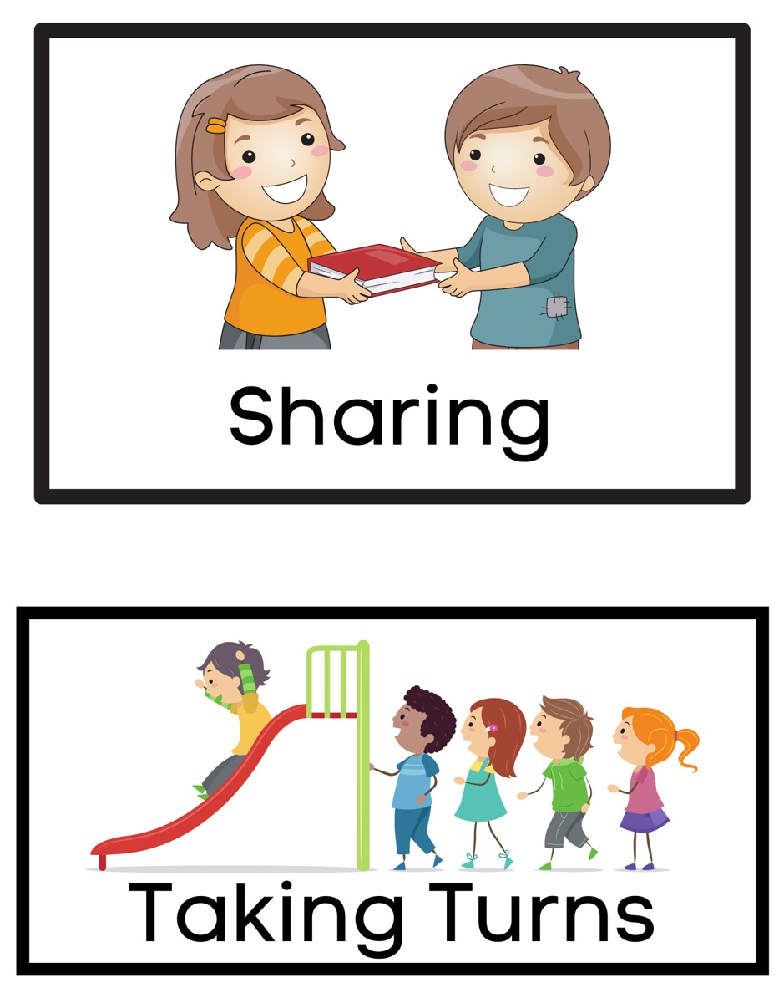

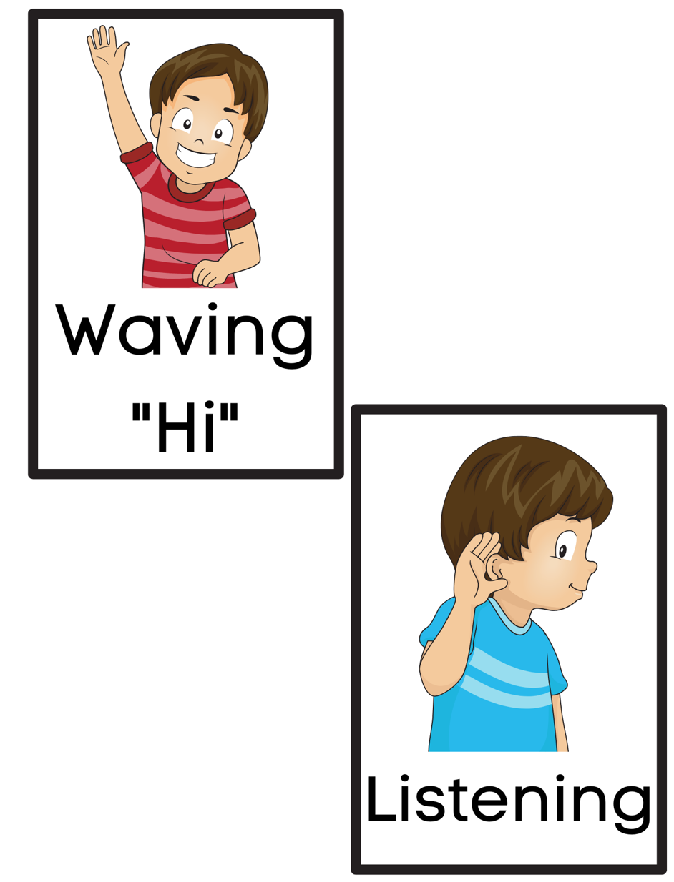





The Law-Related Education Academy is sponsored by the Arizona Foundation for Legal Services & Education with funding made possible by the Arizona Department of Education.

“Screen Time Skills” Academy
(Elementary Grades K-3)
Being Nice Online
Correlations

Civics
K.C1.1 Apply values of respect, responsibility, equality, and fairness within schools and communities.
1.C1.1 Apply values of respect, responsibility, equality, and fairness as a member of a community.

K.C1.2 Follow agreed upon rules for discussions when responding to others and making decisions as a group.
1.C1.2 Follow agreed upon rules for discussions when responding to others and making decisions including consensus building procedures.

K.C4.2 Explain why rules are important within the classroom and school.
1.C3.1 Explain the importance of rules and laws in our community.
2.C4.2 Explain how rules function in public settings.

Speaking & Listening
SL.1 Participate in collaborative conversations (one-on-one, in groups, and teacher-led) with diverse partners on grade level topics and texts, building on others’ ideas and expressing their own clearly.
- Follow agreed-upon rules for discussions (e.g., gaining the floor in respectful ways, listening to others with care, speaking one at a time about the topics and texts under discussion).
- Build on others’ talk in conversations by linking their comments to the remarks of others.
- Ask for clarification and further explanation as needed about the topics and texts under discussion.
SL.3 Ask and answer questions about information from a speaker, offering appropriate elaboration and detail.
SL.4 Tell a story or recount an experience with appropriate facts and relevant, descriptive details, speaking audibly in coherent sentences.
SL.5 Add drawings or other visual displays to descriptions when appropriate to clarify ideas, thoughts, and feelings.
SL.6 Speak in complete sentences when appropriate to task and situation in order to provide requested detail or clarification.

