
The Law-Related Education Academy is facilitated by the Arizona Foundation for Legal Services & Education with funding made possible by the Arizona Department of Education School Safety Program.

“Outstanding Upstanders” Academy
(K-3)
I Can Be a Hero! Lesson Plan
Officers should obtain administrator approval prior to implementing this lesson.

Objectives: Students will…
- learn the qualities of a hero.
- understand that heroes are role-models.
- see themselves having qualities of a superhero.

Protective Factors: High Self-Esteem
Social Emotional Learning Competency: Self-Awareness

Materials:
- Student markers or pencils
- Lesson Slides
- I Can be a Superhero Activity handout pg. 3 (1 per student)

Timeframe: 40 Minutes

Team Teaching: For effective implementation of Law Related Education (LRE), team teach with the classroom teacher by…
- Having both the officer and teacher rotate to different groups. Both instructors will provide positive feedback and engage in friendly conversations with students. This procedure will help reduce classroom disruptions, increase student engagement, and build supportive relationships with students.
- Encouraging classroom teachers to participate in all activities by injecting clarification statements and relating relevant content to their curriculum. In this method, students will see more connections to their student life and be willing to carry over concepts and skills learned in LRE.
- Assigning the classroom teacher part of the lesson instructions. Team teaching with the classroom teacher enables the students to further see the importance of LRE lessons. It also provides an opportunity for the classroom teacher to demonstrate teaching skills conducive for effective teaching. Student attention can be maintained easier with different voices and personalities experienced throughout the lesson.
Helpful Tip: Invite the school’s counselor to co-teach this lesson. Their expertise in the areas of social-emotional learning can greatly benefit the students’ well-being.

Attention Grabber: Display the Lesson Slides.
- Divide students into small groups of 3 or 4 students each.
- Slide 1: Ask students to share with their group who their favorite superhero is? Call on a few volunteers from the class to share different responses.
- Slide 2: Explain that most of their ideas are fictional characters from movies and stories.
- Slide 3: They have pretend super powers such as flying, super strength or x-ray vision.
- Slide 4: A hero is someone who shows courage. They have qualities like helpfulness, caring, honesty, and fairness.
- Slide 5: There are real-life heroes in our everyday life. Ask students to share with their group people who are heroes to them and share a quality or reason why. Call on volunteers to share their real-life hero and one reason why.
- Explain that heroes who have these qualities are role-models for us to follow. We can be heroes too by showing courage and acting out qualities of our superhero role models.

Problem-Solving and Application Activities:
- Explain to students that you are going to show some pictures and for each picture, students can share ways to be a hero in that situation.
- Show picture 1 on Slide 6. Ask students to discuss with their group what they think is happening in the picture and ways to be a hero in that situation.
- Call on one group to report out what is happening and ways to be a superhero in that situation.
- Continue with picture 2 on Slide 7, instructing groups to discuss what is happening and ways to be a superhero. Then call on another group to report out. Inform students that when someone is being hurt either by words, or actions by others over and over and on purpose, that person is being bullied. The person being bullied should report it to a teacher, parent, or other trusted adult. If you see someone being bullied or someone tells you it is happening to them, report it to a teacher, parent, or other adult.
- Continue with Slides 8 and 9, calling on different groups to report out.
- Next, distribute I Can be a Superhero Activity Handout (see pg. 3) to each student. Show Slide 10. Instruct the students to repeat after you as you read each word displayed on the cape.
- Next, instruct students to first, trace the letters. For the last sentence, students can add other qualities they have such as skills or talents that can help them be a superhero to a friend or student at school or someone in their family.
- Then, students may add features to the body to look like themselves and color the cape.
- Ask each student to take turns sharing their picture with their group and reading the words on the cape an any other writing they added.
- As each person in the group shares, the person presenting next can repeat one thing they remember about the last presentation.

Lesson Closure:
- Call on volunteers to share one way they can be a superhero too.

Suggested Book: The Hero Book by Ellen Sobin: http://www.wateringcanpress.com/html/ordernow.html
Suggested Video: A hero Like You by Nikki Rogers
(Video) https://www.youtube.com/watch?v=FgdKD9owv7E

The Law-Related Education Academy is facilitated by the Arizona Foundation for Legal Services & Education with funding made possible by the Arizona Department of Education School Safety Program.

“Outstanding Upstanders” Academy
(K-3)
I Can Be a Hero!

I Can Be a Superhero
Activity Handout

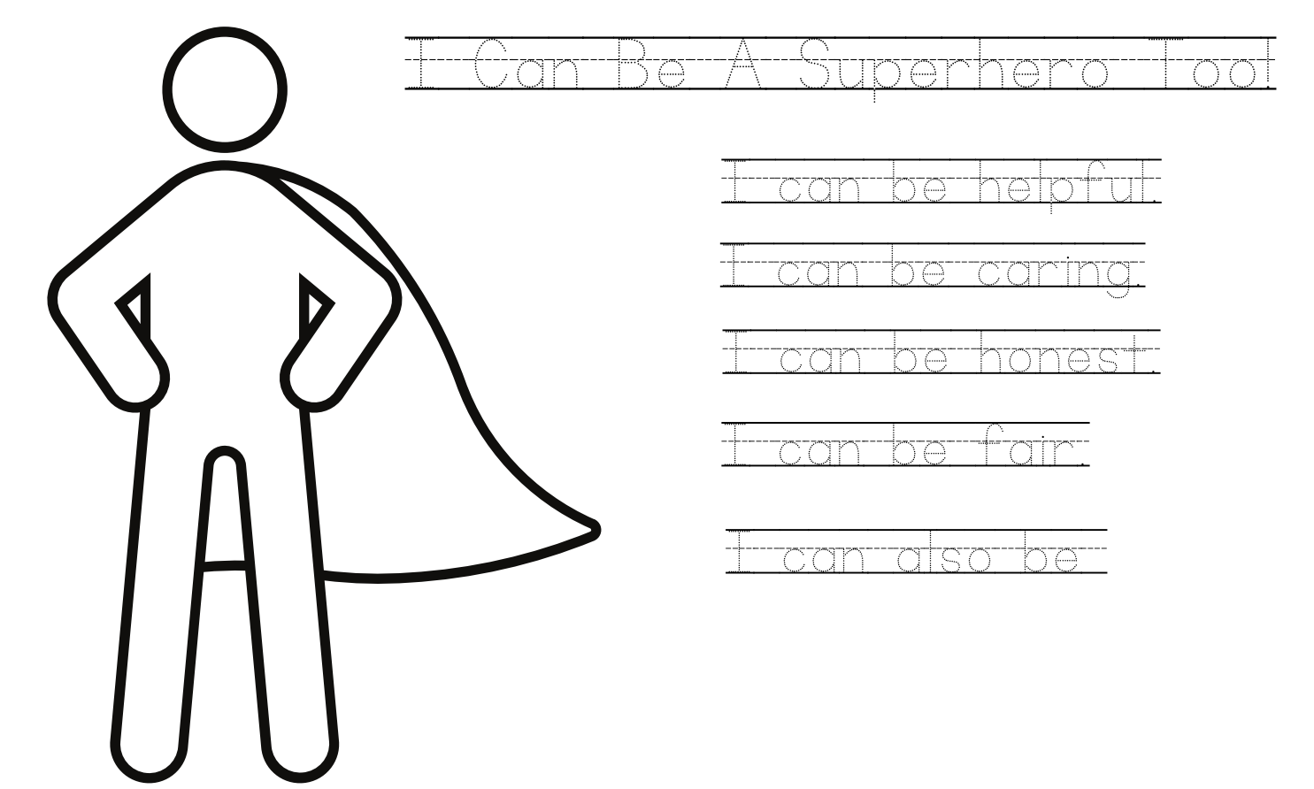

The Law-Related Education Academy is facilitated by the Arizona Foundation for Legal Services & Education with funding made possible by the Arizona Department of Education School Safety Program.

“Outstanding Upstanders” Academy
(K-3)
I Can Be a Hero!
Correlations

Social Studies/Civics Anchor Standards
- C2: Citizens have individual rights, roles, and responsibilities.

Health Concept 2: Self Protection and Dealing with Conflict
- PreK-2 PO 1. Demonstrate ways to respond when in an unwanted, threatening, or dangerous situation
- 3-5 PO 1. Demonstrate nonviolent strategies to manage or resolve conflict

ELA
- SL.1 Participate in collaborative conversations with diverse partners about kindergarten topics and texts with peers and adults in small and larger groups. a. Follow agreed-upon rules for discussions (e.g., listening to others, taking turns speaking about the topics and texts under discussion). b. Continue a conversation through multiple exchanges.
- L.6 Use words and phrases acquired through conversations, reading, and being read to, and responding to texts.

Visual Arts
- Create an imaginative artwork (such as a work that responds to a story or an invented fantasy) and add details. (VA.CR.1.3a)
- Investigate personal ideas through the art-making process. (VA.CR.1.3)

