
The Law-Related Education Academy is facilitated by the Arizona Foundation for Legal Services & Education with funding made possible by the Arizona Department of Education School Safety Program.

“Teasing, Taunting and Pranking”: Academy
(Upper Elementary/Middle)
When has it Gone Too Far? Lesson Plan
Obtain Administrator Approval Prior to Implementing Lesson

Objectives: Students will…
- Understand what bullying is
- Learn how to recognize when teasing, taunting and pranking are forms of bullying
- Practice reporting and helping others report when being bullied

Materials:
- Bullying phrases cut apart-1set ppt slides 1-4
- Turning the Corner to Bullying strips-a different set per group ppt slides 5-12 (1 group would get the set on slide 5, another group the set on slide 6 and so forth)-mix up the strips in each set so they are no longer in the order on the slide; do not mix slides
- Facilitator Guide
- Stop, Go, Yield sign pattern-1 set per group ppt slide 13

Timeframe: 50 Minutes

Activity 1: Bullying Explanation
- Begin the activity by placing students into small groups of 4 or 5 students in each. Provide large paper and markers for each group.
- Inform students that social interactions are ways we communicate and treat each other. Recognizing when social interactions are unwanted and learning to make judgments when dealing with teasing, taunting, pranking or hazing takes practice. This lesson will help students know when social interactions have turned the corner into unacceptable behavior and how to report and get help.
- Hand a volunteer from each group a phrase and ask them to stand in front of the class. Have these volunteers place themselves in the proper order so the phrases form the explanation of bullying. The class can offer direction out loud to help their group member get into the right order. When most of the class is in agreement that the phrases are in correct order, check for accuracy before asking student volunteers to read the explanation.

- Bullying is when a person purposely tries to hurt others by:
- Making them feel uncomfortable. Hurting them by kicking,
- hitting, pushing, tripping, name-calling or spreading
- mean rumors. Bullying hurts the other person over and
- over. The person being bullied might feel smaller or weaker
- than the bully or might feel outnumbered by the bully and
- the bully’s friends. They may feel no one is standing up for
- them or will help them. Bullying can come from a girl or boy.

- Inform students that bullying teasing, taunting, pranking and hazing are some ways bullying can happen. It may start out as having fun but can turn the corner into bullying. It is important to recognize when it is no longer fun for everyone and there could be consequences if the behavior continues.

Activity 2: Path to Bullying
- Hand each group a different set of “Turning the Corner to Bullying” strips. Instruct the groups to place the strips in a line to create a path that could lead to bullying. The action that turns the corner into bullying should be placed at a right angle indicating that the action turned the corner into bullying. Some actions may not turn.
- Rotate around to each group and check for accuracy, prompting them if needed. Ask for one group at a time to call out their strips in order, indicating where the actions turned the corner into bullying if they think it did.
- Ask the listening audience after each presentation to identify if the bullying was an example of teasing, taunting, pranking or hazing. Explain any relevant laws. (See Facilitator Guide)
- Next, ask the groups to discuss things you can do if you notice actions becoming bullying or unwanted. Then, ask for volunteers to call out suggestions as you record them on the board.
Possible Suggestions:
- Ignore name-calling and see if it stops
- Try to not laugh with the one bullying others or let them think you are okay with teasing someone who does not want to be teased
- Ask the target of mean pranks to sit or play with you and your friends
- Let the rumor or mean words stop with you by not repeating them unless you are reporting
- Stop teasing someone who is becoming upset or asks you to stop
- Report anytime someone is being pushed, slapped or punched to a trusted adult
- Say nice things to someone who is being made fun of or insulted
- Encourage your peers to report if someone is asking them to do something that is harmful or humiliating in order to belong to their group

Activity 3: Reporting Bullying Actions
- Remind students that bullying should be reported. Inform the students that there is a law that says schools are required to have a way to report bullying safely and anonymously. To make sure you are not tattling or just trying to get someone in trouble ask yourself if the actions are hurting someone and nothing tried seems to stop it. Anytime someone is hurt or threatened to be hurt, it should be reported immediately. If you are in doubt, talk to an adult.
- Next, ask the class to think of details they should remember in order to accurately report a bullying situation to a trusted adult.
- Instruct the groups to practice reporting bullying to a trusted adult by utilizing the situation from their group’s strips. If their group’s strips did not turn into bullying, have them imagine if the behavior became annoying or hurtful and repeated even after being asked to stop. Group members should be divided into partners and each partner takes a turn reporting the bully actions to the other partner.
- Rotate around to each group and check for understanding. Ask for a few volunteers who demonstrated a good example of reporting to perform their practice for the whole class to observe.

Debrief:
- Hand each student a Stop, Go and Yield sign pattern handout. Instruct the students to write or illustrate one thing they should stop doing to keep from bullying others, one thing they should start doing to help others that are a target of bullying actions and one thing they will watch for to stop it from turning the corner into bullying.
- Call on a few volunteers to report on their Go sign, a few others to report on their Stop sign and a few others to report on their Yield sign.

The Law-Related Education Academy is facilitated by the Arizona Foundation for Legal Services & Education with funding made possible by the Arizona Department of Education School Safety Program.

“Teasing, Taunting and Pranking”: Academy
(Upper Elementary/Middle)
When is it Bullying?
Facilitator Guide

1. Friendly teasing unless being called Shorty bothered Shirley and the name calling continued.
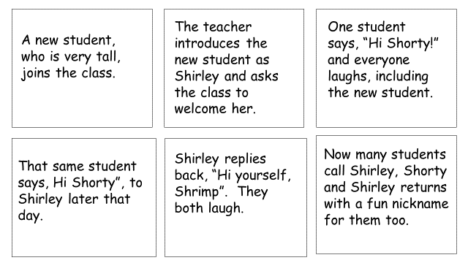
2. Teasing into Bullying, possibly turned the corner after the third strip, “The teacher…”
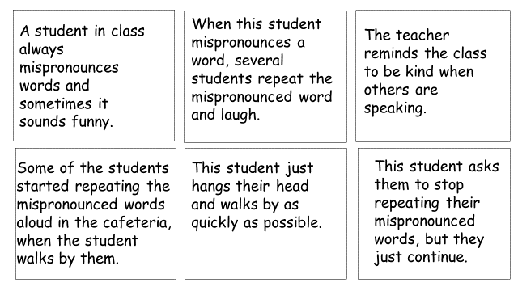
15-341. General powers and duties; immunity; delegation “Under Arizona law A.R.S. § 15-341(A) (37), school district governing boards must prescribe and enforce policies and procedures to prohibit students from bullying, harassing, and intimidating other students on school grounds, school property, school buses and bus stops, and at school-sponsored events and activities, or through use of electronic technology or communication on school computers, networks, forums, and mailing lists.”
3. Friendly Taunting
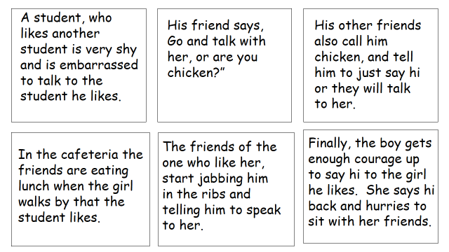
4. Taunting, Intimidating/Bullying possibly after the 2nd strip, “The 5th graders…”
“Bullying is unwanted, aggressive behavior among school aged children that involves a real or perceived power imbalance. The behavior is repeated, or has the potential to be repeated, over time. Both kids who are bullied and who bully others may have serious, lasting problems.”
13-1202. Threatening or intimidating; classification
A. A person commits threatening or intimidating if the person threatens or intimidates by word or conduct:

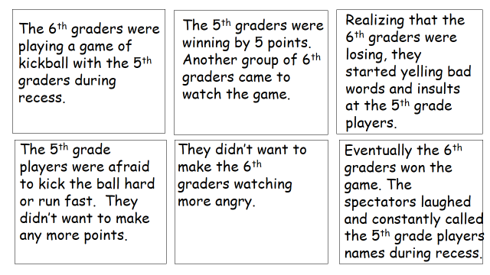

5. Friendly Pranking
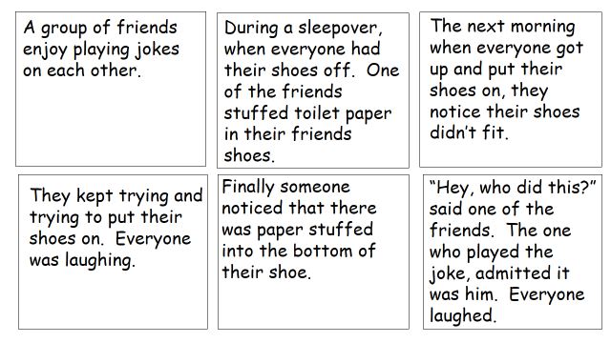
6. Hazing/Pranking/Assault possibly after the 2nd strip, “They are always…”
15-2301. Hazing prevention policies; definitions
A. Every public educational institution in this state shall adopt, post and enforce a hazing prevention policy. The hazing prevention policy shall be printed in every student handbook for distribution to parents and students.
13-1203. Assault; classification
A. A person commits assault by:
1. Intentionally, knowingly or recklessly causing any physical injury to another person; or
2. Intentionally placing another person in reasonable apprehension of imminent physical injury; or
3. Knowingly touching another person with the intent to injure, insult or provoke such person.

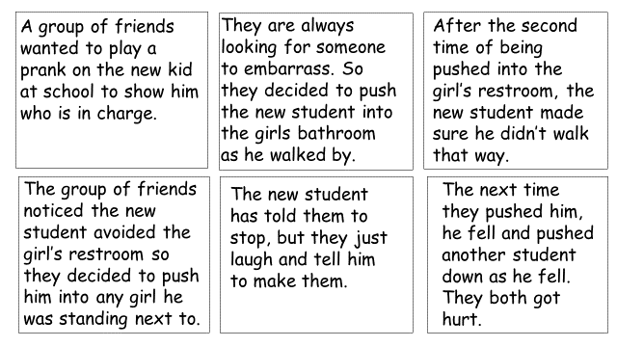
7. Friendly Induction
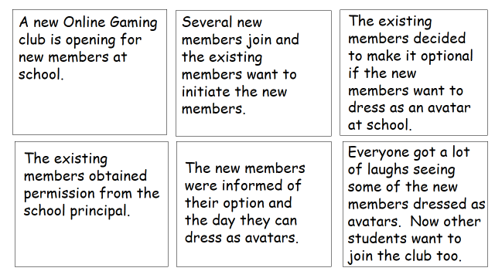
8. Hazing/Threats possibly after the 3rd strip, “They decided to…”
15-2301. Hazing prevention policies; definitions
A. Every public educational institution in this state shall adopt, post and enforce a hazing prevention policy. The hazing prevention policy shall be printed in every student handbook for distribution to parents and students.
13-1202. Threatening or intimidating; classification
A. A person commits threatening or intimidating if the person threatens or intimidates by word or conduct:

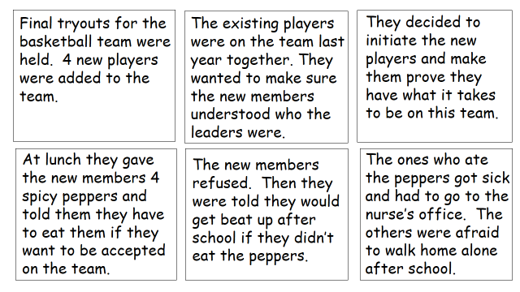

https://www.kzoo.edu/psych/stop_bullying/for_kids/what_is_a_bully.html
https://www.stopbullying.gov/what-is-bullying/index.html

