
The Law-Related Education Academy is facilitated by the Arizona Foundation for Legal Services & Education with funding made possible by the Arizona Department of Education School Safety Program.

“The Impact of Underage Drinking” Academy
(Middle/High School)
Drive Sober Lesson Plan
Please obtain administrator approval prior to implementing this lesson.

Objectives:
- Students should understand DUI laws.
- Students should understand the consequences associated with DUI alcohol, drugs, and medications.

Protective Factor Developed: Critical reasoning skills

Materials:
- Large poster paper and markers for each group
- Drive sober Matching Game, 1 set per group
- Each one/teach one cards, 1 per student
- Debrief toy or soft object to toss, 1 per class

Timeframe: 50 Minutes

Team Teaching: For effective implementation of Law Related Education (LRE), team teach with the classroom teacher by…
- Having both the officer and teacher rotate among students and to different groups. Both instructors will provide positive feedback and engage in friendly conversations with students. This procedure will help reduce classroom disruptions, increase student engagement, and build supportive relationships with students.
- Encouraging classroom teachers to participate in all activities by injecting clarification statements by relating relevant content to their curriculum. In this method, students will see more connections to their student life and be willing to carry over concepts and skills learned in LRE.
- Assigning the classroom teacher part of the lesson instructions. Team teaching with the classroom teacher enables the students to further see the importance of LRE lessons. It also provides an opportunity for the classroom teacher to demonstrate teaching skills conducive for effective teaching. Student attention can be maintained more easily with different voices and personalities experienced throughout the lesson.

Lesson:
- Divide students into small groups of 3 or 4 students each. Provide each group with large poster paper and markers.
- In order to gauge the students’ prior knowledge of DUI laws, hand each group a Drive Sober Matching Game. The groups will work to match the question with the correct answer. Walk around each group and provide any guidance they may need.
- When most groups are finished with their matches, call on one group at a time to read a question and share their group’s response. Continue rotating around the groups until all questions have been addressed and discussed. Use the facilitator guide to provide the students with the correct answers and elaborate when needed.
- Now that the students’ minds are gearing in the right direction of the lesson, hand each student an ‘Each one-Teach one’ card. These cards will have DUI laws, liquor laws, traffic laws, and criminal statutes as they pertain to DUI related offenses.
- Ask the students to read their card a few times then go around the room and teach their fact or information to at least three other students who are not in their group. You may want to call out “switch!” to ensure they move to a new student to teach their fact to.
- Have the students take their seats and share their card with someone near them.
- Collect the cards and ask for volunteers to share the information they learned. Write the facts they share on the board or ask a student to do so.
- Ask the class if there were any facts or information shared that surprised them.
- Next, instruct the groups to come up with a slogan to help students understand the severity of DUI’s and DUI laws. They can choose from alcohol, drugs, and prescription drugs or combine all three.
- Give each group time to present their slogan and have the audience rate the slogan on a scale from 1-5; 1 indicating least persuasive and 5 indicating most persuasive.
- Debrief: Toss a soft object to a willing volunteer and ask for one possible consequence of driving under the influence of a drug or alcohol.

The Law-Related Education Academy is facilitated by the Arizona Foundation for Legal Services & Education with funding made possible by the Arizona Department of Education School Safety Program.

“The Impact of Underage Drinking” Academy
(Middle/High School)
Drive Sober Lesson Plan
Facilitator Guide

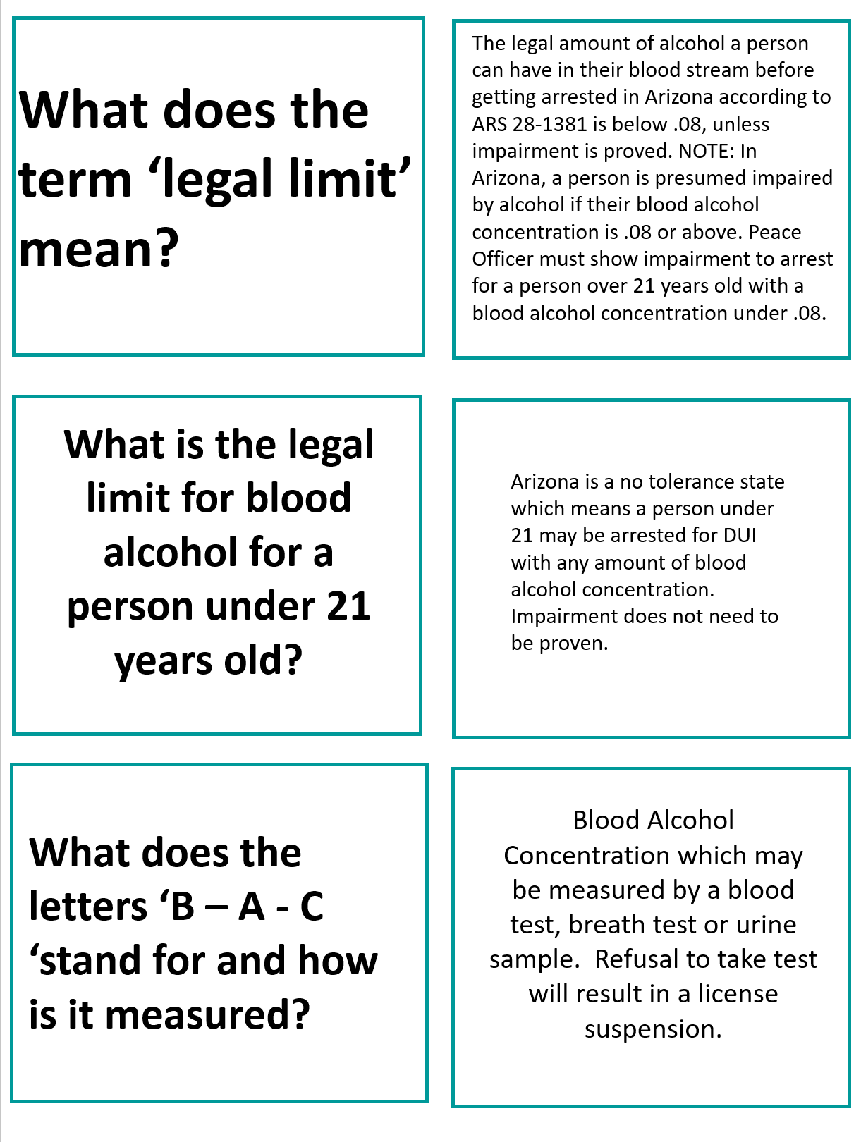

The Law-Related Education Academy is facilitated by the Arizona Foundation for Legal Services & Education with funding made possible by the Arizona Department of Education School Safety Program.

“The Impact of Underage Drinking” Academy
(Middle/High School)
Drive Sober Lesson Plan
Facilitator Guide

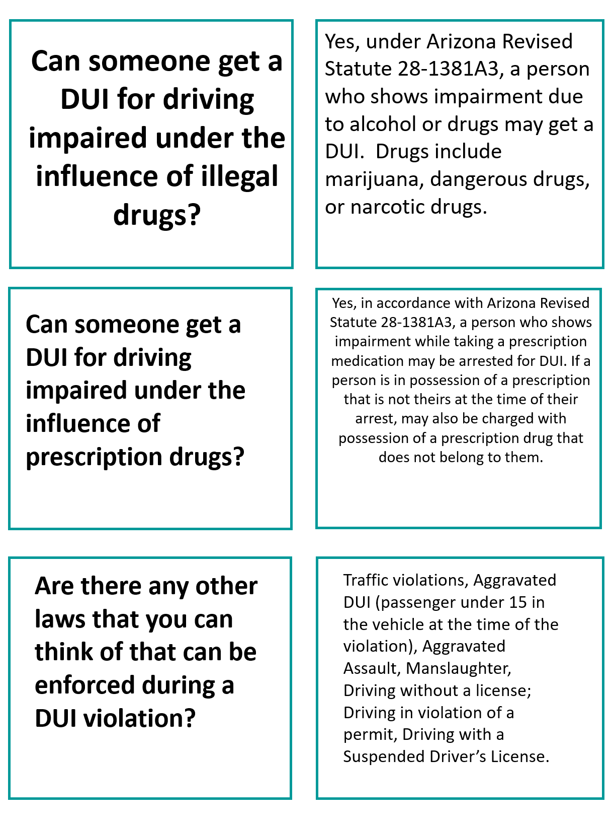
The Law-Related Education Academy is facilitated by the Arizona Foundation for Legal Services & Education with funding made possible by the Arizona Department of Education School Safety Program.

“The Impact of Underage Drinking” Academy
(Middle/High School)
Drive Sober Lesson Plan

Arizona State Standards Correlations

Civics:
Explain the obligations and responsibilities of citizenship: obeying the law and voting. (7-12 S3C4 PO4b-c)
Health:
Examine the likelihood of injury or illness if engaging in unhealthy behaviors. (6-12 S1C6 PO2)

Describe ways to reduce or prevent injuries and other adolescent health problems. (6-12 S1C4 PO1)

Apply effective verbal and nonverbal communication skills to enhance health. (6-12 S4C1 PO1)

Determine when health related situations require the application of a thoughtful decision-making
process. (6-8 S5C2 PO1)

Analyze the outcomes of a health-related decision. (6-8 S5C2 PO6)

Demonstrate how to influence and support others to make positive health choices. (6-12 S8C1 PO2)

Visual Art:
Explain purposeful use of subject matter, symbols, and/or themes in his or her own artwork.
(S1C4PO 201)

