
The Law-Related Education Academy is facilitated by the Arizona Foundation for Legal Services & Education with funding made possible by the Arizona Department of Education School Safety Program.

Truancy Understanding and Overcoming Barriers Academy
(Middle/High School)
Cost of Truancy Lesson Plan
Please obtain administrator approval prior to implementing this lesson.

Objectives:
- Students will learn the economic impact student absences has on school systems
- Students will learn the economic impact student absences has on economic future

Protective Factor Developed: Belief in future

Materials:
- Large poster paper and markers for each group
- Spending Trends Handout, 2 per group
- Ripple Effect Situations, 1 strip per group
- Large Whiteboard, 1 per group: prior to the lesson, hang on the wall next to each group
- Sticky Notes

Timeframe: 40 Minutes

Team Teaching: For effective implementation of Law Related Education (LRE), team teach with the classroom teacher by…
- Having both the officer and teacher rotate among students and to different groups. Both instructors will provide positive feedback and engage in friendly conversations with students. This procedure will help reduce classroom disruptions, increase student engagement, and build supportive relationships with students.
- Encouraging classroom teachers to participate in all activities by injecting clarification statements by relating relevant content to their curriculum. In this method, students will see more connections to their student life and be willing to carry over concepts and skills learned in LRE.
- Assigning the classroom teacher part of the lesson instructions. Team teaching with the classroom teacher enables the students to further see the importance of LRE lessons. It also provides an opportunity for the classroom teacher to demonstrate teaching skills conducive to effective teaching. Student attention can be maintained more easily with different voices and personalities experienced throughout the lesson.

Lesson:
- Divide the class into small groups of 3-4 students each. Provide each group with large poster paper, large whiteboard, sticky notes, and markers.
- Explain that Arizona’s legislative body approves state budgets for funding schools. Schools receive a specific amount per student enrolled. Local and federal funds are also utilized by schools. Federal and state money for school budgets come mainly from taxes collected. Local bond and override elections can also provide school districts additional funds if the election passes by the voters of that school district.
- Ask for a few volunteers to share out what they think Arizona K-12 schools spend money on.
- Facilitator will share the schools spending categories: Instruction, Student support, Instruction support, Administration, Plant operations, Food service, and Transportation
- Next provide each group with a copy of the Spending Trends Handout.
- Instruct the groups to analyze the chart and write on their large poster paper 3 conclusions to share with the class.
- Call on each group to share one of their 3 conclusions that is different from the other group reports.
Facilitator Note of Possible Conclusions: More money is spent on instruction, the amount spent in all areas increased from 2022 to 2023, expected it will increase from 2023-2024 and continue to increase each year. Student attendance has decreased, which could affect school budgets and the quality of education students receive.
- Explain to the class that missing too much school can have a “ripple effect” That means a chain of events that may happen based on the previous event. Examples of economic effects of truancy are:
- Lack skills to obtain better paying job therefore more financial struggles
- More likely to be unemployed
- More likely to depend on government assistance (food, medical, cash etc.)
- Not paying taxes without a legitimate job and therefore not contributing financially to society
- Explain to the class that truancy does not just affect the student. Decrease in student attendance can reduce the funding that the schools receive so truancy also affects their peers. Now we are going to look at how truancy can affect the student in the future.
- Inform the students that each group will be assigned a possible situation that may occur for those who do not achieve a high school diploma. Each situation has financial consequences, and the groups will brainstorm what those could be. The facilitator will pass out one strip of the Ripple Effect Situations to each group.
- Next, illustrate on the board the Ripple Effect Diagram example below. Go through the example together as a class before they get started on their own in their small group.
Effect: May end up paying out-of-pocket for healthcare or dealing with financial insecurity
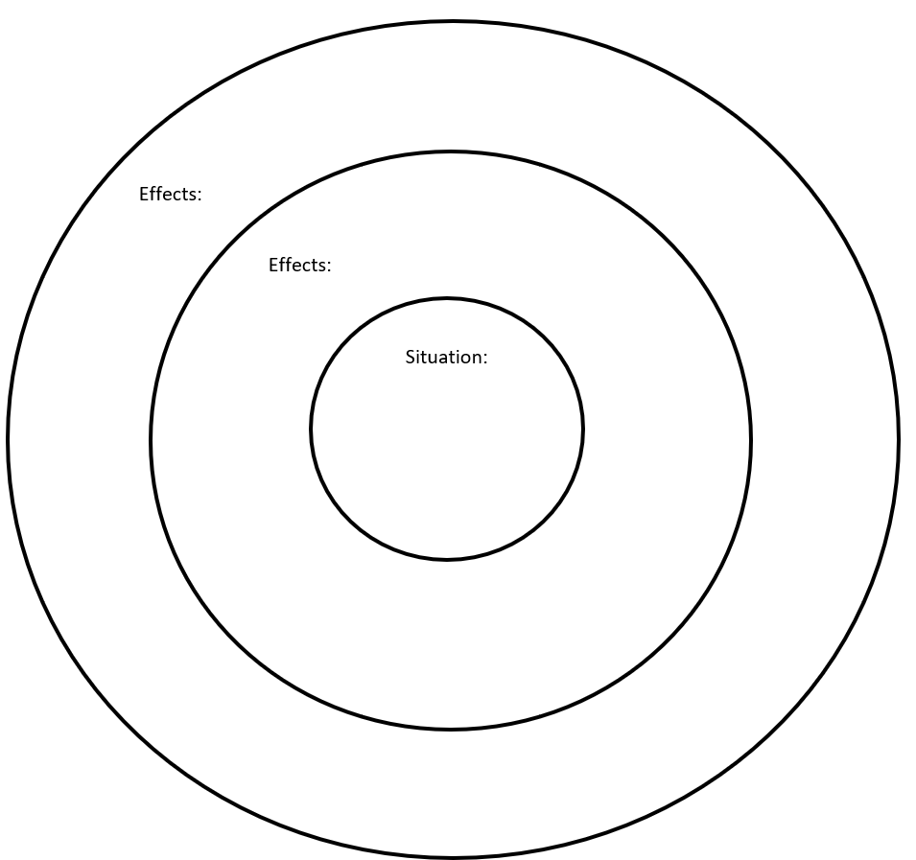
Effect: Can lead to stress individually as well as in the family dynamic
Effect: Might struggle to support loved ones by being unable to afford childcare, healthcare, or basic living expenses
Situation: Missing out on benefits like health insurance, retirement savings, and paid time off that many higher-paying jobs offer.
- Each group will illustrate their own diagram on their large whiteboard so every member of the group may add to the circles from different directions.
- Instruct the groups to collaborate to fill-in the chart with their assigned situation recorded in the middle circle and the possible ripple effects that may immediately follow in the second circle and the long-term effects in the outer circle. Students may list both positive and negative effects.
- Once done, each group will share their diagram.
- Facilitator will state that these outcomes are not guaranteed but a truant teen or teen with chronic absenteeism has a higher risk for the negative effects.
- Last, have students write one idea schools could do to improve student attendance on a sticky note. Collect notes once students are done and review.

The Law-Related Education Academy is facilitated by the Arizona Foundation for Legal Services & Education with funding made possible by the Arizona Department of Education School Safety Program.

Truancy Understanding and Overcoming Barriers Academy
(Middle/High School)
Cost of Truancy Lesson Plan

Arizona State Standards Correlations

Civics and Government
Explain the obligations and responsibilities of citizenship: obeying the law and voting.
(7-12 S3C4 PO4b-c)

Reading:
R.7 Integrate and evaluate content presented in diverse media and formats, including visually and quantitatively, as well as in words.

Writing:
7-12. W. 2 Write informative/explanatory texts to examine a topic and convey ideas, concepts, and information through the selection, organization, and analysis of relevant content.
6‐12. WHST.4 Produce clear and coherent writing in which the development, organization, and style are appropriate to task, purpose, and audience.

Speaking and Listening:
SL.1 Prepare for and participate effectively in a range of conversations and collaborations with diverse partners, building on others’ ideas and expressing their own clearly and persuasively.
SL.2 Integrate and evaluate information presented in diverse media and formats, including visually, quantitatively, and orally.
SL.4 Present information, findings, and supporting evidence such that listeners can follow the line of reasoning and the organization, development, and style are appropriate to task, purpose, and audience.
SL.5 Make strategic use of digital media and visual displays of data to express information and enhance understanding of presentations.

Economics:
6-8.E1.1 Analyze the relationship between education, income, and job opportunities within the context of the time period and region studied.

Financial Reasoning
QR.FR.3: Use models to solve and communicate about contextual financial questions
QR.FR.4: Identify and explain personal and societal consequences of financial decisions.

https://dropoutprevention.org/family-and-student-resources/

