Truancy: Understanding and Overcoming Barriers Academy
Cost of Truancy Lesson
Spending Trends Handout

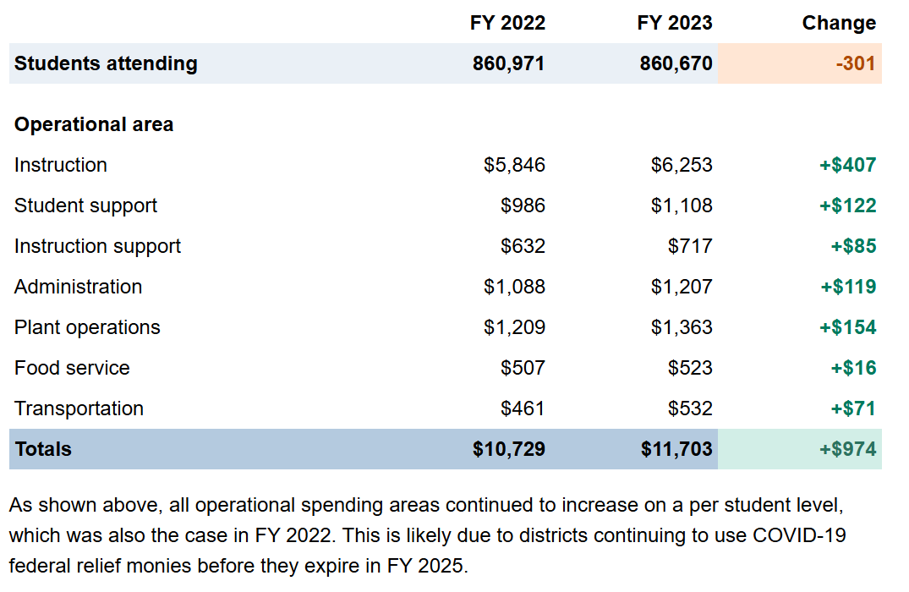
https://sdspending.azauditor.gov/

