
The Law-Related Education Academy is facilitated by the Arizona Foundation for Legal Services & Education with funding made possible by the Arizona Department of Education School Safety Program.
Truancy Understanding and Overcoming Barriers Academy
(Middle/High School)
Goal Setting Lesson Plan
Please obtain administrator approval prior to implementing this lesson.

Objectives:
- Students will understand the importance of staying in school.
- Students will learn the benefits of graduating high school.

Protective Factor Developed: Connection/Committment to school

Materials:
- Large poster paper and markers for each group
- Dry Erase Pocket Sleeves with blank paper inside, 1 per group
- Dry Erase Erasers, 1 per group
- Dry erase dots labeled 1, 2, 3, and 4 (1 number for each student at each group)
- Loose leaf paper, 1 per student
- Sticky Notes
Prior to the lesson, create a large poster, with the following questions:
  - What is the career?
  - How much do they earn?
  - What level of education is required?
  - Are there any other special requirements?

Timeframe: 40 Minutes

Team Teaching: For effective implementation of Law Related Education (LRE), team teach with the classroom teacher by…
- Having both the officer and teacher rotate among students and to different groups. Both instructors will provide positive feedback and engage in friendly conversations with students. This procedure will help reduce classroom disruptions, increase student engagement, and build supportive relationships with students.
- Encouraging classroom teachers to participate in all activities by injecting clarification statements by relating relevant content to their curriculum. In this method, students will see more connections to their student life and be willing to carry over concepts and skills learned in LRE.
- Assigning the classroom teacher part of the lesson instructions. Team teaching with the classroom teacher enables the students to further see the importance of LRE lessons. It also provides an opportunity for the classroom teacher to demonstrate teaching skills conducive to effective teaching. Student attention can be maintained more easily with different voices and personalities experienced throughout the lesson.
Lesson:
- Divide the class into small groups of 3-4 students each. Provide each group with large poster paper, dry erase pocket sleeve, sticky notes, and markers.
- Inform students that truancy is linked to an increased chance of dropping out of high school.
- Pass out a dry erase dot to each student, small groups will determine who is #1,2,3, and 4 and then write the number on their dot to identify their role throughout the lesson.
- Tell the students to discuss in their group what they think the median annual salary is for people with no high school diploma. Explain that median salary means the halfway point between the highest earner and lowest earner in that field. Using the Dry erase dots #1 from each group will write their group’s answer on the dry erase pocket sleeve. The facilitator will ask all groups to hold up their answers at the same time. Facilitator will read the answers and then give the official answer from AZ Central: No High School Diploma - $30k
- Next ask the students to discuss in their group what they think the median annual salary is for people with a high school diploma. Using the Dry erase dots #2 from each group will write their group’s answer on the dry erase pocket sleeve. The facilitator will ask all groups to hold up their answers at the same time. Facilitator will read the answers and then give the official answer from AZ Central: High School Diploma - $37k
- Next ask the students to discuss in their group what they think the median annual salary is for people with a bachelor’s degree. Using the Dry erase dots #3 from each group will write their group’s answer on the dry erase pocket sleeve. The facilitator will ask all groups to hold up their answers at the same time. Facilitator will read the answers and then give the official answer from AZ Central: Bachelor’s Degree - $71k
- Then ask the students to discuss in their group what they think the median annual salary is for people with a master’s degree. Using the Dry erase dots #4 from each group will write their group’s answer on the dry erase pocket sleeve. The facilitator will ask all groups to hold up their answers at the same time. Facilitator will read the answers and then give the official answer from AZ Central: Master’s Degree - $78.5k
- Ask the students to discuss in their group what they think the median annual salary is for people with a doctoral degree. Using the Dry erase dots #1 from each group will write their group’s answer on the dry erase pocket sleeve. The facilitator will ask all groups to hold up their answers at the same time. Facilitator will read the answers and then give the official answer from the Bureau of Labor Statistics: Doctoral Degree - $108k
- Ask the students to discuss in their group what they think the median annual salary is for people in trades. Using the Dry erase dots #2 from each group will write their group’s answer on the dry erase pocket sleeve. The facilitator will ask all groups to hold up their answers at the same time. Facilitator will read the answers and then give the official answer from the Bureau of Labor Statistics:
    - Plumber - $60k
    - Construction Manager - $100k
    - Elevator Mechanic - $100k
    - Power Utility Technician - $75k
    - Electrician - $60k
No experience is required of a new apprentice. Most Registered Apprenticeship programs require applicants to have a high school diploma or GED certificate. Some occupations require completion of specific subjects such as algebra, blueprint reading or related shop work.
- Ask the students if they are surprised by the amounts. Did they think any of the categories would have been higher or lower?
- Have each student think about a career they might be interested in. Students will need access to a computer or smart device. Each student will independently research the career they chose and answer the questions in step 11 on loose leaf paper.
- Introduce the questions on the large poster paper.
  - What is the career?
  - How much do they earn?
  - What level of education is required?
  - Are there any other special requirements?
- Give students 10 minutes to research and record their findings.
- Once time is up, group students by their dry erase dot number. Each number will be given a corner to go to. They will gather with their new group and share what they found. The tallest person will share first and then it will go clockwise.
- The facilitator will circle around the room to each group. Ask students to comment on any similarities or differences they are finding between their group’s responses.
- As a group, have them decide on one thing they found that was unexpected/interesting about one of their careers. Rotate to each group and have them share their one unexpected/interesting thing.
- Debrief the lesson by having students write down on a sticky note one benefit of graduating high school and turn it in to the facilitator when done.

Optional Activity (Complete after step 14):
1. Instruct each student to create a mind map on their own paper.
- They should write “Graduation” on the center of their paper and draw a circle around it. Each group member will have a different colored marker and will add at least one benefit each to graduation and connect it to the middle. If those benefits have other benefits, have them expand the map outwards. (See the included example.)
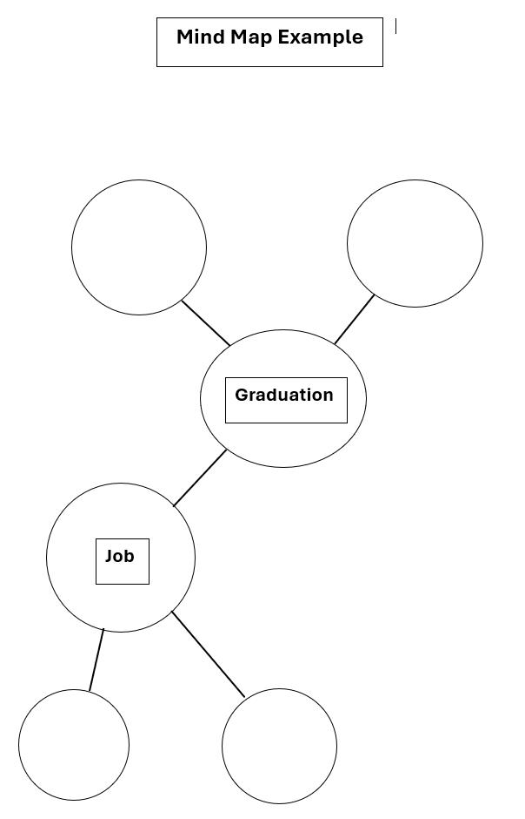
- When they have exhausted their benefits, rotate to each group and have them share out.
The Law-Related Education Academy is facilitated by the Arizona Foundation for Legal Services & Education with funding made possible by the Arizona Department of Education School Safety Program.

Truancy Understanding and Overcoming Barriers Academy
(Middle/High School)
Goal Setting Lesson Plan

Arizona State Standards Correlations

Civics
(7-12 S3C4 PO4b-c) Explain the obligations and responsibilities of citizenship: obeying the law.
(HS S3C4 PO3) Examine the basic political, social responsibilities of citizenship: analyzing public issues and policy making.

Writing:
7-12. W. 2 Write informative/explanatory texts to examine a topic and convey ideas, concepts, and information through the selection, organization, and analysis of relevant content.
6‐12. WHST.4 Produce clear and coherent writing in which the development, organization, and style are appropriate to task, purpose, and audience.

Speaking and Listening:
SL.1 Prepare for and participate effectively in a range of conversations and collaborations with diverse partners, building on others’ ideas and expressing their own clearly and persuasively.
SL.2 Integrate and evaluate information presented in diverse media and formats, including visually, quantitatively, and orally.

https://apnews.com/article/school-attendance-sick-day-chronic-absenteeism-270f6d07041760e90bf84d9f4108aa4d
https://www.azcentral.com/story/news/local/arizona/2023/12/26/arizonans-earn-more-with-college-degree/71537780007/
https://www.azcentral.com/story/news/local/arizona/2023/12/26/arizonans-earn-more-with-college-degree/71537780007/
https://www.azcentral.com/story/news/local/arizona/2023/12/26/arizonans-earn-more-with-college-degree/71537780007/
https://www.azcentral.com/story/news/local/arizona/2023/12/26/arizonans-earn-more-with-college-degree/71537780007/
Education pays, 2022 : Career Outlook: U.S. Bureau of Labor Statistics
Education pays, 2022 : Career Outlook: U.S. Bureau of Labor Statistics
https://des.az.gov/services/employment/apprenticeship-program/job-seekers#:~:text=No%20experience%20is%20required%20of,reading%20or%20related%20shop%20work

