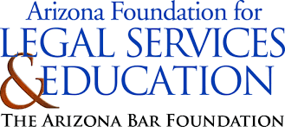
“When You Turn 18: Preparing Students for Financial Success” Academy
(High School)
Banking Teacher Questions

- List two types of bank accounts.
Answer: (Pick 2) Checking, Savings, Money market (MMA), Certificate of deposit (CD)
- Name one extra step someone can take to make mobile banking more secure.
Answer: (Pick 1) strong password, not using public WiFi, not storing login information on device
- Writing a check without having the funds to cover is illegal. This is also known as…
Answer: Bouncing a check
- “What are the legal requirements?” and “What are the fees involved?” are questions you might ask when doing what?
Answer: Opening a bank account
- I have lost my debit card. I have already reported to the bank. What should I do now?
Answer: (Pick 1) Check bank/card statement carefully, follow up via email
- True or False: If you feel your bank is doing something wrong or even illegal, you may want to contact the Consumer Financial Protection Bureau.
Answer: True

