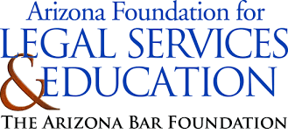
“When You Turn 18: Preparing Students for Financial Success” Academy
(High School)
Banking Expert Group Topic Cards

How to Open a Bank Account  - Steps to open a checking or savings account.  - Documents legally required (ID, proof of address).  - Legal age requirements and parental consent (if under 18). |  | Types of Bank Accounts  - Differences between checking, savings, and money market accounts.  - Features, benefits, and typical uses for each.  - Legal rights and responsibilities as a bank account holder.
Banking Fees and How to  Avoid Them  - Common fees (overdraft, ATM, maintenance).  - Ways to avoid fees (minimum balance, direct deposit).  - Understanding fee-free accounts. |  | Online and Mobile Banking  - How to set up and use online banking.  - Features like mobile check deposit, bill pay, and monitoring.  - Security tips for safe online banking.
Using Debit Cards and ATMs  - How debit cards work and where they can be used.  - ATM transactions like withdrawing cash and checking balances.  - Avoiding ATM fees and staying safe. |  | Overdraft Protection and  Responsible Spending  - What overdraft protection is and how it works.  - Risks and fees associated with overdrafts.  - Budgeting to avoid overdrawing your account.
Building and Managing Credit  - Difference between debit and credit cards.  - Basics of credit scores and how banking decisions (like loans) impact them.  - Tips for building good credit early. |  | Bank Account Safety and Fraud Prevention  - Recognizing and preventing phishing scams.  - Safeguarding personal and account information.  - Steps to take if your account is compromised.

