
The Law-Related Education Academy is facilitated by the Arizona Foundation for Legal Services & Education with funding made possible by the Arizona Department of Education School Safety Program.

“Outstanding Upstanders” Academy
(K-3)
Upstander Vocabulary Words Review Lesson Plan
Formatted for Online Learning
Officers should obtain administrator approval prior to implementing this lesson.

Objectives: Students will…
- determine the correct example of vocabulary words related to being an upstander.
- match vocabulary words with pictures.
- practice writing the vocabulary words.

Protective Factor: Academic Achievement
Social Emotional Learning Competency: Social Awareness

Materials:
- Matching Activity Sheet pg. 4
- Matching Key pg. 5
- Writing Activity Sheet pg. 6

Timeframe: 30 Minutes

Team Teaching: For effective implementation of Law Related Education (LRE), team teach with the classroom teacher by…
- Encouraging classroom teachers to participate in all activities by injecting clarification statements and relating relevant content to their curriculum. In this method, students will see more connections to their student life and be willing to carry over concepts and skills learned in LRE.
- Assigning the classroom teacher part of the lesson instructions. Team teaching with the classroom teacher enables the students to further see the importance of LRE lessons. It also provides an opportunity for the classroom teacher to demonstrate teaching skills conducive for effective teaching. Student attention can be maintained easier with different voices and personalities experienced throughout the lesson.
- Implementing LRE online with the classroom teacher will also provide support with teaching online. The teacher can help monitor chats and address raised hands and technical difficulties.
- Follow the system that teachers have in place for online learning and work in conjunction with the teacher to make sure that they have a plan in place to monitor appropriately.

Attention Grabber:
- Explain to students that they will participate in an activity to review their vocabulary words from the lessons they have been receiving on the topic of being an outstanding upstander.
- Have the students practice the following motions with you by demonstrating each one and then instructing the students to copy your motions. Hold up one arm, outstretched forward, over your head and say “ONE!” Then hold up both arms, outstretched forward, over your head and say, “TWO!” Practice this a few times with students.
- Next, read each statement below Step 4 and instruct students to choose if it is an example of a bystander by holding up one arm for #1 and saying “ONE” or is it an example of an upstander by holding up both arms for #2 and saying, “TWO!”
- If the correct answer is #2, ask a few students what they could do to be an upstander. Call on different students to respond each time. (See red text for debriefing each example.)
- You see your friend getting teased by some older girls at lunch again. It seems to start happening as soon as she sits down before you join her. You tell the teacher what is happening and tell your friend to wait in the lunch line with you and you will walk with her to the lunch table. (#1 Bystander and #2 Upstander: When teasing is repeated and meant to upset the person being teased, it is a form of bullying. Bullying is against school rules, it causes the one being bullied to feel afraid to come to school and upset with being treated meanly and should always be reported. An upstander would help report the incident or report themselves. Staying with the person being targeted so they are less likely to get bullied is another action of an upstander.)
- While riding home on the bus you see a smaller student getting teased. You look the other way and don’t say anything to anyone. (#1 Bystander and #2 Upstander: A bystander sits by and does not try to get help or take safe actions to stop the wrongdoing. An upstander could sit with the student, ask if they are okay or need help reporting it to someone, tell a parent, teacher, or bus driver, etc.)
- You see a classmate fall off the swings and start to cry, you can also see that they are bleeding at the knee. You keep playing and ignore it. (#1 Bystander and #2 Upstander: A bystander stands by and does not try to get help or take safe actions to stop the wrongdoing. An Upstander would report it to the adult on the playground, then go see if they are okay, volunteer to help the classmate to the nurse’s office, etc.)
- You saw some students taking things out of other students’ backpacks during recess. You informed the teacher, what you saw. (#1 Bystander and #2 Upstander: An upstander would report a crime to help the victim. Reports can be made anonymously, that means the adult will not say who told; stealing is against school rules and causes others to be afraid, upset that their property is gone; by reporting they may get their property back and the stealing may stop)
- The teacher allows students to choose a partner for reading time. The new student in class does not know anyone yet and no one picks her to be a partner with them. You already chose a partner but decide to ask the new student to join you and your partner too. (#1 Bystander and #2 Upstander: It takes a while for new students to make friends, partnering with her is a great way to get to know her better)

Problem-Solving and Application Activities:
- Display the Matching Activity Sheet pg. 4 on your screen. Explain how to match the words in the center with the examples on the side. Choose either option #1 or #2.
Option 1:
- Provide the link for parents to print.
- Instruct students to work independently for 7 minutes.
- Call on volunteers to share one answer.

Option #2:
- Display the Matching Activity sheet on your screen, read the first word in the center list, then indicate two different choices from the examples on the side, reading the captions too.
- Refer to the choices as #1 or #2 with one of those choices being the correct choice.
- Instruct students to use the same motions from Step 3 to indicate their choice.
- Reveal the correct response by drawing a line from the word to the correct example. See Matching Key pg. 5

- Next, display the Writing Activity Sheet pg. 6 on your screen. Explain how to trace the letters and then write the word on their own next to the traced letters.
- Provide the link for parents to download. Students can work independently for 5 minutes, or students may copy the words on their own paper or word document. (Students who are able, may want to also use the words in a sentence. Call on students to share their sentences.)
- Next, instruct students to think of a way they could be an upstander. Call on volunteers to share with the class.

Lesson Closure:
- Ask students to show on their faces the way they may feel if someone acts in an upstanding way towards them. Students may also draw a face expressing the emotion and sharing the picture on screen.

The Law-Related Education Academy is facilitated by the Arizona Foundation for Legal Services & Education with funding made possible by the Arizona Department of Education School Safety Program.

“Outstanding Upstanders” Academy
(K-3)
Upstander Vocabulary Words Review
Matching Activity Sheet
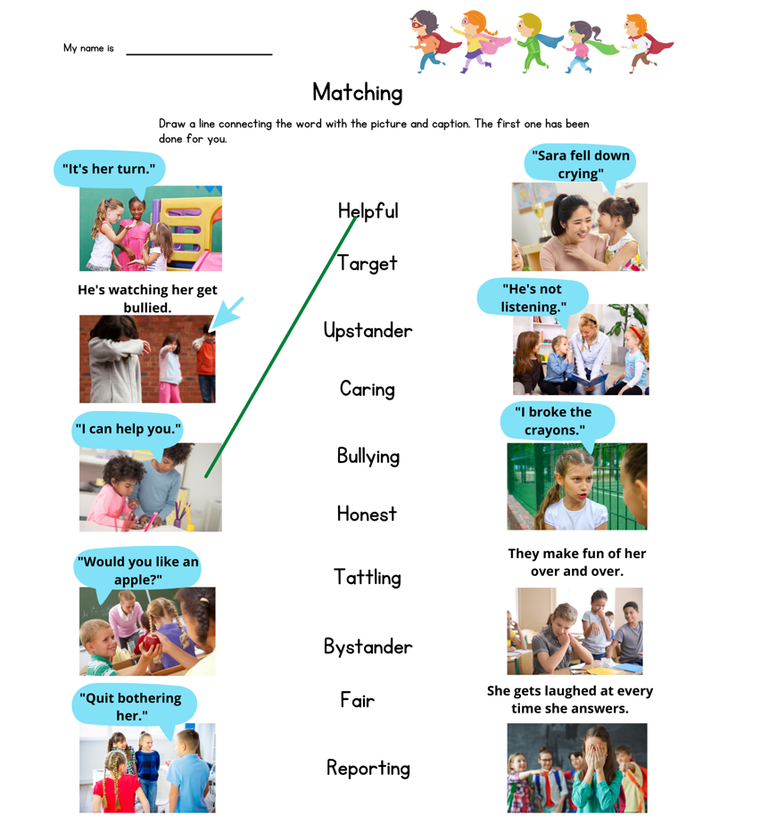
The Law-Related Education Academy is facilitated by the Arizona Foundation for Legal Services & Education with funding made possible by the Arizona Department of Education School Safety Program.

“Outstanding Upstanders” Academy
(K-3)
Upstander Vocabulary Words Review
Matching Key
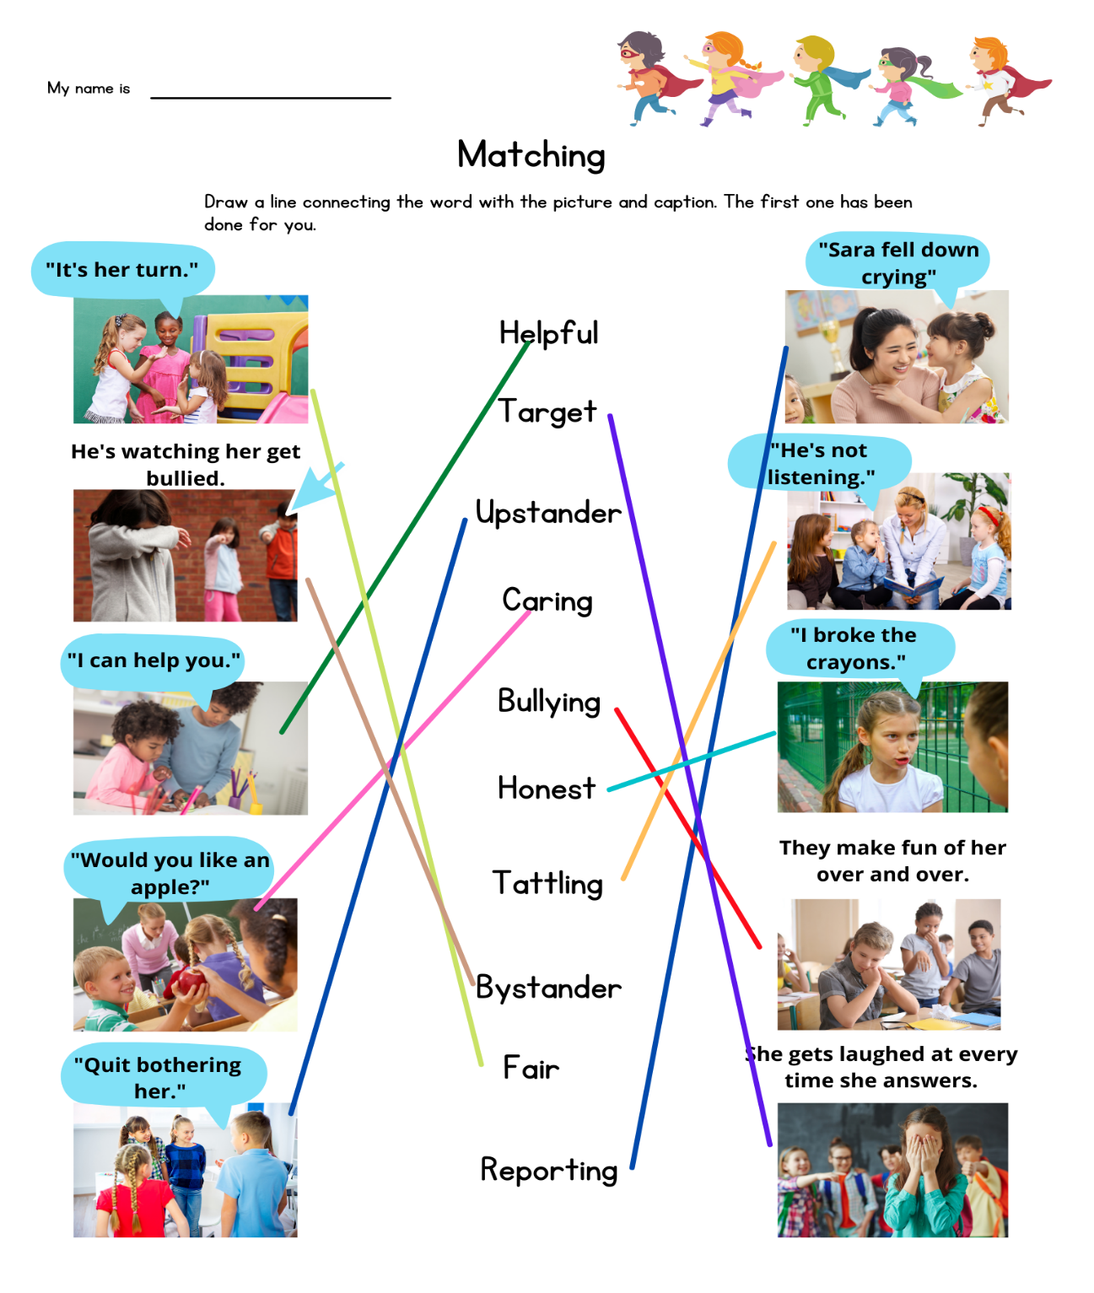
The Law-Related Education Academy is facilitated by the Arizona Foundation for Legal Services & Education with funding made possible by the Arizona Department of Education School Safety Program.

“Outstanding Upstanders” Academy
(K-3)
Upstander Vocabulary Words Review
Writing Activity Sheet
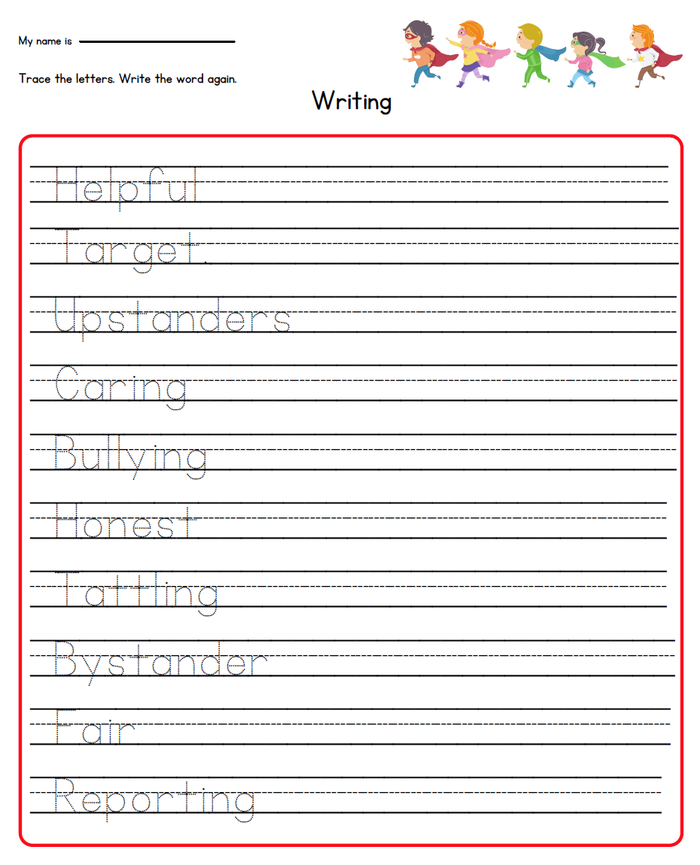
The Law-Related Education Academy is facilitated by the Arizona Foundation for Legal Services & Education with funding made possible by the Arizona Department of Education School Safety Program.

“Outstanding Upstanders” Academy
(K-3)
Upstander Vocabulary Words Review
Correlations

Social Studies/Civics Anchor Standards
- C2: Citizens have individual rights, roles, and responsibilities.
- C4: Process, rules, and laws direct how individuals are governed and how society addresses problems.

Health Concept 2: Self Protection and Dealing with Conflict
- PreK-2 PO 1. Demonstrate ways to respond when in an unwanted, threatening, or dangerous situation
- 3-5 PO 1. Demonstrate nonviolent strategies to manage or resolve conflict

Health Concept 3: Asking for Help
- PreK-2 PO 1. Demonstrate ways to tell a trusted adult if threatened or harmed
- 3-5 PO 1. Demonstrate how to ask for assistance to enhance personal health

ELA
- SL.1 Participate in collaborative conversations with diverse partners about kindergarten topics and texts with peers and adults in small and larger groups. a. Follow agreed-upon rules for discussions (e.g., listening to others, taking turns speaking about the topics and texts under discussion). b. Continue a conversation through multiple exchanges.
- SL.2 Confirm understanding of a text read aloud or information presented orally or through other media by asking and answering questions about key details and requesting clarification if something is not understood.
- L.6 Use words and phrases acquired through conversations, reading, and being read to, and responding to texts.
- W.8 With guidance and support from adults, recall information from experiences or gather information from provided sources to answer a question.
- RI.1 With prompting and support, ask and answer questions about key details in a text.

