
The Law-Related Education Academy is facilitated by the Arizona Foundation for Legal Services & Education with funding made possible by the Arizona Department of Education School Safety Program.

“Connecting LRE to Multiple Classroom Subjects” Academy
(Middle/High)
Shoeprint Analysis Lesson Plan
Officers should obtain administrator approval prior to implementing this lesson.

Objectives: Students will…
- understand the difference between a shoeprint and a shoe impression.
- learn how shoeprints relate to forensic science.
- collaborate with peers to analyze a shoeprint.

Class Subjects: Science, Civics, Government, and Social Studies (See pg. 8 for correlations)
Protective Factors: Critical Reasoning Skills
Social Emotional Competencies: Relationship Skills

Materials:
- Large poster paper and markers for each group
- Shoeprint Analysis Activity Sheet see pg. 3-1 per group
- Shoeprints for each group see pgs. 4-7 For more prints see:
https://www.google.com/search?q=shoe+prints+to+analyze&tbm=isch&chips=q:shoe+prints+to+analyze,online_chips:impression:zTQmqnpP1ig%3D&rlz=1C1CHBF_enUS786US786&hl=en&sa=X&ved=2ahUKEwibpOSCv-vyAhWSkZ4KHfspCEkQ4lYoAXoECAEQFA&biw=805&bih=393
- Student personal journals

Timeframe: 50 Minutes

Team Teaching: For effective implementation of Law Related Education (LRE), team teach with the classroom teacher by…
- Having both the officer and teacher rotate among students and to different groups. Both instructors will provide positive feedback and engage in friendly conversations with students. This procedure will help reduce classroom disruptions, increase student engagement, and build supportive relationships with students.
- Encouraging classroom teachers to participate in all activities by injecting clarification statements by relating relevant content to their curriculum. In this method, students will see more connections to their student life and be willing to carry over concepts and skills learned in LRE.
- Assigning the classroom teacher part of the lesson instructions. Team teaching with the classroom teacher enables the students to further see the importance of LRE lessons. It also provides opportunity for the classroom teacher to demonstrate teaching skills conducive for effective teaching. Student attention can be maintained easier with different voices and personalities experienced throughout the lesson.

Attention Grabber:
- Begin the activity by placing the students into small groups of 4 or 5 students in each. Supply each group with large poster paper and markers.
- Instruct students to discuss with their group what they think the difference between a “Shoeprint” and a “Shoe Impression” is.
- Ask volunteers to share a response. (Answer: Impression is 3-dimensional/print-2-dimensional)
- Next, instruct students to discuss with their group what they think can be learned from a shoe impression or print.
- Ask different volunteers to share a response. (Answers: speed, type of shoe, weight, gait, etc.)
- Next, explain the difference between individual and general characteristics of a shoeprint.
Individual Characteristics: size, trend, wear pattern, abnormalities, specific to a person.
General Characteristics: make/model, brand, material

Problem-Solving and Application Activities:
- Share the following pretend crime: “Students, there was a break-in and vandalism in the school gym over the weekend. Footprints were found at the back door and the lock on the door was broken. The police need your help with identifying the possible shoes making the footprint.”
- Ask the class what possible crimes were committed in this pretend crime. Allow students to call out ideas. Share the following:
- 13-1506. Burglary in the third degree; classification
- 13-1602. Criminal damage; classification
Consequences: Charged with a misdemeanor or felony depending on the amount of damage. Possible court costs, probation, detention, and fines. See: https://lawforkids.org/vandalism
- Inform students that they will collaborate with their group to analyze footprints and find the matching shoe.
- But first ask the students to call out behaviors their group will need to work effectively together. Record ideas on the class board.
Possible Responses: listen to each other, take turns speaking, validate reasonable ideas from each other, even if you disagree, encourage everyone to contribute with positive words, etc.
- Provide each group with a Shoeprint Analysis Activity sheet (see pg. 3) briefly review then provide each group a different Shoeprint (see pgs. 4-7). Groups should choose a recorder and a reporter.
- The teacher and you should move around to each group, checking for understanding and providing supportive feedback. Call on each group to present their findings.
- Next, instruct groups to discuss how shoeprint analysis may aid investigators with solving crimes. Call on each group to share an idea.

Lesson Closure:
- Ask students to reflect on how their group collaborated to analyze their shoeprint.
- Instruct the students to write a reflection in their personal journal on what went well and what needed improvement with the group’s collaboration.
- Call on volunteers to share one action their group exhibited that allowed for a positive group interaction.
- Ask the class to comment, either in their journal or publicly, how forensic teams may benefit from collaboration with their peers to solve crimes.
The Law-Related Education Academy is facilitated by the Arizona Foundation for Legal Services & Education with funding made possible by the Arizona Department of Education School Safety Program.

“Connecting LRE to Multiple Classroom Subjects” Academy
(Middle/High)
Shoeprint Analysis Lesson Plan
Shoeprint Analysis Activity Sheet
Individual Characteristics:
- Measurements:
What is the length of the shoe?
What is the width of the shoe?
What is the estimated height of the person wearing this shoe? (Multiply the length by 7)

- Condition - New, worn, damaged?

- Distinctive Identifiers – cuts, nicks, wear patterns.

General Characteristics:
- What style of shoe do you think it is?- athletic shoe, work boot, dress shoe (men’s vs. women’s)

- Describe the shoe’s tread pattern(s)- direction of ridge line, circular, rectangular, significant shapes.

- General Observations – can this shoe easily be identified? Why or why not?

What questions do you still have that could not be answered by the shoeprint?

Speculate your conclusion:

The Law-Related Education Academy is facilitated by the Arizona Foundation for Legal Services & Education with funding made possible by the Arizona Department of Education School Safety Program.

“Connecting LRE to Multiple Classroom Subjects” Academy
(Middle/High)
Shoeprint Analysis Lesson Plan
Shoeprints
Group 1:
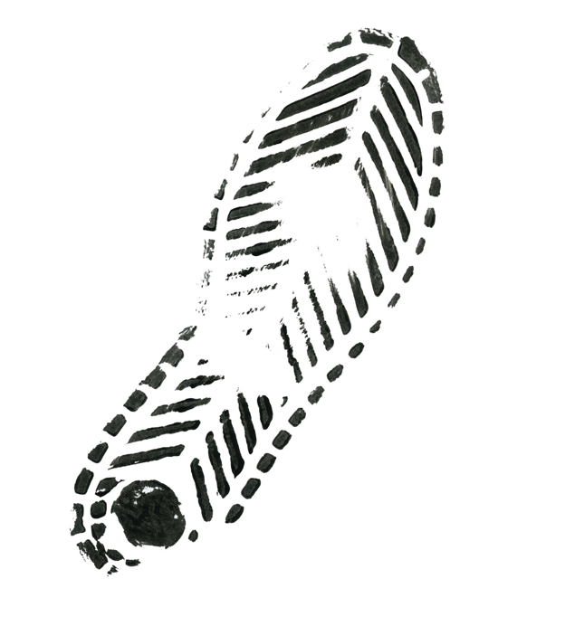
12 x 4 inches
The Law-Related Education Academy is facilitated by the Arizona Foundation for Legal Services & Education with funding made possible by the Arizona Department of Education School Safety Program.

“Connecting LRE to Multiple Classroom Subjects” Academy
(Middle/High)
Shoeprint Analysis Lesson Plan
Shoeprints
Group 2:
11 x 4 inches
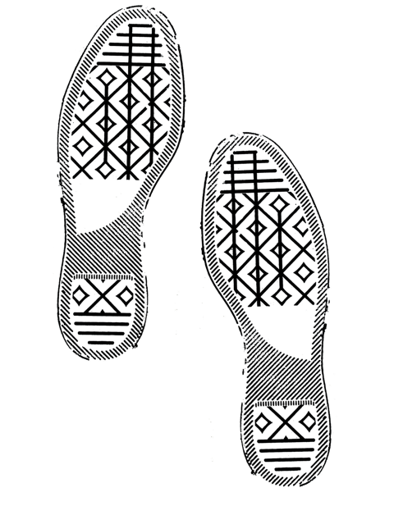
The Law-Related Education Academy is facilitated by the Arizona Foundation for Legal Services & Education with funding made possible by the Arizona Department of Education School Safety Program.

“Connecting LRE to Multiple Classroom Subjects” Academy
(Middle/High)
Shoeprint Analysis Lesson Plan
Shoeprints
10 x 4 inches
Group 3:
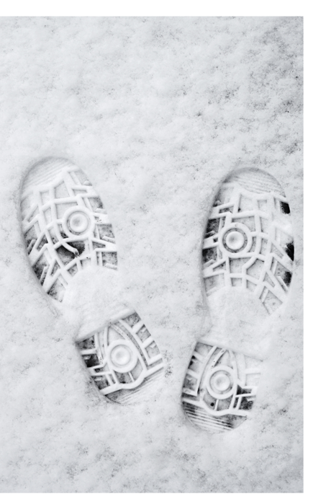
The Law-Related Education Academy is facilitated by the Arizona Foundation for Legal Services & Education with funding made possible by the Arizona Department of Education School Safety Program.

“Connecting LRE to Multiple Classroom Subjects” Academy
(Middle/High)
Shoeprint Analysis Lesson Plan
Shoeprints
9 x 3.5 inches
Group 4:
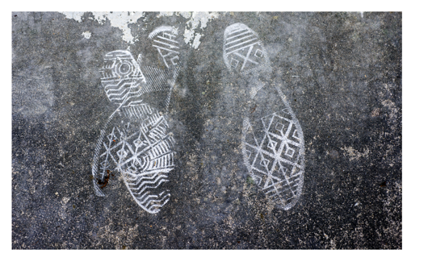

The Law-Related Education Academy is facilitated by the Arizona Foundation for Legal Services & Education with funding made possible by the Arizona Department of Education School Safety Program.

“Connecting LRE to Multiple Classroom Subjects” Academy
(Middle/High)
Shoeprint Analysis Lesson Plan
Correlations
Civics:
Civic virtues and democratic principles are key components of the American political system.
C4: Process, rules, and laws direct how individuals are governed and how society addresses problems.
Citizens have individual rights, roles, and responsibilities
HS.C2.4 Analyze the responsibilities of citizens
Process, rules, and laws direct how individuals are governed and how society addresses problems.
HS.C4.6 Assess options for action to address local, regional, and global problems by engaging in self- reflection, strategy identification, and Arizona History and Social Science Standards modified 8/23/19 Page 51
complex causal reasoning.

Core Ideas for Using Science: (8-12 Grades)
U1: Scientists explain phenomena using evidence obtained from observations and or scientific investigations. Evidence may lead to developing models and or theories to make sense of phenomena. As new evidence is discovered, models and theories can be revised.
U2: The knowledge produced by science is used in engineering and technologies to solve problems and/or create products. U3: Applications of science often have both positive and negative ethical, social, economic, and/or political implications.

Appendix 2: Science and Engineering Practices The science and engineering practices describe how scientists investigate and build models and theories of the natural world or how engineers design and build systems. They reflect science and engineering as they are practiced and experienced. As students conduct investigations, they engage in multiple practices as they gather information to solve problems, answer their questions, reason about how the data provide evidence to support their understanding and then communicate their understanding of phenomena. Student investigations may be observational, experimental, use models or simulations, or use data from other sources. These eight practices identified in Chapter 4 of A Framework for K-12 Science Education4 are critical components of scientific literacy. They are not instructional strategies.

https://www.azed.gov/sites/default/files/2018/10/6-8_Updated_10_19_19.pdf?id=5bd338b81dcb250184c8cefc

