
The Law-Related Education Academy is facilitated by the Arizona Foundation for Legal Services & Education with funding made possible by the Arizona Department of Education School Safety Program.

“Connecting LRE to Multiple Classroom Subjects” Academy
(Middle/High)
Forensic Sketch Artist Lesson Plan
Formatted for Online Learning
Officers should obtain administrator approval prior to implementing this lesson and MUST speak with their administration/teacher to discuss whether breakout room formats are appropriate or not.

Objectives: Students will…
- understand the important role of a witness.
- learn questions to ask an eyewitness of a crime in order to compose a sketch.
- collaborate to shape an artistic investigation for a composite drawing.

Class Subjects: Visual Arts, Government, and Social Studies (See pg. 5 for correlations)
Protective Factors: Decision-Making Skills
Social Emotional Competency: Relationship Skills

Materials:
- Whiteboard or other online drawing program
- Timer
- Shared Word Document
- L3 Example Picture
- Suspect Picture (see pg. 5)
- Student personal Reflection Journals and writing implement, drawing paper and tools

Timeframe: 50 Minutes

Team Teaching: For effective implementation of Law Related Education (LRE), team teach with the classroom teacher by…
- Encouraging classroom teachers to participate in all activities by injecting clarification statements and relating relevant content to their curriculum. In this method, students will see more connections to their student life and be willing to carry over concepts and skills learned in LRE.
- Assigning the classroom teacher part of the lesson instructions. Team teaching with the classroom teacher enables the students to further see the importance of LRE lessons. It also provides an opportunity for the classroom teacher to demonstrate teaching skills conducive for effective teaching. Student attention can be maintained easier with different voices and personalities experienced throughout the lesson.
- Following the system that teachers have in place for online learning and work in conjunction with the teacher to make sure ensure breakout rooms and chats are monitored appropriately.

Attention Grabber:
- Introduce the lesson topic and ask students to enter in the chat box or call out what they know about Forensic Sketch or Composite Artist. Share the following information: “Forensic sketch artists work with police to interview victims or witnesses of crimes in order to recreate a semi-realistic drawing that reflects the image of the perpetrator to the best of the witness’s memory.”
- Inform the class that they are going to briefly see a person on screen. Then they are to write down everything they can remember about what they saw.
- Display the L3 Example Picture (see pg. 4) for 30 seconds then remove it and instruct the class to write down everything they remember on their own paper. Give the class 1 minute.
- Then display the picture again and instruct the class to check off all the items they remembered correctly.
- Ask the class what was challenging about the exercise and enter their comments in the chat box or say aloud.
- Ask the class what was the easiest features to remember and what was the most difficult? Allow for the class to openly comment and describe their experience.

Problem-Solving and Application Activities:
- Inform students that they will have an opportunity to practice their forensic composite sketching skills. Instruct students to imagine they are interviewing an eyewitness to obtain a description of a suspect involved in a crime.
- Display a Shared word document and instruct students to add at least one question that should be asked of an eyewitness to a suspect. Inform students that if someone else already listed a question they were thinking of, to place a mark on that question. For this activity, we will only focus on the suspect’s head.
Possible Responses: M/F, age, who do they look like, shape and color of face, hair style and color, shape and color of eyes, shape of nose, shape of lips, make-up, face/ear jewelry, tattoos, scars, uneven features, shape and color of eyebrows, shape of chin, dimples, acne, shape of neck, shape, and color of teeth, etc.
- Inform students that they will be placed in breakout rooms with a group for 15 minutes. One will be the eyewitness and the other 3 will be the sketch artists.
- Inform the artist to have paper and drawing tools ready. Their eyewitness will describe the suspect to them as they sketch and ask questions. The artists may show their sketch to the eyewitness to gain additional feedback and make adjustments.
- Send the sketch artist to their breakout rooms now and instruct them to wait a few minutes for their eyewitness, but to be collaborating on the questions they may want to ask.
- Now, display the Suspect Picture (see pg. 5) on your screen, only to the eyewitnesses, for 1 minute. Before sending the eyewitness to the breakout room, inform them that they will slowly describe the suspect to their artists, pausing to allow the artists to draw and ask more questions. Their artists will show them their sketches to make adjustments. The eyewitnesses are to choose the sketch that comes the closest to their memory of the suspect.
- When the time is up, bring the groups back to the main room. Instruct the artists that were chosen in the breakout rooms to reveal their sketch by holding it up to the camera.
- Share the Suspect Picture on screen and instruct the class to vote on the sketch that is the closest to the picture, by sending the assigned number in a private chat to you. Ask if anyone thinks they may have come closer than the one in their group chosen. They can also hold up their sketch for vote.
- Reveal the winner. Then ask the winner and their eyewitness to share what factors played into the sketch coming the closest to the actual picture.
If Breakout Rooms are Not Available:
- Instruct everyone to turn off their cameras.
- Choose a volunteer to be the eyewitness and think of a famous person they know or cartoon character.
- Next, have the eyewitness call out the description of that person or character, without giving any information other than what their face looks like.
- Instruct the class to compose a sketch. They may ask clarifying questions.
- Set a timer for 15 minutes.
- When the time is up, call for students to reveal their drawing in groups. Instruct the eyewitness to choose the closest depiction from each group.
- Instruct the class to turn their cameras back on and reveal the person chosen as the suspect.
- Instruct the class to choose the overall closest depiction by entering the number of their choice in a private chat to you. Reveal the results.
- Next, ask the class to comment on how being a good witness can help the safety of the school, ensure the wrong person doesn’t get blamed,
- Share the following statute:
13-2907.01. False reporting to law enforcement agencies; classification
A. It is unlawful for a person to knowingly make to a law enforcement agency of either this state or a political subdivision of this state a false, fraudulent, or unfounded report or statement or to knowingly misrepresent a fact for the purpose of interfering with the orderly operation of a law enforcement agency or misleading a peace officer.
B. Violation of this section is a class 1 misdemeanor.
- Ask the class to call out, tips for being a good eyewitness for police.
Possible Responses: be honest, tell what you saw or heard not what you think, try to report as soon as possible, or write it down while the memory is fresh, avoid withholding information, pay attention to your surroundings, avoid being overly distracted, etc.

Lesson Closure:
- Instruct students to write a reflection in their journal on the importance of being an accurate eyewitness to solving crimes and helping to keep your community safe for all.
- Call on volunteers to report out their comments.

Optional Videos:
Should I Become a Police Sketch Artist?
https://study.com/articles/How_to_Become_a_Police_Sketch_Artist_Career_Roadmap.html.
- Police Sketches: How sketch Artists make Composite Drawings
https://www.youtube.com/watch?v=2X4Lubyqb2M
The Law-Related Education Academy is facilitated by the Arizona Foundation for Legal Services & Education with funding made possible by the Arizona Department of Education School Safety Program.

“Connecting LRE to Multiple Classroom Subjects” Academy
(Middle/High)
Forensic Sketch Artist Lesson Plan
Example Picture
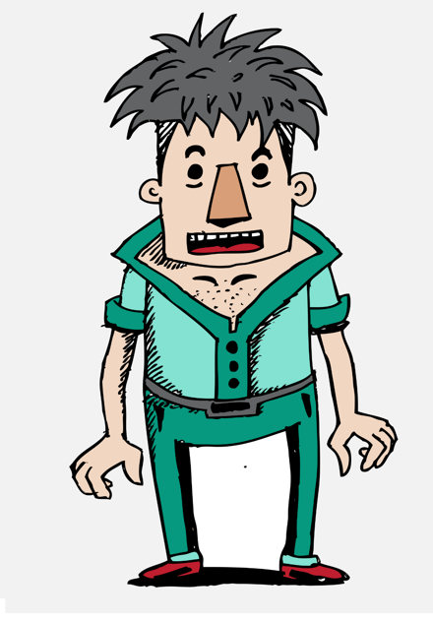
The Law-Related Education Academy is facilitated by the Arizona Foundation for Legal Services & Education with funding made possible by the Arizona Department of Education School Safety Program.

“Connecting LRE to Multiple Classroom Subjects” Academy
(Middle/High)
Forensic Sketch Artist Lesson Plan
Suspect Picture
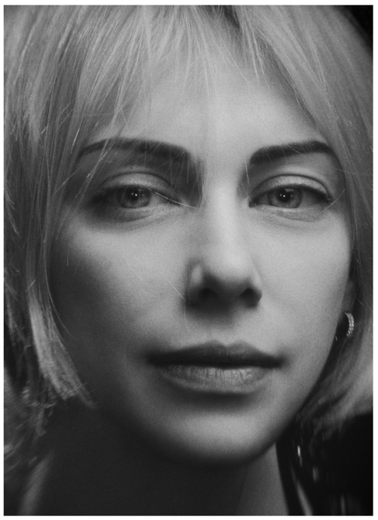
The Law-Related Education Academy is facilitated by the Arizona Foundation for Legal Services & Education with funding made possible by the Arizona Department of Education School Safety Program.

“Connecting LRE to Multiple Classroom Subjects” Academy
(Middle/High)
Forensic Sketch Artist Lesson Plan
Correlations

Civics:
Civic virtues and democratic principles are key components of the American political system
8.C1.2 Demonstrate civic virtues that contribute to the common good and democratic principles within a variety of deliberative processes and settings.
8.C1.3 Analyze the influence of personal interests and perspectives when people address issues and problems in government and civil society.
Citizens have individual rights, roles, and responsibilities
8.C2.2 Explain specific roles, rights, and responsibilities of people in a society.
HS.C2.1 Explain the importance of individual participation in civic and political institutions.
HS.C2.4 Analyze the responsibilities of citizens.

Visual Arts:
Anchor Standard 1-Generate and conceptualize artistic ideas and work
CR.1.8 b. Collaboratively shape an artistic investigation of an aspect of present-day life using contemporary practices of art and design.
VA.CR.1.HS3a. Visualize and hypothesize to generate plans for creating art or design that explores social issues.
VA.CR.1.HS1b. Shape an artistic investigation of an aspect of present-day life using contemporary practices of
art or design.
Anchor Standard #10 - Synthesize and relate knowledge and personal experiences to make art
VA.CN.10.HS2 Utilize inquiry methods of observation, research, and experimentation to explore community concerns through artmaking.
Anchor Standard 11-Relate artistic ideas and works with societal, cultural, and historical context to deepen understanding
MA.CN.11.8a Demonstrate and explain how media artworks and ideas relate to various purposes, values,
cultures, and contexts (such as democracy, environment, and connecting people and places)

https://www.crimemuseum.org/crime-library/forensic-investigation/forensic-sketch-artist/

