
2026 Arizona Law Day
How has the United States Changed from 1776 to Today? Lesson
Facilitator Guide
1776 Today
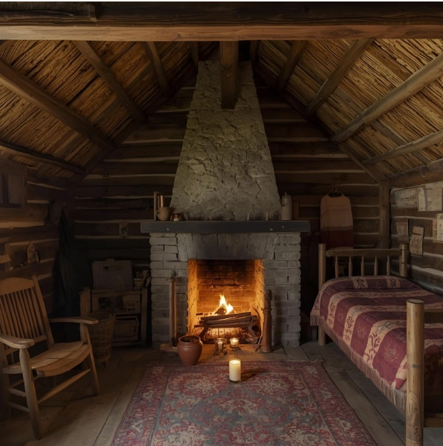  Homes were made of wood or logs and usually had one room. There was no electricity or running water, so people used candles for light and got their water from a well. |   Homes are made of bricks, wood, or concrete and usually have more than one room. There’s electricity for lights, heating, and cooling.
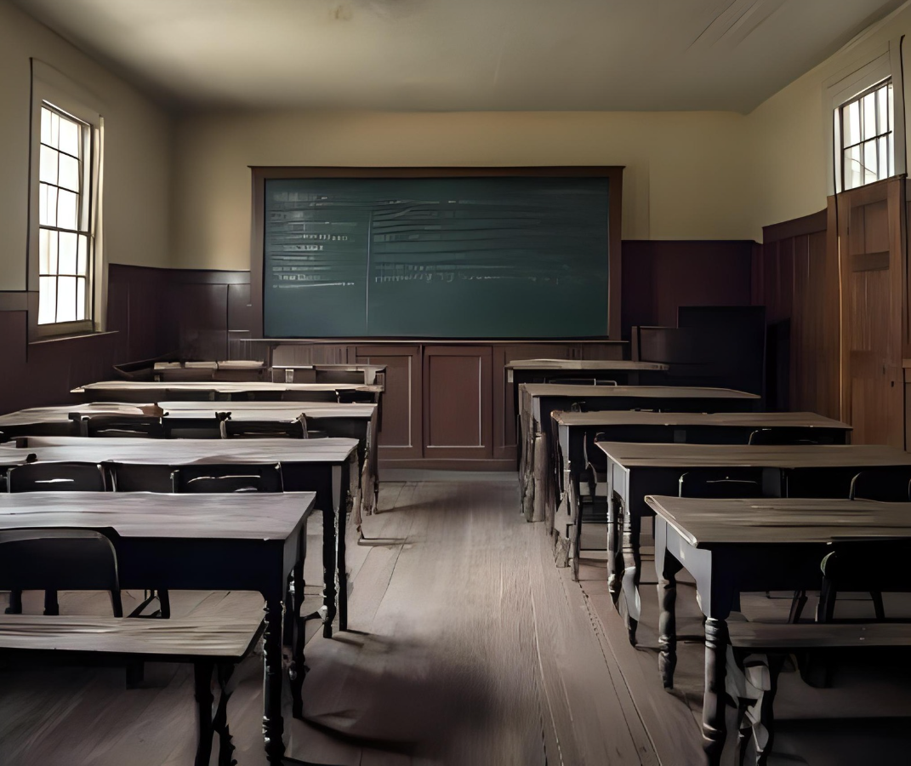  Students learned in one small room with students of all ages. One teacher taught all the students, and they used slates (little chalkboards) instead of notebooks. |   Students learn in many rooms with students of the same age. Many schools use technology daily, and some students even learn from home on the internet.
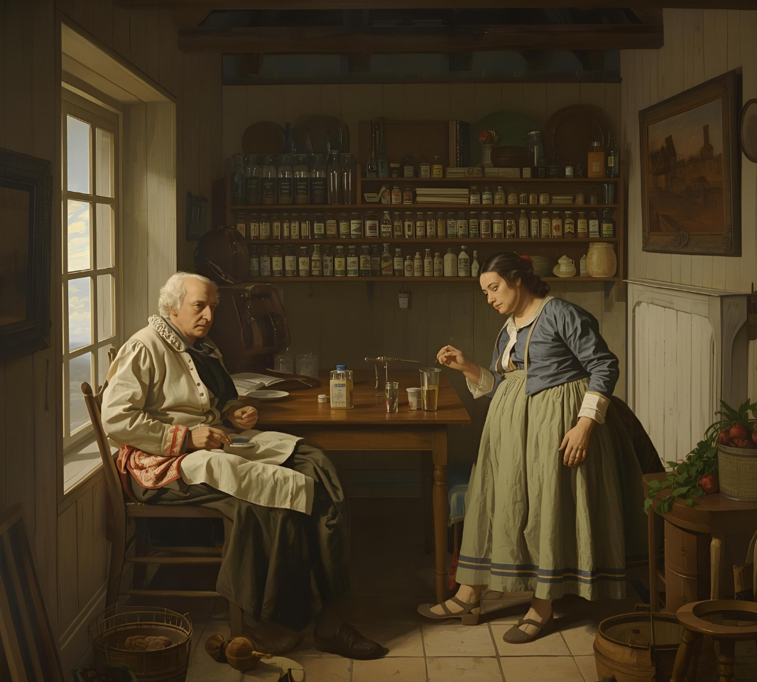  Doctors used plants and herbs to treat people. Many people made their own remedies at home. |   There are doctors, hospitals, vaccines, and many kinds of medicine to treat illnesses.
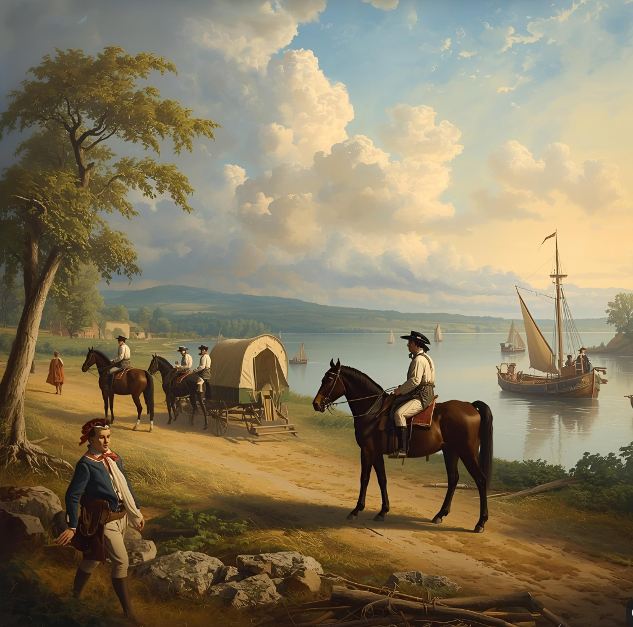  People got around by walking, riding horses, or using horse-drawn wagons. Boats and ferries were used to cross rivers and lakes. | 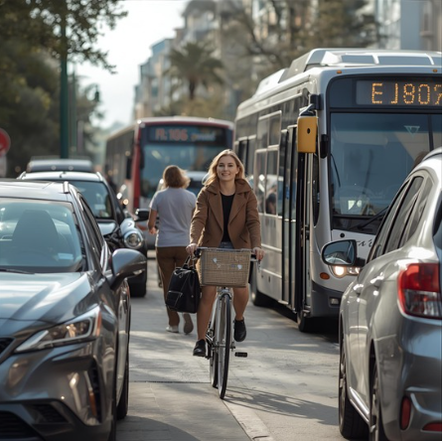  People get around by walking or using cars, buses, trains, bicycles, scooters, and airplanes.
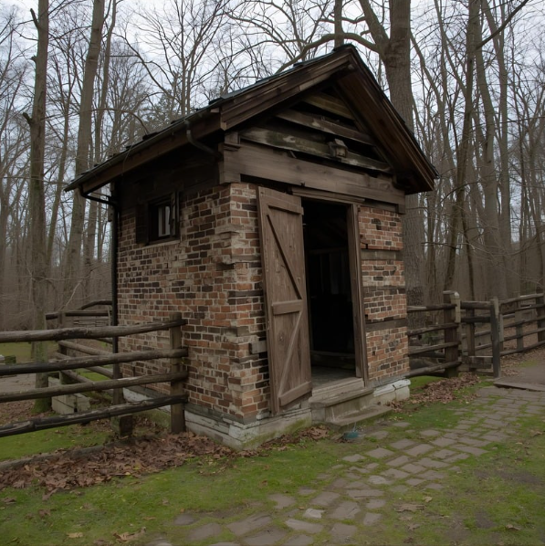  Bathrooms were in a separate building called the outhouse. There were no toilets or sinks. Baths were rare, a sponge, bowl and pitcher of water were used to wash up. | 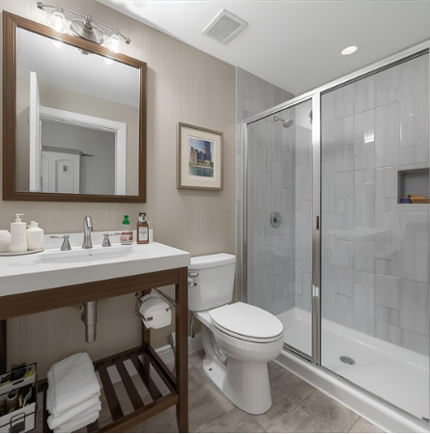  Bathrooms are inside our homes and have toilets, sinks, and showers. There is clean running water to wash hands, brush teeth, and take regular baths or showers to stay clean.
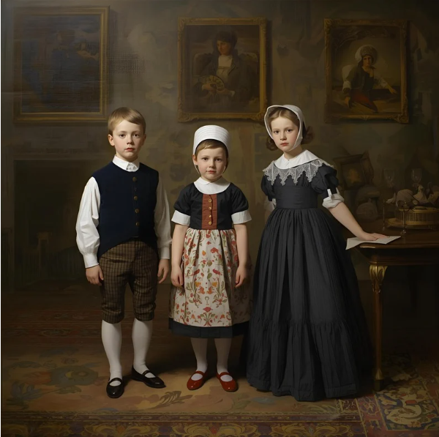  Boys wore a cotton shirt, vest, stockings and knee-length pants called breeches. Girls wore long dresses, aprons, and bonnets. |   Boys and girls have many options for clothes. People choose what to wear based on comfort, weather, and personal style.
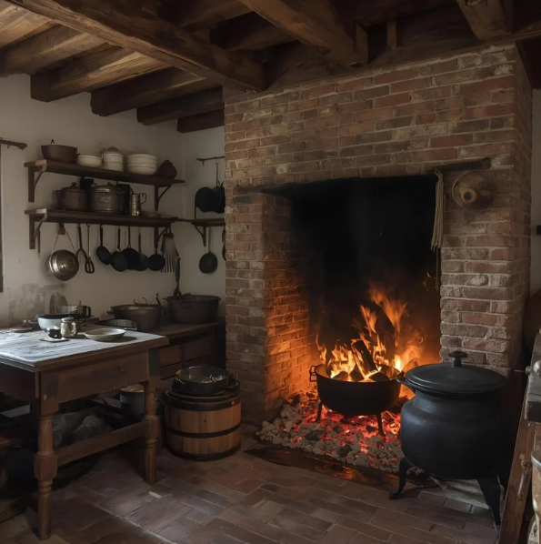  There were no stoves, refrigerators, or microwaves. People cooked over a big fire in the fireplace. |   Kitchens have stoves, ovens, refrigerators, and microwaves to make cooking faster and easier.
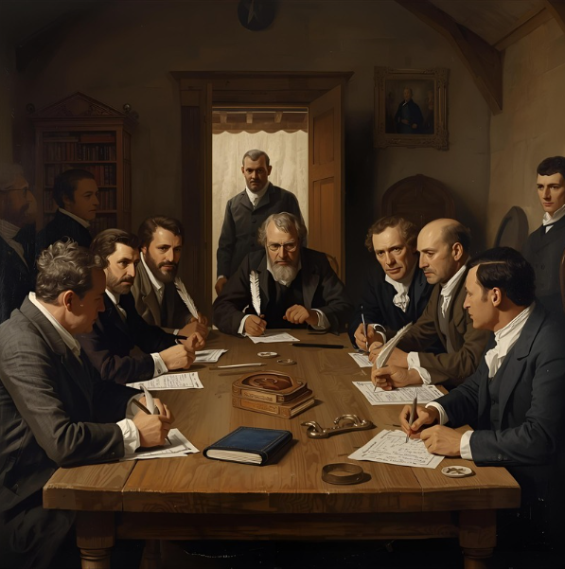  White men who owned land were allowed to vote. They voted in town meetings using quill pens and ink or sometimes by raising their hands. | 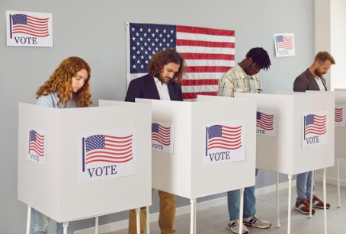  American citizens over 18 years old vote by filling out paper or electronic ballots.

https://www.ducksters.com/history/american_revolution/daily_life_during_the_revolutionary_war.php
https://www.ducksters.com/history/colonial_america/

