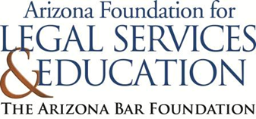

The Law-Related Education Academy is sponsored by the Arizona Foundation for Legal Services & Education with funding made possible by the Arizona Supreme Court and the Arizona Department of Education.

Scramble Activity

Jobs of the President or National Government | Jobs of the  State Government
      Oversee the U.S. Army and U.S Navy |   Oversee the Arizona National Guard
  Negotiate agreements with foreign countries |   Decide what is taught in public schools, and who can teach
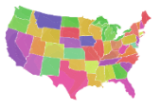  Make laws that affect all states |   Make laws that just affect Arizona
  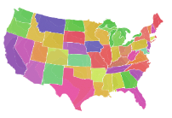  Give consequences to criminals who commit crimes that affect more than one state |     Give consequences to criminals who commit crimes that only affect people in Arizona
    Maintain and build interstate highways, or roads that go across multiple states |     Maintain and build roads that just go around Arizona

