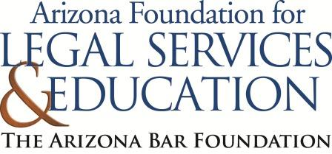
The Law-Related Education Academy is facilitated by the Arizona Foundation for Legal Services & Education with funding made possible by the Arizona Department of Education School Safety Program.

Preventing Dangerous Situations in School Academy
(Middle/High School)
When to Report? Lesson Plan
Please obtain administrator approval prior to implementing this lesson.

Objectives:
- Students should be able to understand their role in helping prevent school shootings.
- Students should learn the steps to take if they are aware of a threat to the school community.
- Help students identify when reporting is necessary.
- Help students identify who to report to.

Protective Factor Developed: Decision making skills

Materials:
- Signs “report” and “ignore”, one of each
- 4 social media posts, 1 set per group
- Poster paper, 1 per group
- Sticky notes, 1 per student

Timeframe: 50 Minutes

Team Teaching: For effective implementation of Law Related Education (LRE), team teach with the classroom teacher by…
- Having both the officer and teacher rotate among students and to different groups. Both instructors will provide positive feedback and engage in friendly conversations with students. This procedure will help reduce classroom disruptions, increase student engagement, and build supportive relationships with students.
- Encouraging classroom teachers to participate in all activities by injecting clarification statements by relating relevant content to their curriculum. In this method, students will see more connections to their student life and be willing to carry over concepts and skills learned in LRE.
- Assigning the classroom teacher part of the lesson instructions. Team teaching with the classroom teacher enables the students to further see the importance of LRE lessons. It also provides an opportunity for the classroom teacher to demonstrate teaching skills conducive for effective teaching. Student attention can be maintained more easily with different voices and personalities experienced throughout the lesson.

Lesson:
- Place students into small groups with 3-4 students in each.
- Ask half of the groups to brainstorm what the goal of telling on someone is. Ask the other half of the groups to brainstorm what the goal of reporting is.
- Ask each group to share their ideas. If they do not reach the correct answer, provide it for them and write it on the board:
  - The goal of telling on someone is to get them in trouble
  - The goal of reporting is to prevent someone from getting hurt
- Explain to students that they will participate in a continuum. On one side of the room display a sign with the word “report” and on the other side “ignore”. Read different short scenarios and students will move in the continuum indicating if that is a behavior that needs to be reported or ignored, and have different students explain their reasoning for where they are standing after each situation is read.
- Alexis lies to her teacher and uses the bathroom pass to go visit her friends that are in their lunch hour.
- Alora gets her cell phone taken away. After class she says “I hate that teacher. Maybe I should find her on the weekend and show her how much I hate her.”
- Liam is tired of everyone making fun of him. He posted on social media that everyone will pay for making him feel like nothing and he has a hit list.
- You see one of your peers has a weapon in their backpack at school.
- Have students return to their small groups. Discuss with the class that the scenarios give perspective of the importance of reporting when someone could get hurt. Ask the students to talk within their group and discuss what could be the consequences of not reporting situations where someone could get hurt.
- Have each group share out what they discussed. Possible answers: could save lives, prevent a dangerous situation from occurring, or people that need help could get it.
- Explain that each group will receive 4 social media posts. Groups will discuss the following questions:
- Could someone get hurt?
- Can you tell if the person is telling the truth in the post?
- Does the post need to be reported?
- What could happen if the post was not reported?
- After groups have considered as many social media posts as time will allow, ask groups to share out their responses with the class. (Refer to facilitator guide) Correct or add to their responses as needed.
- Explain that they have reviewed different situations regarding when and why it is important to report. Now, we will brainstorm who to report to.
- Each group will draw a poster size person on their poster paper. Everyone in the group will write different words on the “person” that describes a trustworthy adult. Possible answers: good listener, they show they care, show interest, make you feel safe, someone who makes you feel respected, etc.
- Each group will share their poster with the class.
- Explain that there are different people in our lives that hold those characteristics that make them trustworthy adults and sometimes those people are: their parents, their SRO, their coaches, school counselors, principals, or school staff.
- Explain that after discussing different situations in which reporting is necessary and describing a trustworthy adult, the steps needed to be taken are the following:
- Go to your trustworthy adult.
- Explain to them that you have something very important to talk to them about and let them know your concerns. If there are written examples such as a social media post, show those.
- If your trusted adult takes the situation seriously, they will take the necessary steps to ensure everyone is safe.
- If your trusted adult chooses not to take action (sometimes this happens), go to your next trusted adult and try again.
- Regardless of the outcome, you can ensure that you have done the right thing by informing an adult to ensure you and your peers are safe. Even if the situation does not escalate, you did the right thing by reporting it, and let the situation get investigated to determine what is the best way to keep everyone safe. Debrief the lesson by having each student write on a sticky note how reporting can prevent dangerous situations. Students can volunteer to share or keep to themselves. Have them turn in their sticky note as they leave the classroom.

The Law-Related Education Academy is facilitated by the Arizona Foundation for Legal Services & Education with funding made possible by the Arizona Department of Education School Safety Program.

Preventing Dangerous Situations in School Academy
(Middle/High School)
When to Report? Lesson Plan

Facilitator Guide
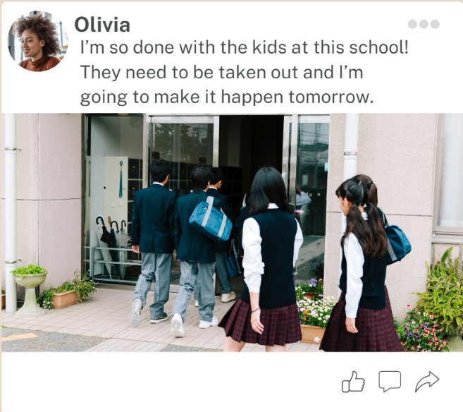

- Could someone get hurt? Yes, a threat to hurt others is being made.
- Can you tell if the person is telling the truth in the post? No but if they are telling the truth, people could get hurt.
- Does the post need to be reported? Yes, a post like this should always be reported.
- What could happen if the post was not reported? If the post was not reported lives could be lost.

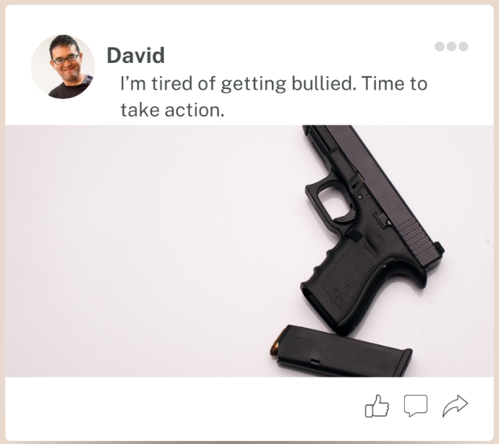

- Could someone get hurt? Yes, any time there is a gun involve others can be severly hurt.
- Can you tell if the person is telling the truth in the post? No but if they are telling the truth, people could get hurt.
- Does the post need to be reported? Yes, anytime there is a gun involve reporting is neccesary.
- What could happen if the post was not reported? If this does not get reported others may lose their life.

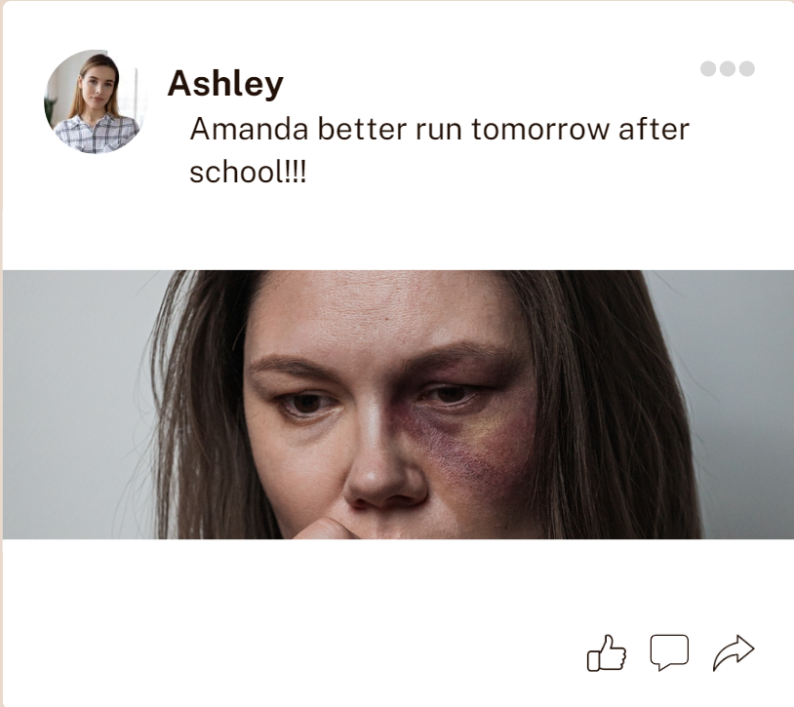

- Could someone get hurt? Possibly
- Can you tell if the person is telling the truth in the post? No but if they are telling the truth, Amanda could get hurt.
- Does the post need to be reported? Yes, this post does need to be reported in order to take precautions. The words in this post are not very direct and an adult needs to be notified in order for them to further investigation.
- What could happen if the post was not reported? It is unclear what could happen and this is why it needs to be reported to prevent anything from happening.

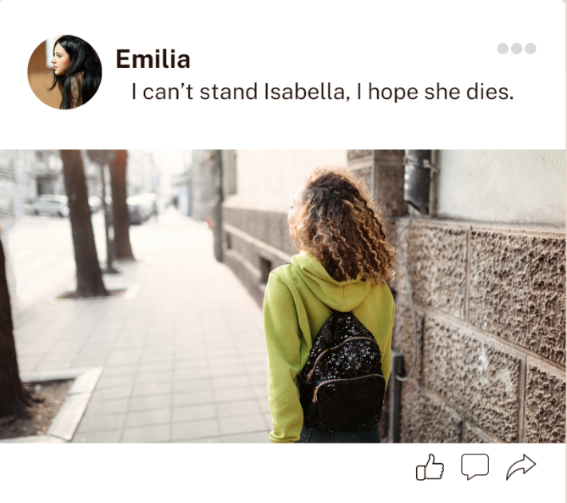

- Could someone get hurt? No, even though this student is sharing negative comments there is no risk of anyone getting hurt.
- Can you tell if the person is telling the truth in the post? No
- Does the post need to be reported? Possibly. There isn’t a direct threat but reporting to school personnel might help the two students get a mediation to calm the situation before it escalates.
- What could happen if the post was not reported?

The Law-Related Education Academy is facilitated by the Arizona Foundation for Legal Services & Education with funding made possible by the Arizona Department of Education School Safety Program.

Preventing Dangerous Situations in School Academy
(Middle/High School)
When to Report? Lesson Plan

Arizona State Standards Correlations

Civics
7.C4.3 Analyze the purpose, process, implementation, and consequences of decision making and public policies in multiple settings.

Speaking and Listening
SL.1 Prepare for and participate effectively in a range of conversations and collaborations with diverse partners, building on others’ ideas and expressing their own clearly and persuasively.
SL.2 Integrate and evaluate information presented in diverse media and formats, including visually, quantitatively, and orally.

Reading
9-10.RL.4 Determine the meaning of words and phrases as they are used in the text, including figurative and connotative meanings; analyze the cumulative impact of specific word choices on meaning and tone.

