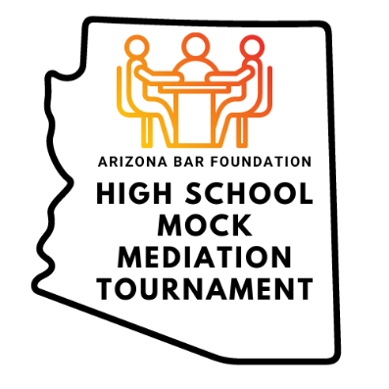
Speaking Up: When Student Speech Meets School Policy Head-On

DEFENDANT CONFIDENTIAL FACTS: Jordan

Jordan deeply regrets the tone and language used in their social media posts, and they never intended to cause harm to the school or its students. Jordan genuinely believed that the posts were meant as satire and light-hearted teasing, especially given their close friendship with Jamie, whom they have been friends with since they were in 1st grade.

Jordan’s family is also aware Jamie’s family provided the school administration with a signed letter stating Jordan’s family are close family friends and this incident was not a threat or form of bullying in Jamie’s eyes. Jordan voluntarily removed the post from their social media and believes the school should consider that heavily in their decision. Jordan is willing to apologize about the post but only if they are reinstated in their position with the high school newspaper as chief editor.

Jordan's parents are deeply concerned about the disciplinary actions taken against their child, particularly the two-week suspension and the infraction on Jordan's school record. They fear these consequences could adversely affect Jordan's academic record and future college applications. Jordan’s family hopes the school will sign a non-disclosure agreement and reverse the infraction as not to appear on Jordan’s school record.

Jordan's family believes that the school should consider the unique circumstances surrounding the posts, Jordan's active involvement in school activities, and the nature of Jordan and Jamie's friendship when determining a fair resolution. They are eager to avoid any long-term consequences that could hinder Jordan's education and prospects.

Jordan’s family is also willing to meet with the parents of the other students and apologize but only if the school agrees not to suspend Jordan. Jordan’s family is aware of the Supreme Court precedent limiting school control over free speech and is prepared to sue the school if this matter is not resolved. However, the 9th Circuit decision supports the school’s position since Jordan made comments toward other student council members, not just Jamie. Thus, Jordan’s family wants to avoid litigation if possible because there is no guarantee they will succeed.

