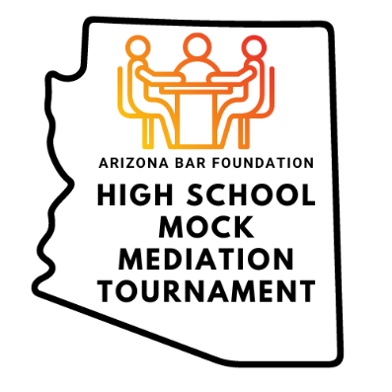
School Pranks: Senior Tradition or Disciplinary Action?

GENERAL FACTS:

Desert Sunset High School is a close-knit Arizona high school consisting of 3,000 students, with a long history of academic excellence and spirited traditions. Senior pranks have been a beloved tradition for decades. Throughout the years, the high school has witnessed its fair share of senior pranks. Some in the form of simple decorations on school grounds, such as putting balloons over lockers, banners, and streamers throughout the premises. Others have been coordinated efforts where seniors all “skip” school together, often with the school’s knowledge and permission. There have even been some years where senior prank weeks amongst students were allowed with the school’s permission because they were viewed as lighthearted activities.

These pranks were typically harmless, fun, and embraced by the school administration and the community. Last year, however, a large group of seniors snuck into the school after hours. Students put baby oil and marbles all over the floors, dropped goldfish into water coolers, and wrote their graduation class on the walls with what they thought was washable marker, but it wouldn’t wash off. This senior prank cost the school over $15,000 in repairs and was forced to close for a week to fix the damage left by the students. Over 50 students were banned from attending graduation and three teachers filed compensation claims after slipping and falling in the aftermath.

In January, the school's new principal, Dr. Islands, implemented a Senior Prank Ban with no exceptions. The ban prohibits any form of senior pranks and threatens severe disciplinary actions, including suspension, community service, and the loss of privileges, to avoid any risks and damage. Students are upset because they believe senior pranks are a long-standing right of passage before graduation in which they should be able to participate.

A small group of 25 seniors, led by the senior class president, Riley, took issue with the new ban because they had already received permission to execute their senior prank 2 months before the ban was announced. Except for last year’s seniors, they questioned why previous senior classes were allowed to engage in pranks without consequences and believe that the ban is arbitrary and unjust. The previous year’s principal had already reviewed and approved Riley’s proposal which involved putting thousands of red solo cups in the school courtyard, filling them with water and spelling out the graduating class’s year.

The seniors’ prank proposal stated the students would pick up the cups by the time lunch ended and that they would not fill the cups with anything other than water to avoid causing damage to school property. Believing the new ban did not apply to Riley’s already approved prank, the small group of seniors snuck into the school early in the morning and put down 3,000 red solo cups in the school’s courtyard as proposed. One student noticed the entrance separating the large indoor hallway leading into the courtyard was open. Realizing this, Riley and the group took the extra 5,000 cups they had not used, filled them with water, and covered the whole hallway.

Early the next morning, the janitor and faculty came into the school to find the large hallway covered in cups and were unable to get to their classes. School staff had 1 hour before classes began to dump the water and pick up the cups. However, there was not enough time to clean up the 8,000 cups before students arrived on campus to witness the prank. To ensure student classes would not be interrupted, Dr. Islands and teachers picked up about 3,000 cups to make a path in the hallway. From 8:30 a.m. to 12:00 p.m., the remaining 5,000 cups were out on display for the school to see.

Once lunchtime began, Riley gathered over 500+ students into the school’s courtyard and announced “We just committed the largest red solo cup prank ever! But now the time has come to clean it all up. Please help us out!” Almost immediately, the small group of seniors began handing out trash bags and over 500+ students began picking up the cups; the prank took 15 minutes to clean and resulted in over 75 trash bags filled with red solo cups.

A few teachers witnessed Riley’s announcement, told Dr. Islands, and immediately sent Riley to the office. Riley’s parents were notified and informed of the senior prank ban policy, which includes an opportunity for mediation with the school principal to help determine a mutually agreed upon disciplinary path. Otherwise, the school board could determine an appropriate punishment and criminal charges. Riley’s parents accepted the opportunity to mediate the matters.

Dr. Islands seeks to impose a punishment that is appropriate. They are concerned with not being too lenient as the senior prank ban will not act as a deterrent for other students in the future. The damage from last year’s seniors cannot happen again and if students believe they can get away with it then they will not adhere to policy. They recognize that Riley is a model student, serves as the senior class president, and has never been in trouble. Further they acknowledge that Riley is deeply regretful about the prank and the possibility of not being able to participate in the rest of the senior class activities, including prom or walk for graduation. The school hopes to meet with Riley’s parents and consider their suggestion on how best to move forward with this issue.

Riley’s family and counsel seek to mitigate the list of possible punishments against Riley because Riley is a straight “A” student that many students look up to, serves as the class president, and has always followed the rules until this prank occurred. Riley thought the prank was not included in the ban because it had been approved by the previous principal. Riley’s family has strong influence over the community and could garner support from other families in the school to highlight this new student prank ban. Riley’s family has been attending Desert Sunset High School for four generations and are familiar with the school’s integrated history for senior pranks. Riley’s family is open to ideas from the school on what they believe is an appropriate course of action for Riley violating the ban, which was in full effect when the prank occurred.

