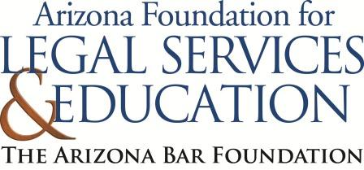
The Law-Related Education Academy is facilitated by the Arizona Foundation for Legal Services & Education with funding made possible by the Arizona Department of Education School Safety Program.

School Threats Community Lesson (Middle/High)
This lesson is intended for the families of the students. Please obtain administrator approval prior to implementing this lesson.

Objectives:
- Participants will identify behaviors that are helpful and harmful during a school emergency
- Participants will learn what to expect from school communication during a school emergency

Protective Factor Developed: Critical reasoning skills

Materials:
- Helpful vs Harmful Sort, 1 copy per pair
- T-Chart, 1 copy per pair
- Tape
- Sticky Note, 1 per participant
Prior to the lesson:
- Review your school’s emergency response plan
- Cut and place each Helpful vs Harmful sort into their own sealable plastic bag so there is one bag per pair

Timeframe: 40 Minutes

Introduce yourself and explain your role as a School Resource Officer. Thank everyone for coming and share the objectives for this meeting and your school site’s data on disrespect.

Lesson:
- Begin the activity by placing participants into small groups of 3 or 4 people in each.
- Read aloud the following scenario: It’s 10:30 am and you get a text that your child’s school is on lockdown. You can’t reach anyone. You see news crews showing live footage of the school, but you don’t know what’s happening inside.
- Ask participants to reflect and share how they would feel and what would be the first thing they would want to do.
- Explain that their feelings are completely normal but how we respond can make a huge difference in keeping everyone safe. Tell participants that they will now review actions and decide whether the action is helpful or harmful during an emergency.
- Create a T-Chart on the board with one side labeled helpful and the other side labeled harmful.
- Have participants work in pairs and give each pair a helpful vs harmful sort and T-chart.
- Instruct pairs to work together to sort the actions in the correct column: Helpful or Harmful.
- Next, call on pairs to share an action and explain which side they placed it on, then they will tape the action on to the board’s T-chart.
- Continue to rotate to each pair, until all actions have been shared and added. As the facilitator, expand and elaborate when needed.
- Then assign each pair one harmful action and ask them to discuss and share:
How might the person in the situation feel?
Why is it important to recognize harmful actions?
How could this behavior be changed to make it safer?
- Remind participants when parents rush to campus, they can become part of the emergency which makes it harder for law enforcement and endangers others.
- Review your school’s emergency response plan.
For Example:
- The school will activate lockdown or evacuation protocols as needed.
- Law enforcement and emergency responders take control of the site.
- Families will receive verified information through:
- Text/email alerts
- The school’s website or social media
- District or local emergency channels
- Reunification: Parents will be told when and where to meet their children safely.
- Emphasize that during an emergency, calm cooperation and trust in school staff are crucial.
- Debrief the lesson by having the participants write on a sticky note one way they can help during an emergency.
- Collect sticky notes as participants exit and review to ensure they understand the content.

